Maths | English | Topic
Maths Year 5  Wednesday  Complete 1 Fluent in Five arithmetic set daily.  Week 4 – test 3  (Mark with your parents and talk through ones where you have made mistakes)  Complete one rapid reasoning  Week 4 – Test 3  (Answers are available)  Follow the below link for today’s maths lesson:  https://whiterosemaths.com/homelearning/year-5/  Summer Term – Week 2  Lesson 3 - Adding decimals with a different number of decimal places – Watch the PowerPoint  2 – Work through the task  3 - The answers are available for you to check your work  Thursday  Complete 1 Fluent in Five arithmetic set daily.  Week 4 – test 4  (Mark with your parents and talk through ones where you have made mistakes)  Complete one rapid reasoning  Week 4 – Test 4  (Answers are available)  Follow the below link for today’s maths lesson:  https://whiterosemaths.com/homelearning/year-5/  Summer Term – Week 2 - Lesson 4 - Subtracting decimals with a different number of decimal places  1 – Watch the PowerPoint  2 – Work through the task  3 - The answers are available for you to check your work  Maths Year 6  Wednesday  Complete 1 Fluent in Five arithmetic set daily.  Week 4 – test 3  (Mark with your parents and talk through ones where you have made mistakes)  Complete one rapid reasoning  Week 4 – Test 3  (Answers are available)  Follow the below link for today’s maths lesson:  https://whiterosemaths.com/homelearning/year-6/  Summer Term – Week 2 - Lesson 3 - Problem Solving  1 – Watch the PowerPoint  2 – Work through the task  3 - The answers are available for you to check your work  Thursday  Complete 1 Fluent in Five arithmetic set daily.  Week 4 – test 4  (Mark with your parents and talk through ones where you have made mistakes)  Complete one rapid reasoning  Week 4 – Test 4  (Answers are available)  Follow the below link for today’s maths lesson:  https://whiterosemaths.com/homelearning/year-6/  Summer Term – Week 2 – Lesson 4 - Problem Solving  1 – Watch the PowerPoint  2 – Work through the task  3 - The answers are available for you to check your work | English – Year 5  Warm Up –  Complete one of the vocabulary ninja sheets.  Talk for Writing Book (PDF)  Year 5 = The Game  Follow the instructions from page 15 onwards.  Tasks include:  - Sentence imitation  - Adjective game  - Planning your story (guidelines / worksheets available)  - First draft of your story.  - Proof read and edit  - Option to publish as a mini book.  This has continued from Monday and Tuesday – I would love to see your stories!  English – Year 6  Warm Up –  Complete one of the vocabulary ninja sheets.  Talk for Writing Book (PDF)  Year 6 = Doors  Complete activities from 7 – 10.  I would love to read your stories if you could post them on google classroom!  Guided Reading Year 5 and 6  Independently read a chapter of your own book and write a summary for the chapter.  Year 5: Dystopia Guided Reading  Year 6 : The history of Red and Yellow cards  Spellings for Friday:  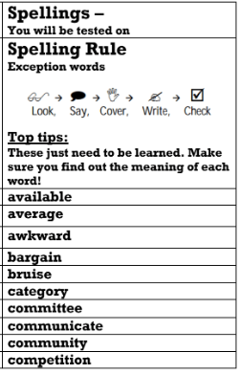 | Science  Our new topic for this term is Light  Follow the PowerPoint:  Science: Light: How We See Year 6 Lesson Pack 1  Activity:  Create a poster / education programme (images and dialogue using the writing frame) describing how we see things.  PE -  Mr Challinor has set us a Stoke City challenge.  Have a go for the chance of winning a signed shirt.  Computing:  (All about keeping safe online)  Follow this link  https://www.thinkuknow.co.uk/parents/Support-tools/home-activity-worksheets/8-10s/  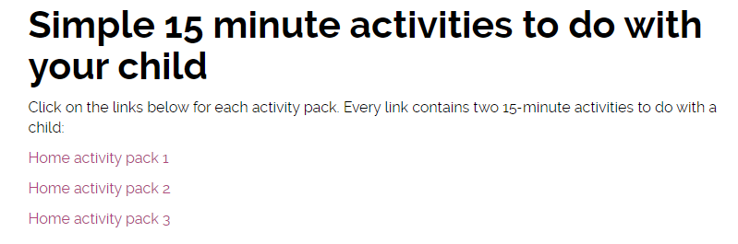  The above should show:  There are 3 work packs to support your learning at home.  Art:  Zentangle Art  A teacher has shared this art idea online – it looks fantastic. Have a go and upload any of your challenges.  (DO NOT TWEET THE TEACHER MENTIONED IN THE INTRODUCTION)
Additional Learning Opportunities:
- Daily reading (30 mins)
- Time Tables Rock Stars and Maths Frame (30 mins)
- Spelling Shed (30 mins)
- https://mathsframe.co.uk/en/resources/resource/477/Multiplication-Tables-Check
- PE with Joe Wicks https://www.youtube.com/watch?v=qGKGNzNbWjU
- Cosmic Yoga https://www.youtube.com/user/CosmicKidsYoga
- Education City

