Maths | English | Topic
Maths Year 5  Monday  Complete 1 Fluent in Five arithmetic set daily.  Week 5 – test 1  (Mark with your parents and talk through ones where you have made mistakes)  Complete one rapid reasoning  Week 5 – Test 1  (Answers are available)  Follow the below link for today’s maths lesson:  https://whiterosemaths.com/homelearning/year-5/  Summer Term – Week 3  Lesson 1 - Multiply 2-digit numbers (area model)  – Watch the PowerPoint  2 – Work through the task  3 - The answers are available for you to check your work  Tuesday  Complete 1 Fluent in Five arithmetic set daily.  Week 5 – test 2  (Mark with your parents and talk through ones where you have made mistakes)  Complete one rapid reasoning  Week 5 – Test 2  (Answers are available)  Follow the below link for today’s maths lesson:  https://whiterosemaths.com/homelearning/year-5/  Summer Term – Week 3  Lesson 2 - Multiply 4-digits by 2-digits  1 – Watch the PowerPoint  2 – Work through the task  3 - The answers are available for you to check your work  Maths Year 6  Monday  Complete 1 Fluent in Five arithmetic set daily.  Week 5 – test 1  (Mark with your parents and talk through ones where you have made mistakes)  Complete one rapid reasoning  Week 5 – Test 1  (Answers are available)  Follow the below link for today’s maths lesson:  https://whiterosemaths.com/homelearning/year-6/  Summer Term – Week 3  Lesson 1 - Simplify fractions  1 – Watch the PowerPoint  2 – Work through the task  3 - The answers are available for you to check your work  Tuesday  Complete 1 Fluent in Five arithmetic set daily.  Week 5 – test 2  (Mark with your parents and talk through ones where you have made mistakes)  Complete one rapid reasoning  Week 5– Test 2  (Answers are available)  Follow the below link for today’s maths lesson:  https://whiterosemaths.com/homelearning/year-6/  Summer Term – Week 3  Lesson 2 - Compare and order fractions  1 – Watch the PowerPoint  2 – Work through the task  3 - The answers are available for you to check your work | English – Year 5  Warm Up –  Complete one Grammar Warm Up  Talk for Writing Book (PDF)  Year 5 = Rhi-swano-zeb-tah workbook  Page 4 – Read Where the Wild Things Are – stimulus (link available)  Page 5 – Look and listen to the new creation made by the explorer  (Link available)  Page 6 -7 Read the information text  Complete the activity on page 8  Complete the word exploration on page 9  Compete the activity on page 10 – example / non example  Complete fill the gaps on page 11  Complete review learning on page 11  STOP HERE  English – Year 6  Warm Up –  Complete one Grammar Warm Up  Talk for Writing Book (PDF)  Year 6 = The City of Silence  Introduction and Game – Page 4  Activity 1 - 6  Guided Reading Year 5 and 6  Independently read a chapter of your own book and write a summary for the chapter.  Complete a reading revision mat –  Year 5 – To Whoever Finds this  Year 6 – Tim D’Rella  Spellings for Friday:  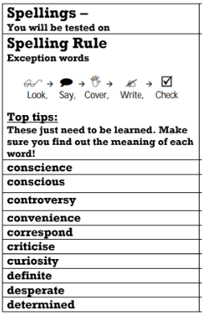 | Geography  Our new topic for this term is Trade.  Lesson 4 – Investigating Fairtrade  Work through the provided PowerPoint.  Your Task:  Create a poster using the template provided Why Pay More?  Write the reasons why people should pay more for fairtrade products and the positive impact of buying fairtrade products on people in developing countries.  Illustrate your poster with pictures of different fairtrade products (five from the price comparison  table- football, chocolate, gold ring, roses, face cream) linking your source location the correct  location on the world map.  PE -  Mr Challinor has set us some more challenges:  https://mailchi.mp/3379a8a38383/draft-of-school-games-newsletter-2782605  https://getseteatfresh.co.uk/  Computing:  (All about keeping safe online)  Follow this link  https://www.thinkuknow.co.uk/parents/Support-tools/home-activity-worksheets/8-10s/  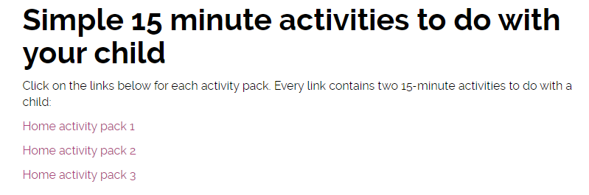  The above should show:  There are 3 work packs to support your learning at home.  Art:  Zentangle Art  A teacher has shared this art idea online – it looks fantastic. Have a go and upload any of your challenges.  (DO NOT TWEET THE TEACHER MENTIONED IN THE INTRODUCTION)
Additional Learning Opportunities:
- Daily reading (30 mins)
- Time Tables Rock Stars and Maths Frame (30 mins)
- Spelling Shed (30 mins)
- https://mathsframe.co.uk/en/resources/resource/477/Multiplication-Tables-Check
- PE with Joe Wicks https://www.youtube.com/watch?v=qGKGNzNbWjU
- Cosmic Yoga https://www.youtube.com/user/CosmicKidsYoga
- Education City

