Maths | English | Topic
Maths Year 5  Monday  Complete 1 Fluent in Five arithmetic set daily.  Week 6 – test 1  (Mark with your parents and talk through ones where you have made mistakes)  Complete one rapid reasoning  Week 6 – Test 1  (Answers are available)  Follow the below link for today’s maths lesson:  https://whiterosemaths.com/homelearning/year-5/  Summer Term – Week 4  Lesson 1 - Area of rectangles  – Watch the PowerPoint  2 – Work through the task  3 - The answers are available for you to check your work  Tuesday  Complete 1 Fluent in Five arithmetic set daily.  Week 6 – test 2  (Mark with your parents and talk through ones where you have made mistakes)  Complete one rapid reasoning  Week 6 – Test 2  (Answers are available)  Follow the below link for today’s maths lesson:  https://whiterosemaths.com/homelearning/year-5/  Summer Term – Week 4  Lesson 2 - Equivalent fractions  1 – Watch the PowerPoint  2 – Work through the task  3 - The answers are available for you to check your work  Maths Year 6  Monday  Complete 1 Fluent in Five arithmetic set daily.  Week 6 – test 1  (Mark with your parents and talk through ones where you have made mistakes)  Complete one rapid reasoning  Week 6 – Test 1  (Answers are available)  Follow the below link for today’s maths lesson:  https://whiterosemaths.com/homelearning/year-6/  Summer Term – Week 4  Lesson 1 - Multiply fractions by integers  1 – Watch the PowerPoint  2 – Work through the task  3 - The answers are available for you to check your work  Tuesday  Complete 1 Fluent in Five arithmetic set daily.  Week 6 – test 2  (Mark with your parents and talk through ones where you have made mistakes)  Complete one rapid reasoning  Week 6– Test 2  (Answers are available)  Follow the below link for today’s maths lesson:  https://whiterosemaths.com/homelearning/year-6/  Summer Term – Week 4  Lesson 2 - Multiply fractions by fractions  1 – Watch the PowerPoint  2 – Work through the task  3 - The answers are available for you to check your work | English – Year 5  Warm Up –  Complete one Grammar Warm Up  Talk for Writing Book (PDF)  Year 5 = Rhi-swano-zeb-tah workbook  Page 19 – 20  Write Away Activity  Page 21 – 24  Iguana Activity  Page 24 – 25  Create your own creature and plan your writing.  English – Year 6  Warm Up –  Complete one Grammar Warm Up  Talk for Writing Book (PDF)  Year 6 = The City of Silence  Activity 10 - 13  Guided Reading Year 5 and 6  Independently read a chapter of your own book and write a summary for the chapter.  Complete a reading revision mat –  Year 5 – The Contraption  Year 6 – Tim Berners Lee  Spellings for Friday:  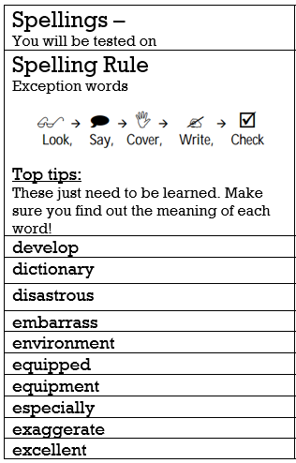 | Geography  Our new topic for this term is Trade.  Lesson 5 – Exports  Work through the provided PowerPoint.  Your Task:  Have a look at the data relating to the top 10 exports from the UK.  Use the table to create your own table ordering the ten UK exports from smallest to largest.  Then using this table, create a bar chart (you can do this in your books, or for a challenge try using excel). Make sure you label the axis and include a clear title.  There is an example one you can use to check your work at the end.  PE -  Mr Challinor has set us some more challenges:  https://mailchi.mp/3379a8a38383/draft-of-school-games-newsletter-2782605  https://getseteatfresh.co.uk/  Computing:  (All about keeping safe online)  Follow this link  https://www.thinkuknow.co.uk/parents/Support-tools/home-activity-worksheets/8-10s/  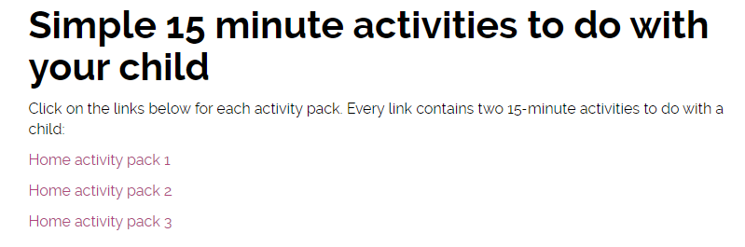  The above should show:  There are 3 work packs to support your learning at home.  Art:  Zentangle Art  A teacher has shared this art idea online – it looks fantastic. Have a go and upload any of your challenges.  (DO NOT TWEET THE TEACHER MENTIONED IN THE INTRODUCTION)
Additional Learning Opportunities:
- Daily reading (30 mins)
- Time Tables Rock Stars and Maths Frame (30 mins)
- Spelling Shed (30 mins)
- https://mathsframe.co.uk/en/resources/resource/477/Multiplication-Tables-Check
- PE with Joe Wicks https://www.youtube.com/watch?v=qGKGNzNbWjU
- Cosmic Yoga https://www.youtube.com/user/CosmicKidsYoga
- Education City

