Maths | English | Topic
Maths Year 5  Wednesday  Complete 1 Fluent in Five arithmetic set daily.  Week 6 – test 3  (Mark with your parents and talk through ones where you have made mistakes)  Complete one rapid reasoning  Week 6 – Test 3  (Answers are available)  Follow the below link for today’s maths lesson:  https://whiterosemaths.com/homelearning/year-5/  Summer Term – Week 4  Lesson 3 - Converting improper fractions to mixed numbers and vice versa  Watch the PowerPoint  2 – Work through the task  3 - The answers are available for you to check your work  Thursday  Complete 1 Fluent in Five arithmetic set daily.  Week 6 – test 4  (Mark with your parents and talk through ones where you have made mistakes)  Complete one rapid reasoning  Week 6 – Test 4  (Answers are available)  Follow the below link for today’s maths lesson:  https://whiterosemaths.com/homelearning/year-5/  Summer Term – Week 4  Lesson 4 - Compare and order fractions less than one  1 – Watch the PowerPoint  2 – Work through the task  3 - The answers are available for you to check your work  Maths Year 6  Wednesday  Complete 1 Fluent in Five arithmetic set daily.  Week 6 – test 3  (Mark with your parents and talk through ones where you have made mistakes)  Complete one rapid reasoning  Week 6 – Test 3  (Answers are available)  Follow the below link for today’s maths lesson:  https://whiterosemaths.com/homelearning/year-6/  Summer Term – Week 3  Lesson 3 - Divide fractions by integers  1– Watch the PowerPoint  2 – Work through the task  3 - The answers are available for you to check your work  Thursday  Complete 1 Fluent in Five arithmetic set daily.  Week 6 – test 4  (Mark with your parents and talk through ones where you have made mistakes)  Complete one rapid reasoning  Week 6– Test 4  (Answers are available)  Follow the below link for today’s maths lesson:  https://whiterosemaths.com/homelearning/year-6/  Summer Term – Week 3  Lesson 4 - Fractions of an amount  1 – Watch the PowerPoint  2 – Work through the task  3 - The answers are available for you to check your work | English – Year 5  Warm Up –  Complete one Grammar Warm Up  Talk for Writing Book (PDF)  Year 5 = Rhi-swano-zeb-tah workbook  Page 26 onwards  Write, edit and publish your information text.  You can be as creative as you wish with your presentation.  English – Year 6  Warm Up –  Complete one Grammar Warm Up  Talk for Writing Book (PDF)  Year 6 = The City of Silence  Activity 14  You could record your poem and post on google classroom?  Guided Reading Year 5 and 6  Independently read a chapter of your own book and write a summary for the chapter.  Complete a reading revision mat –  Year 5 – Tutankha-whom?  Year 6 – PICKLES SAVES THE WORLD CUP  Spellings for Friday:  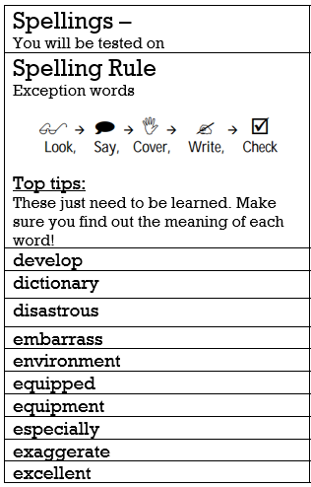 | Science  Our new topic for this term is Light  Follow the PowerPoint:  Science: Light: Reflecting Light Year 6 Lesson Pack 3  Refraction  Activity:  Complete the refraction Investigations  PE -  Mr Challinor has set us some more challenges:  https://mailchi.mp/3379a8a38383/draft-of-school-games-newsletter-2782605  https://getseteatfresh.co.uk/  Computing:  (All about keeping safe online)  Follow this link  https://www.thinkuknow.co.uk/parents/Support-tools/home-activity-worksheets/8-10s/  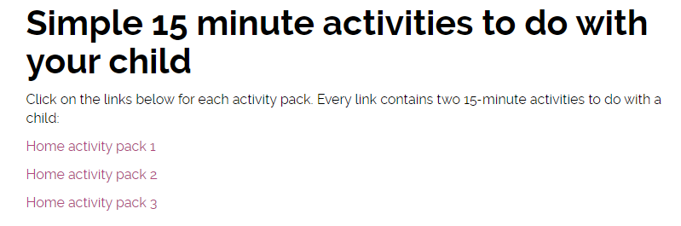  The above should show:  There are 3 work packs to support your learning at home.  Art:  Zentangle Art  A teacher has shared this art idea online – it looks fantastic. Have a go and upload any of your challenges.  (DO NOT TWEET THE TEACHER MENTIONED IN THE INTRODUCTION)
Additional Learning Opportunities:
- Daily reading (30 mins)
- Time Tables Rock Stars and Maths Frame (30 mins)
- Spelling Shed (30 mins)
- https://mathsframe.co.uk/en/resources/resource/477/Multiplication-Tables-Check
- PE with Joe Wicks https://www.youtube.com/watch?v=qGKGNzNbWjU
- Cosmic Yoga https://www.youtube.com/user/CosmicKidsYoga
- Education City

