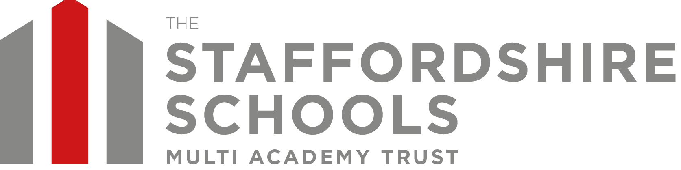

5th January 2021

Dear Parents and Carers,

We have taken the decision to close The Howard Primary School from Wednesday 6th January 2021 and provide cover for the children of Critical Workers and those who are vulnerable, at Richard Crosse.

For all children who are being educated at home, we will be providing daily online lessons and teacher support throughout the day, five days a week. Lessons will finish on Friday lunchtimes at 12.30, to enable teachers to have their statutory planning and preparation time on Friday afternoon, as they currently do.

Our remote learning policy can be found on the school/trust website which details what you can expect from us. Miss Mills will be in communication with you in order to explain and to show how the online/home learning will work in practice. She will also convey the school’s/trust’s expectations with regards to pupil behaviour whilst online and their readiness to learn.

I appreciate that none of us wish to be in this situation and we all want children to be in school rather than learning at home, however it is imperative that we all do our utmost to prevent the spread of the virus and to become safe as quickly as possible.

Thank you for your continued support.

Very best wishes
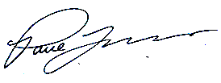

Mr P J Lovern
Chief Executive Officer

