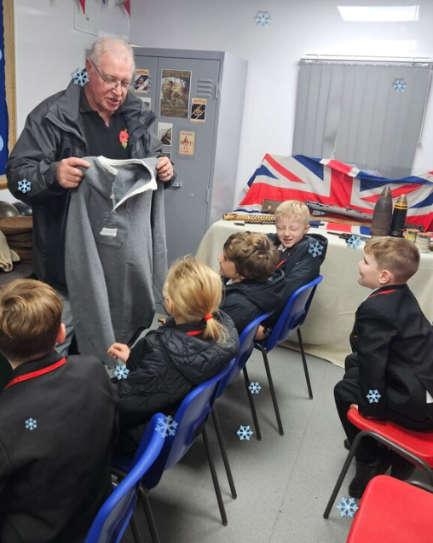
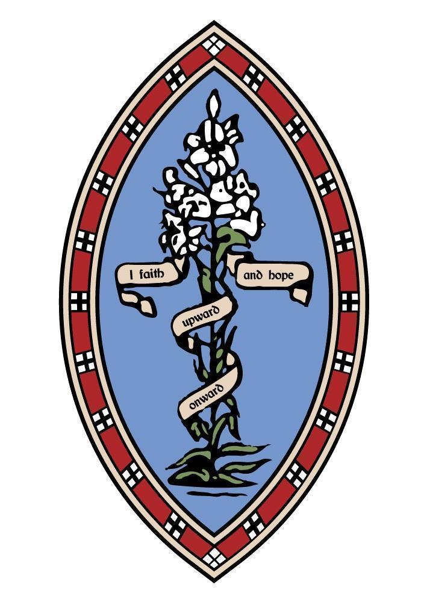
The Howard Primary School, Elford

As our first term at The Howard draws to a close, we reflect on a period brimming with joy, creativity, and positivity. The growth our children have shown in independence and self-confidence has been remarkable, allowing them to thrive and make significant progress in a very short space of time.
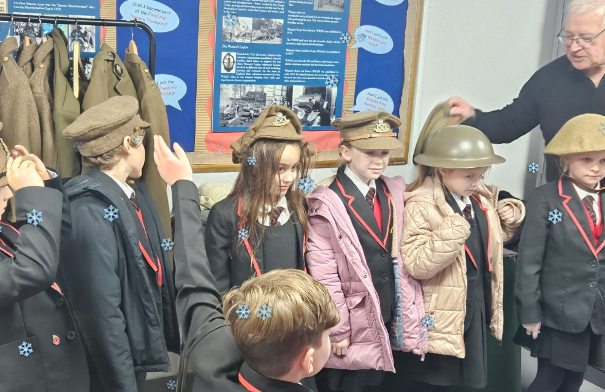
This final half term has been full of enriching experiences for all of the children.
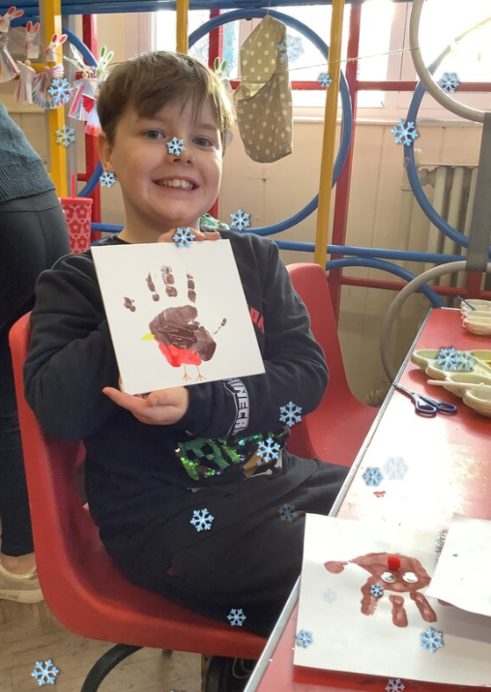
To enhance their historical studies, Class 3 took a trip to the Staffordshire Regiment Museum, gaining valuable firsthand insight into their topic. The children were, as always, such wonderful representatives of our school.

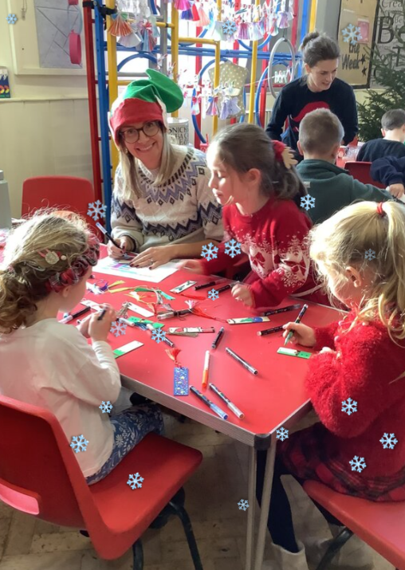
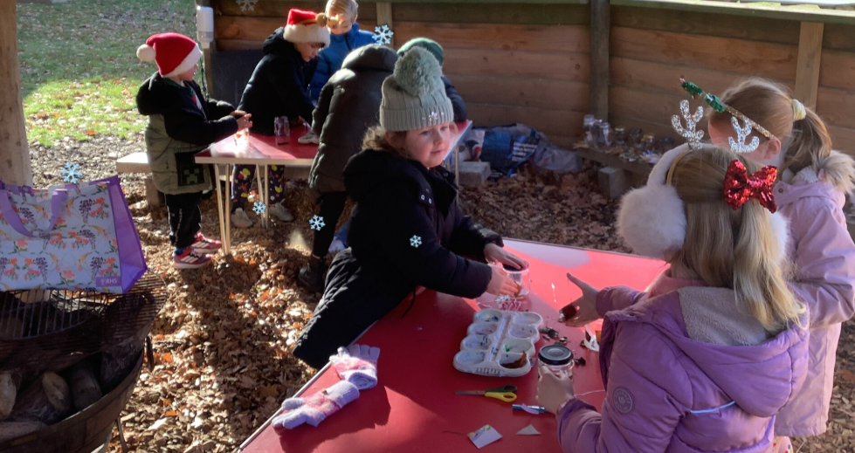
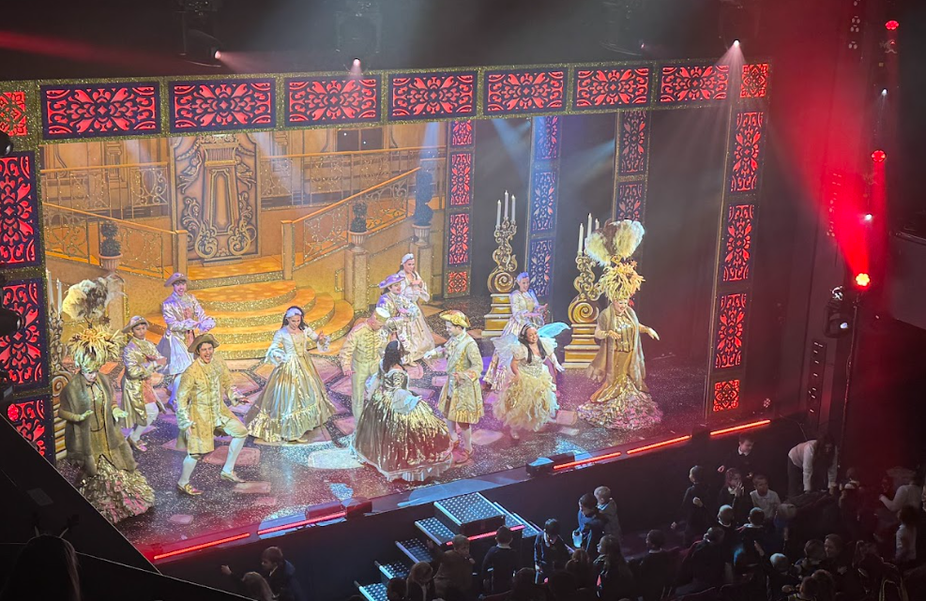
The festive season at The Howard kicked off in wonderful fashion with our Christmas Craft Day, expertly organized by our wonderful PTA! With the help of dedicated volunteers, the hall and our outdoor classroom became truly magical spaces. Children spent the day crafting, making wonderful use of the setting to create special, treasured gifts for their families.
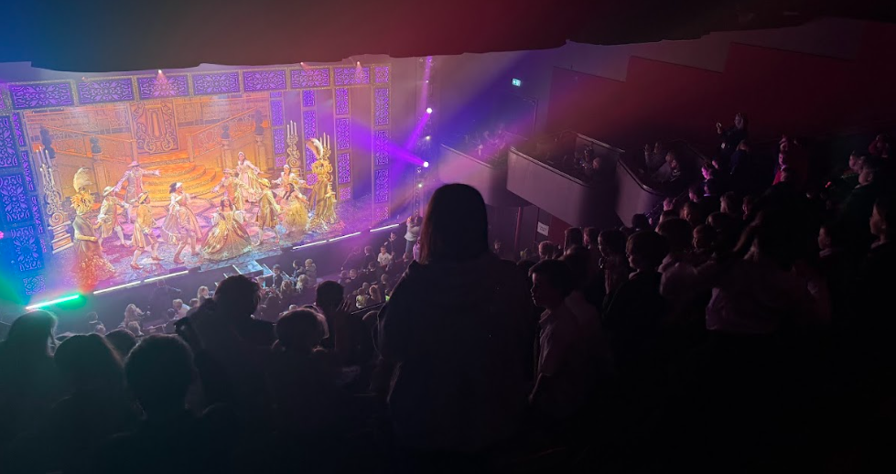
Our annual trip to the Lichfield Garrick was a huge success! The whole school enjoyed a fun-filled afternoon watching Cinderella, with everyone singing and dancing along. A truly wonderful yearly treat for all!

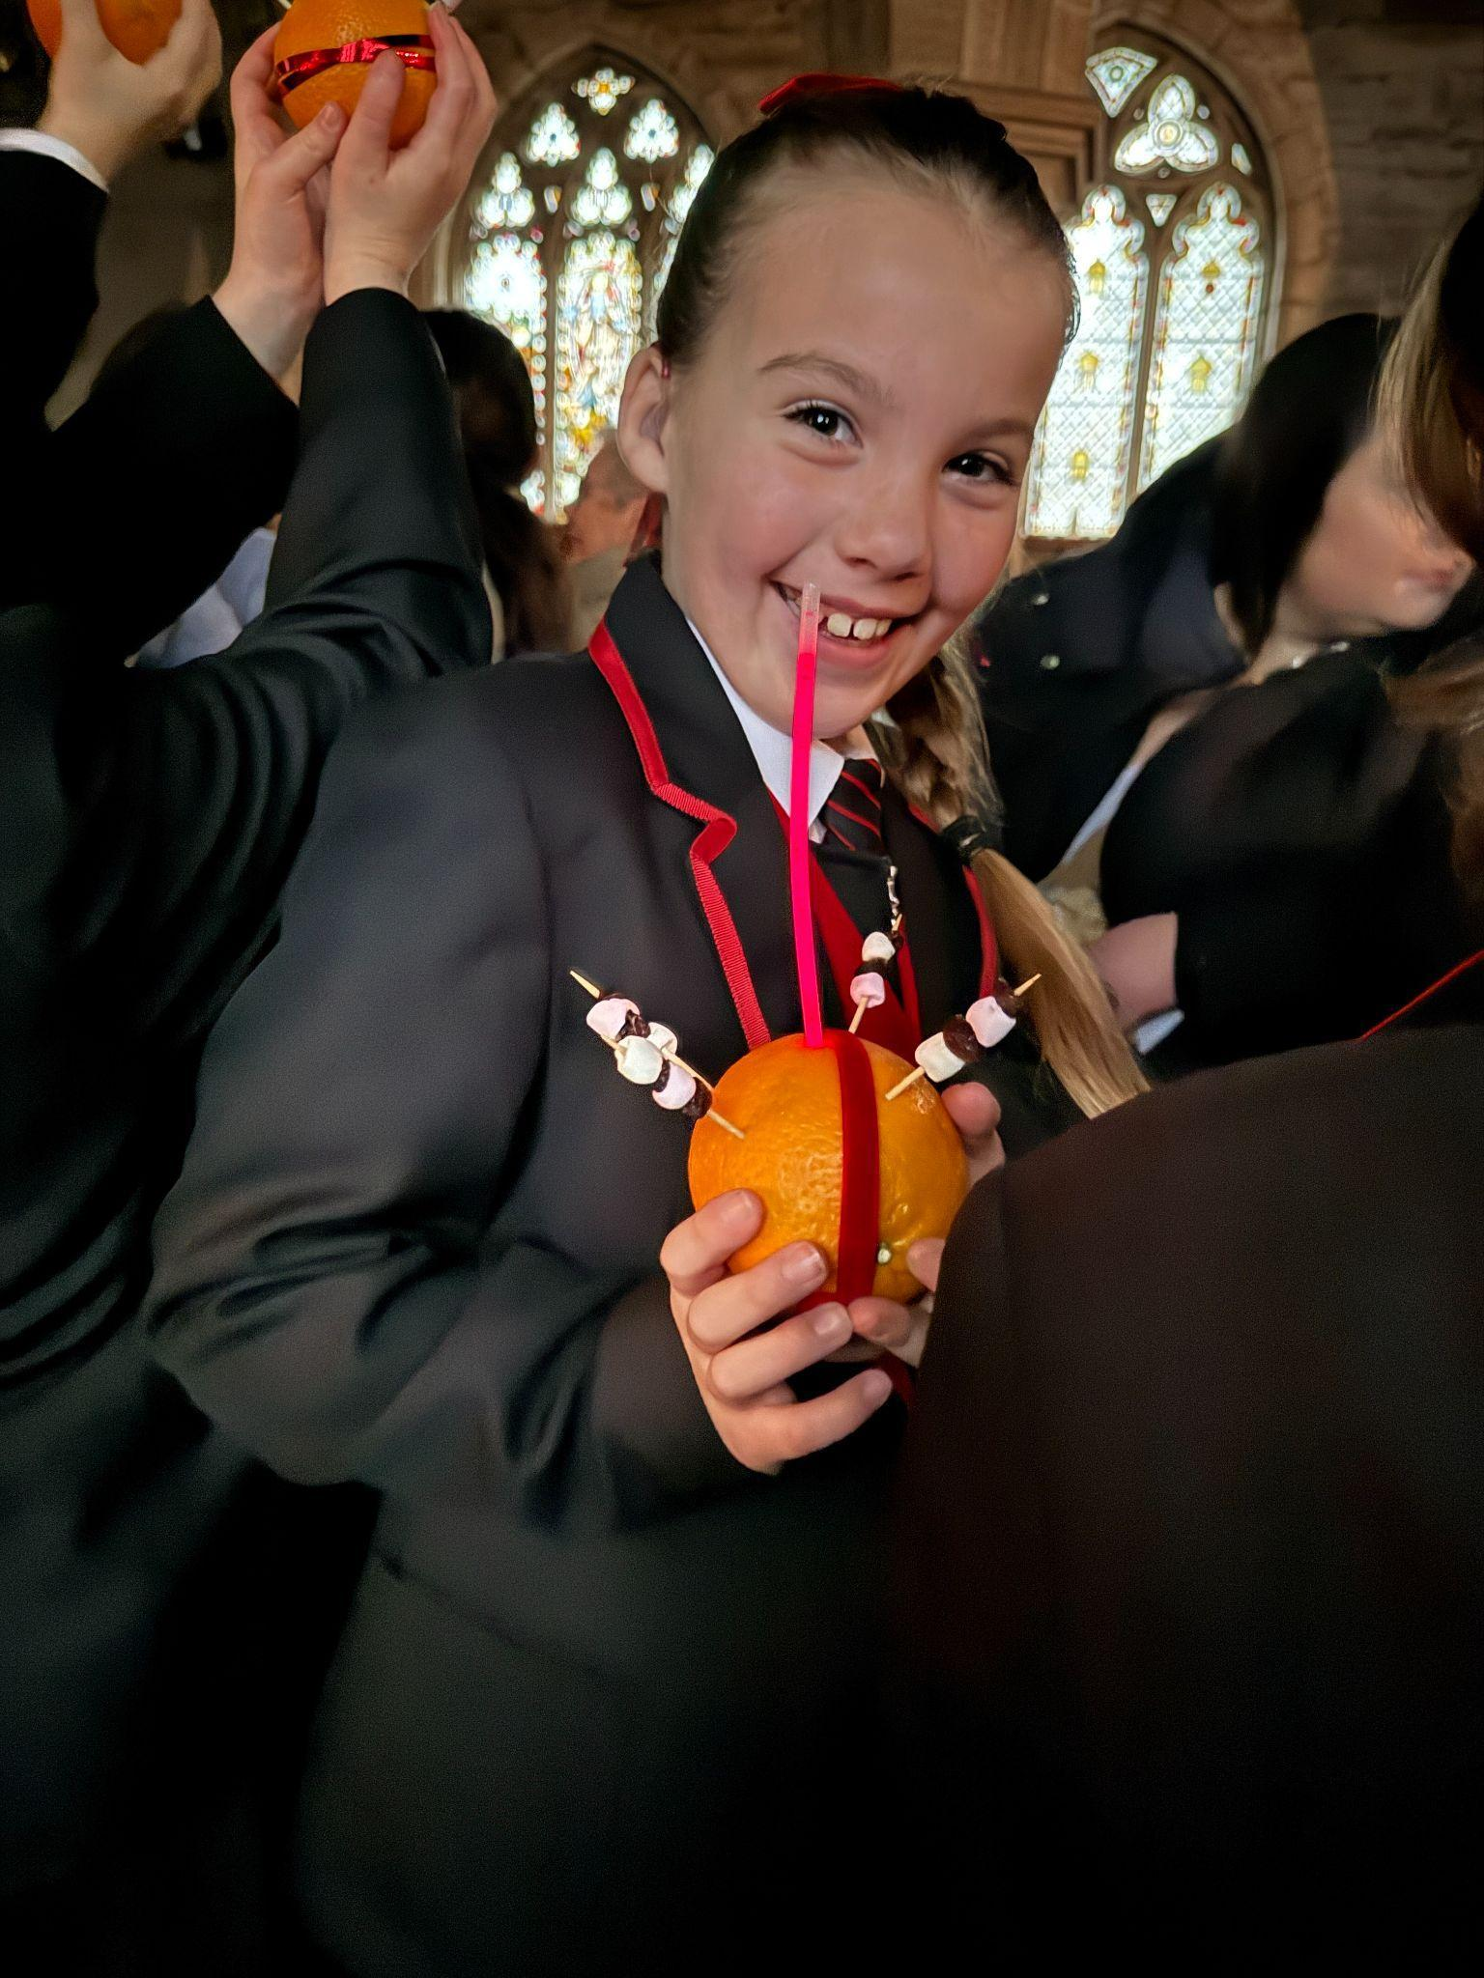
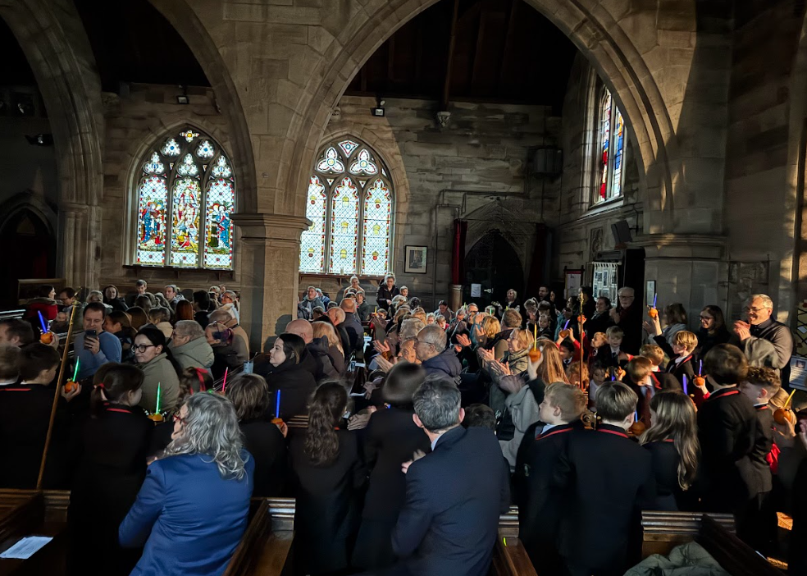
Class 4 expertly led our traditional Christingle service at St Peter’s church. The children reflected on the tradition and meaning behind the Christingle and Christmas time. It was a truly wonderful service to a packed church.

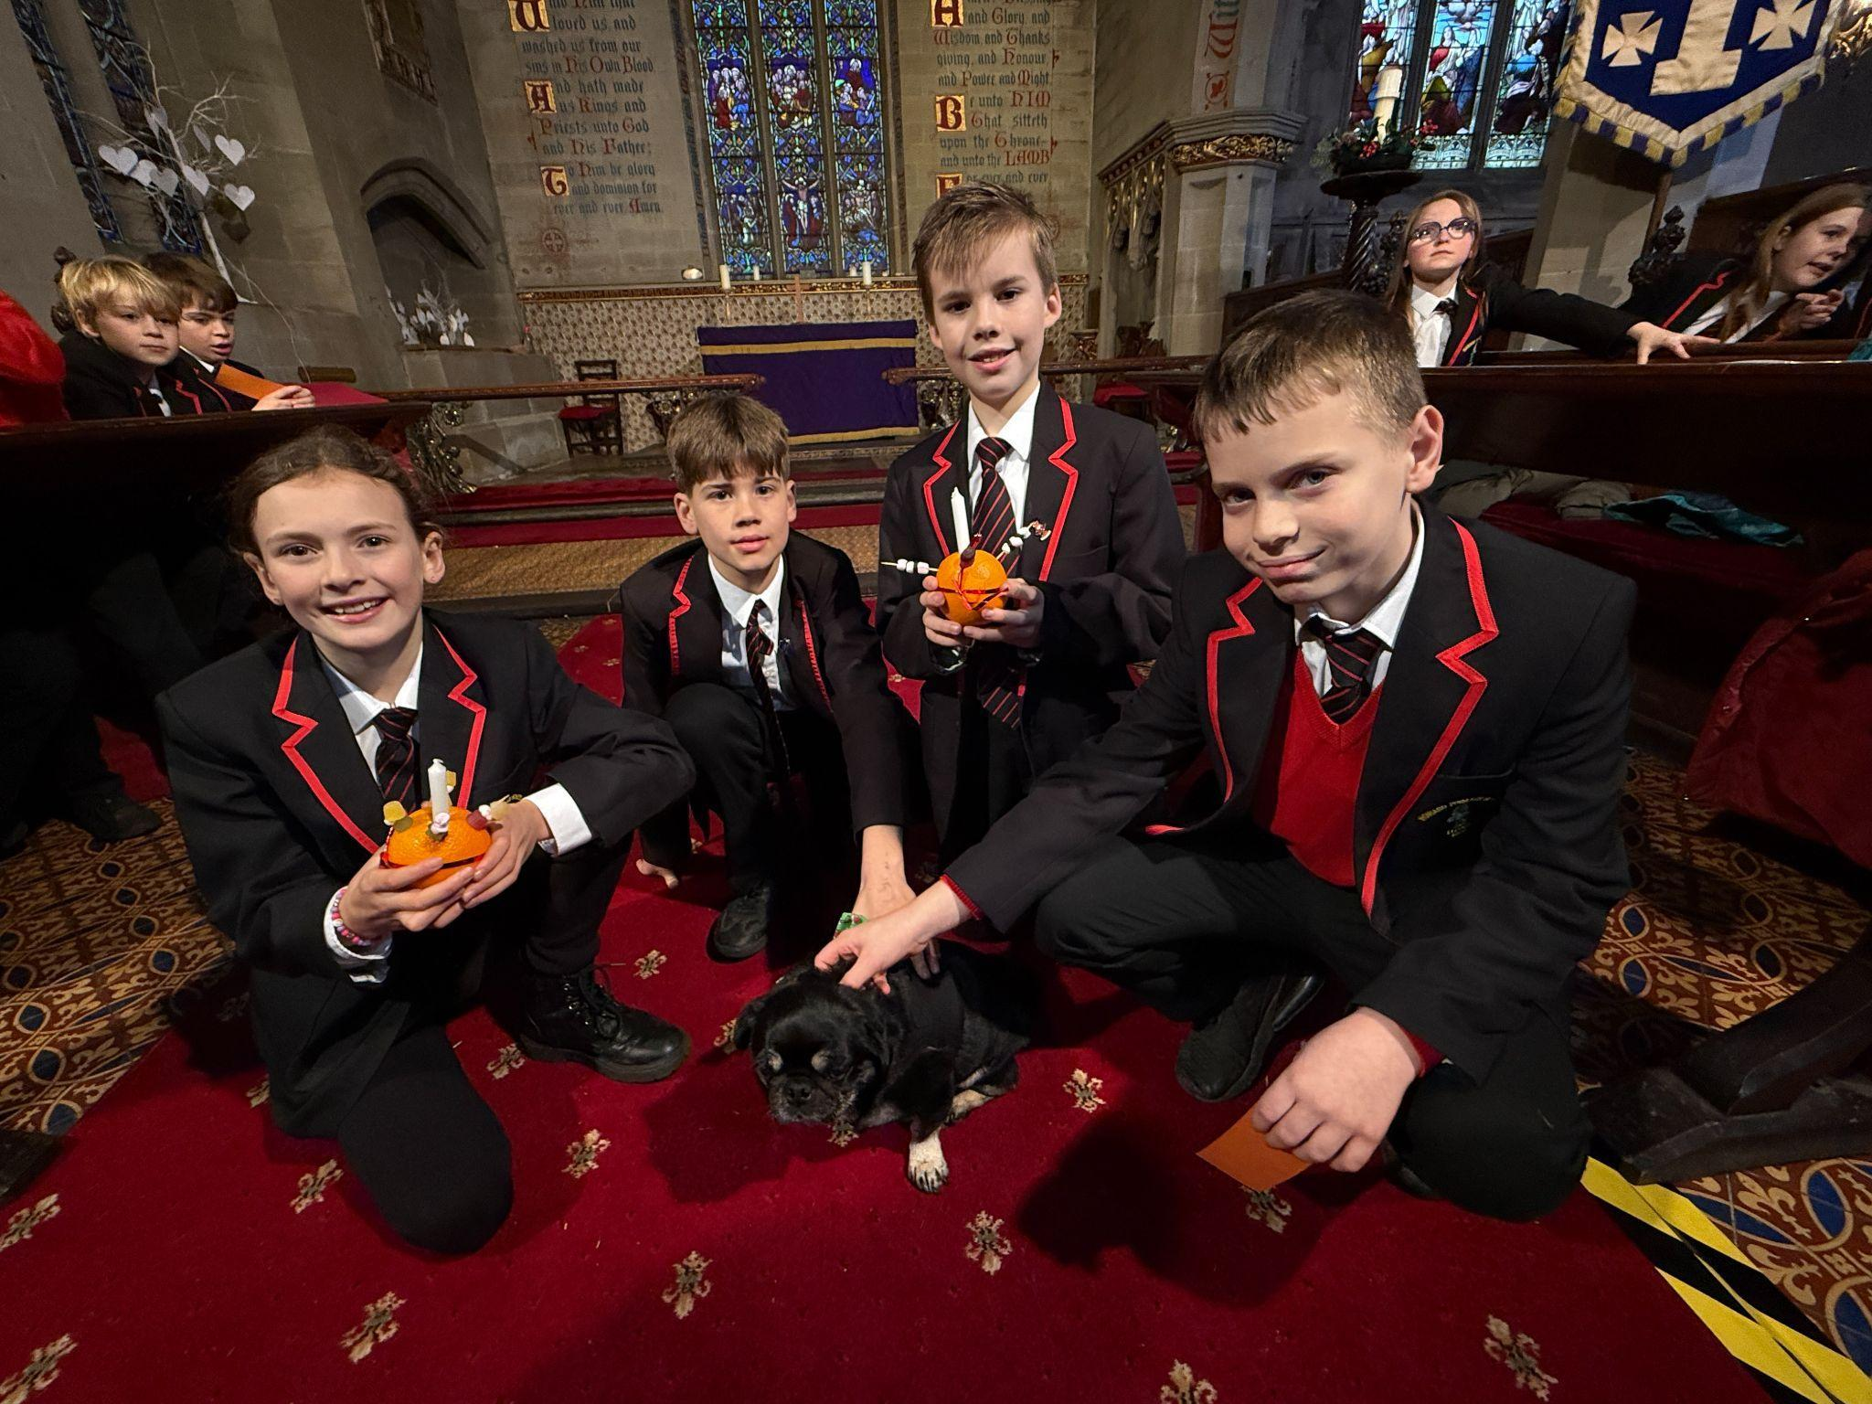
We were delighted to be invited to the Village Hall's coffee shop morning to sing carols. Our children performed beautifully, entertaining members of the community. We are incredibly grateful to the coffee shop for their immense generosity; they donated all profits made—an amazing £200—to the school. This significant contribution will be put to excellent use for the children in the new year.

Spreading festive cheer, a small group of children from Class 3 and Class 4, accompanied by Mr. Challinor, visited the local care home - Stubby Leas- to sing carols. The residents were absolutely delighted and thoroughly enjoyed hearing our children's beautiful voices.
To wrap up the term, our incredible Reception and Key Stage 1 children put on a truly amazing Nativity! It was a brilliant show that garnered plenty of laughs and rapturous applause from a very proud audience.

We would like to wish you all a very merry christmas and a wonderful new year.

From everyone at The Howard Primary

