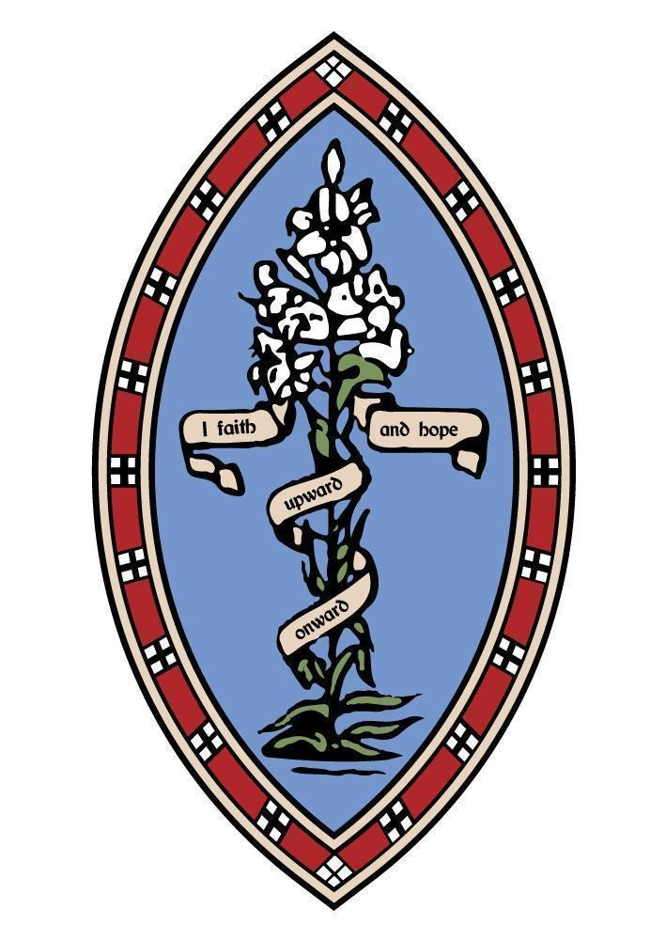
The Howard Primary School, Elford
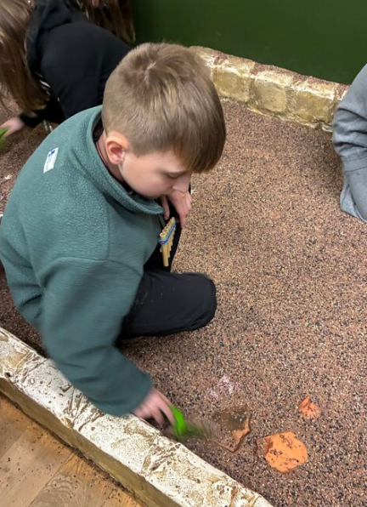
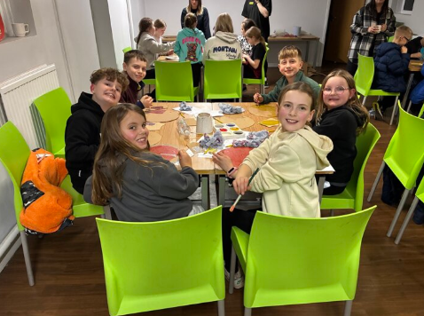
We have welcomed February with plenty of love here at The Howard. It has been a whirlwind of activity lately, and we are delighted to share some of the highlights from across the school. Our classrooms are buzzing with energy, and we have recently showcased our children’s wonderful work to their parents/ carers during parents’ evenings.
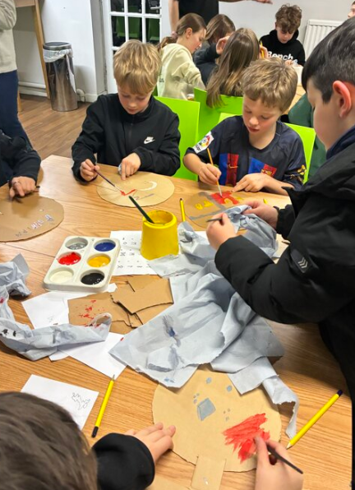
At the end of January our Class 4 pupils returned from their overnight residential trip to York, and what a trip it was! The children fully immersed themselves in history, stepping back over a thousand years to discover what life was like in the Viking age. The highlights of the trip were truly unforgettable: pupils explored the sights and smells of the Jorvik Centre, unearthed history during a hands-on archaeological dig, and showcased their artistic flair by designing and painting authentic Viking shields. Beyond the activities, we would like to extend a huge "well done" to the children themselves. They had a brilliant time and were wonderful representatives of our school, demonstrating kindness, curiosity, and excellent manners throughout the stay. We couldn't be prouder of them!
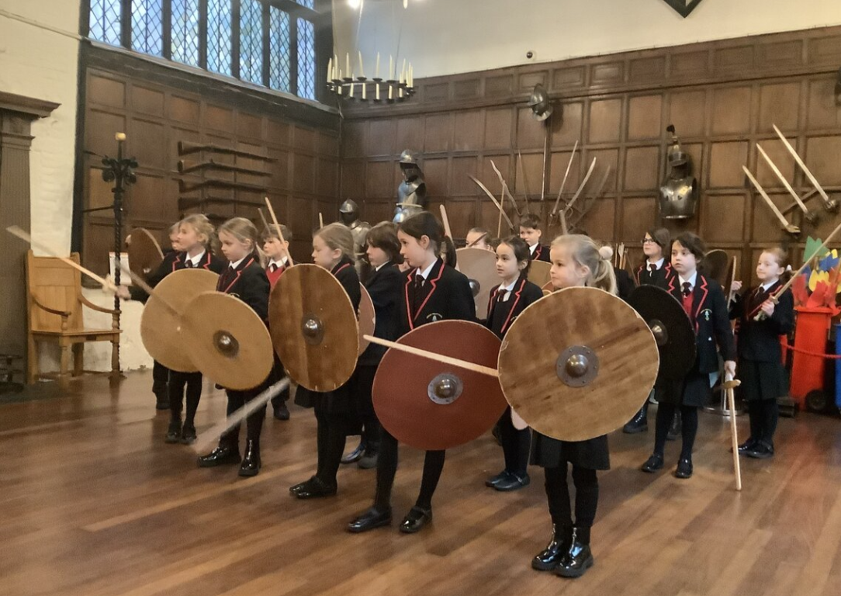
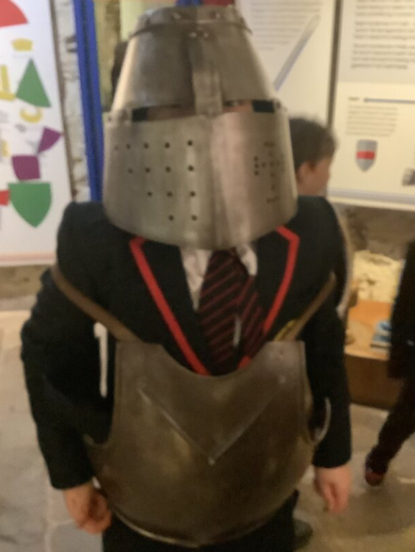
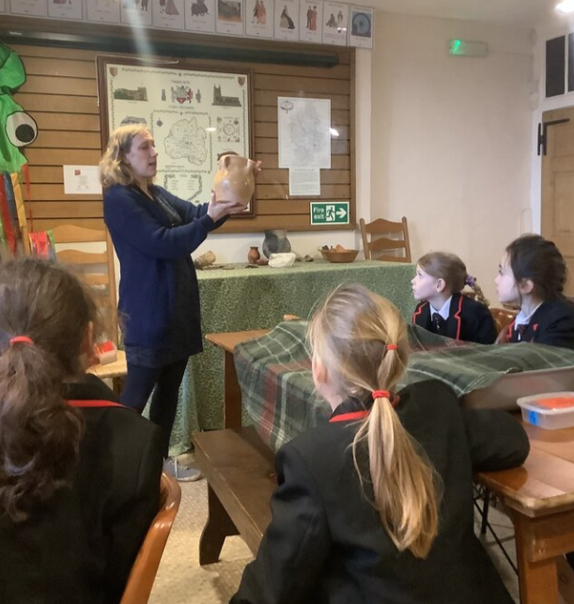
Our Class 3 students had a fantastic opportunity to step back in time during their visit to Tamworth Castle. It was wonderful to see their History topic truly come to life as they explored the realities of Saxon daily life. Most impressively, the children discovered a newfound pride in our local heritage, learning that the capital of the ancient Saxon kingdom of Mercia was located right here in Tamworth!

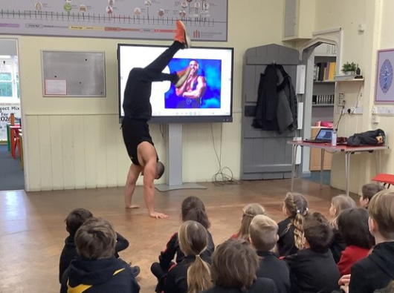
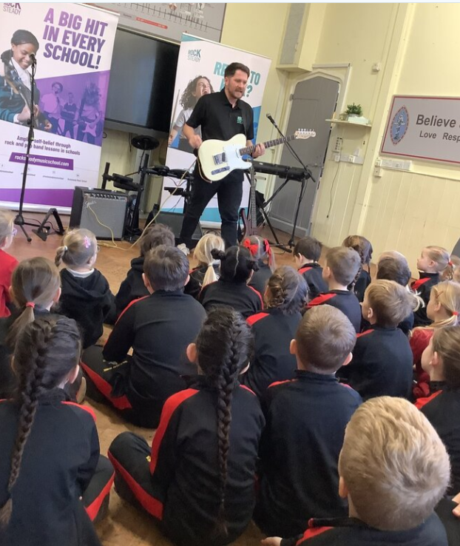
We have had many wonderful experiences shared by the whole school this past month. Firstly, our wonderful PTA organised for us to meet a sports personality, Zack George, best known as Steel from Gladiators. He talked to the children about the importance of being healthy and following your dreams. We might have future gladiators amongst us here at The Howard!
We were also thrilled to host Rocksteady, who visited to inspire our budding musicians to form their own mini-bands. It is fantastic to see so many children signing up for these extra lessons, and we are already looking forward to the creative energy of their end-of-term performances.
As we approach the break, we are all looking forward to some well-deserved rest and quality time with our families. These moments away from the classroom are vital for recharging our batteries. We look forward to welcoming everyone back soon, ready for another term filled with inspired learning and, of course, plenty of fun!
From everyone at The Howard Primary

