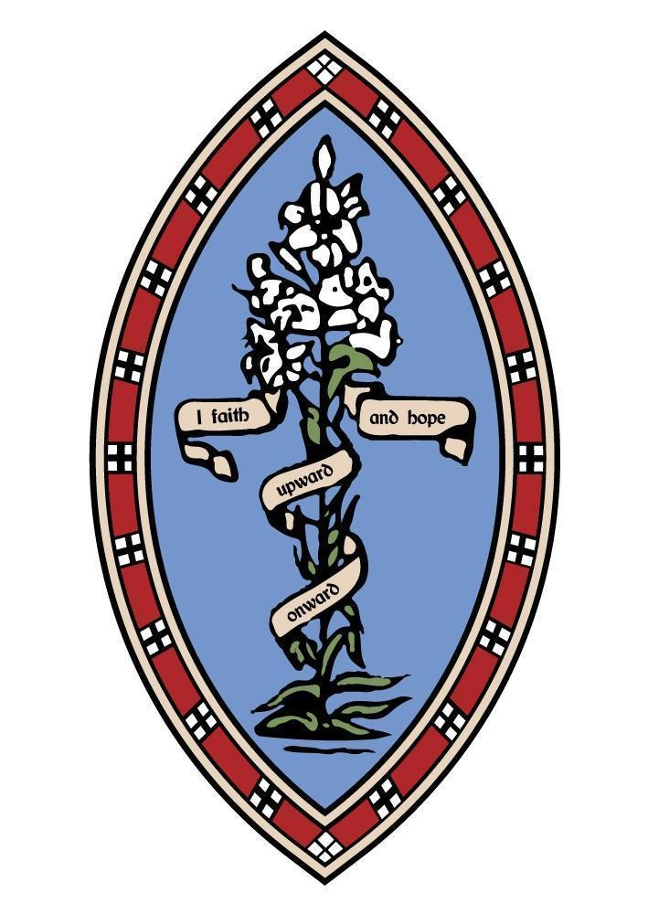
The Howard Primary School, Elford
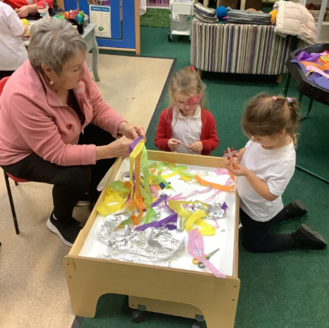
As our first term at The Howard draws to a close, we reflect on a period brimming with joy, creativity, and positivity. The growth our children have shown in independence and self-confidence has been remarkable, allowing them to thrive and make significant progress in a very short space of time.
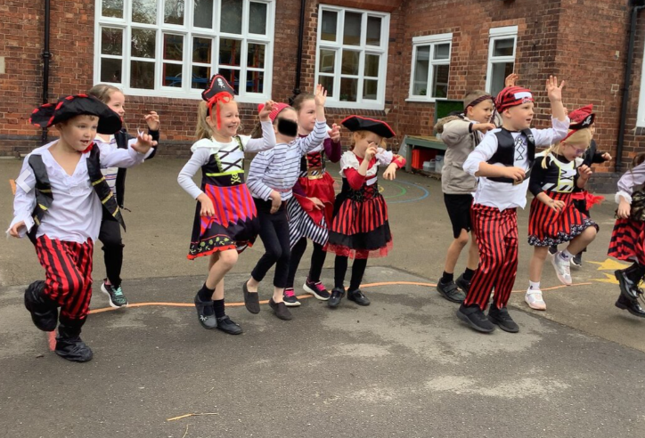
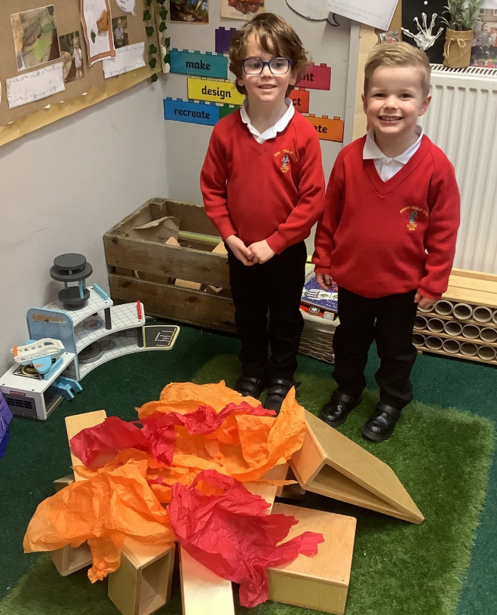
They built bonfires in the construction area, painted fireworks and decorated biscuits, plus many more wonderful activities. A big thank you to those that attended. Class 1 have also had lots of fun learning about superheroes (real and fiction). They ended their learning with a dress up as a superhero day.
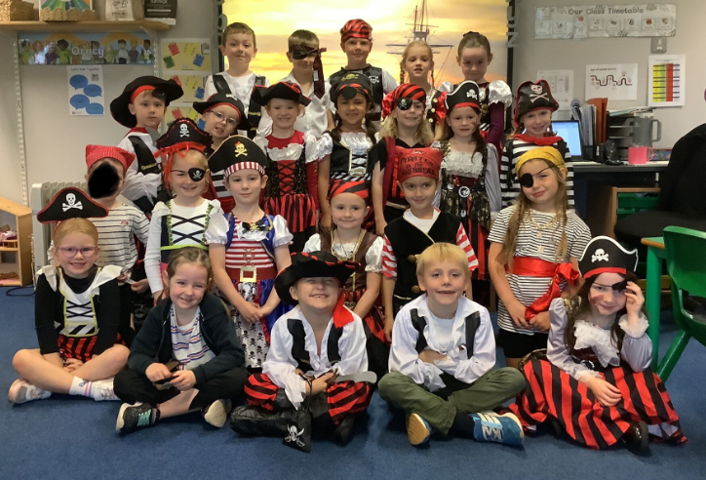
Class 2 children have written amazing non-chronological reports about Pirates which are proudly on show in our school library. To end a wonderful few weeks learning about pirates, they held a Pirate Day where the children dressed up, learned to talk like a pirate and played lots of Pirate games.
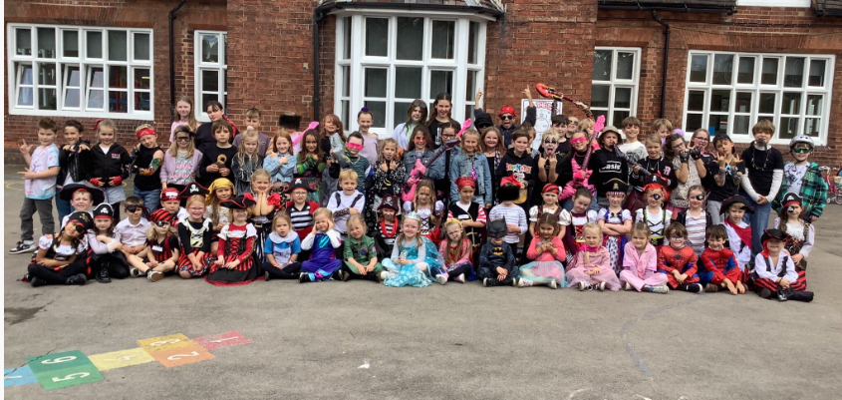
Class 3 and 4 have been working extremely hard to improve their multiplication knowledge and recall speed. The children had a super day dressed as Rockstars for the launch of Timestable Rockstars.

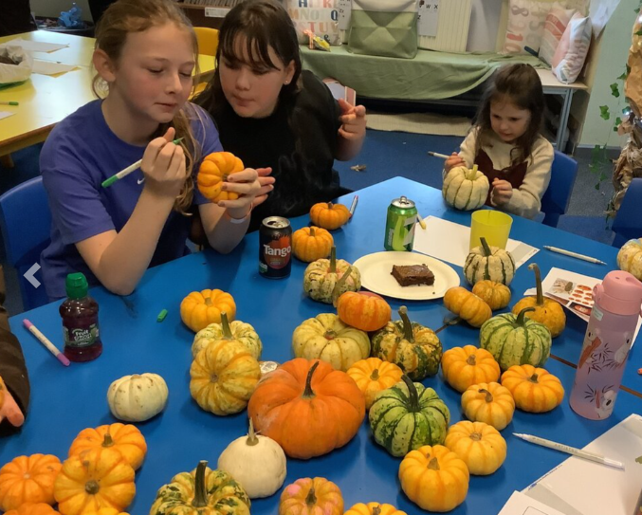
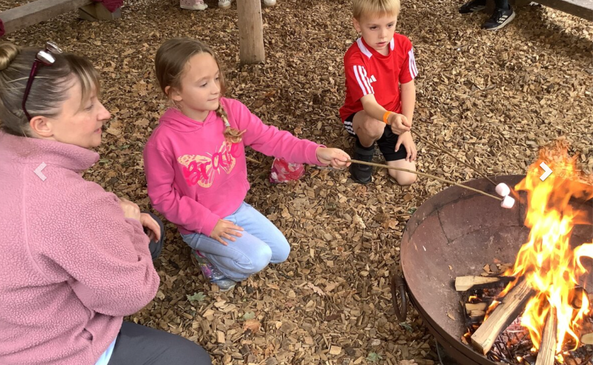
To finish off the first half term, our wonderful PTA arranged an Autumn Festival. The children enjoyed taking part in pumpkin crafts, roasting marshmallows and making magic wands. There was also a glow disco! Thank you to everyone who gave up their time to make this such a wonderful event. Everyone had such a great time.
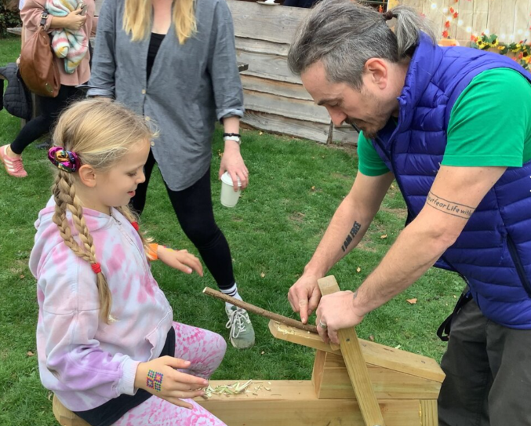

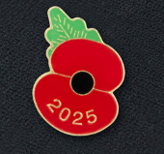

On Tuesday 11th November, the children and staff had a thought provoking assembly, led by Mr Challinor, remembering those who have fought so that we may live. The school paid their respects with a two minute silence to reflect. Year 6 children have given up their breaktimes to sell poppies to raise money for The Royal British Legion. We are incredibly proud of how respectful our children have been.

We are looking forward to another busy half term full of Christmas magic, the nativity from EYFS and KS1 and our Christingle service at the church.

From everyone at The Howard Primary

