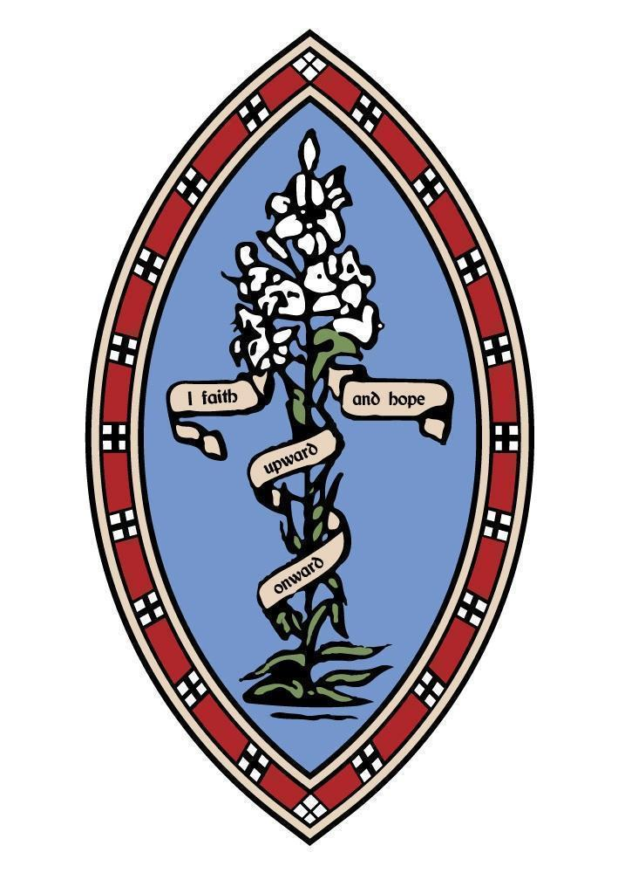
The Howard Primary School, Elford
September Newsletter

We are so pleased to be back at The Howard after a wonderful summer of fun with our friends and families! Our newest Howard children have settled into school life wonderfully and we are all so excited to see them begin their learning journey at The Howard. Class 2 children have enjoyed two wonderful weeks of learning in their new classroom and outdoor area, demonstrating our values of respect, believe and achieve, love and friendship.
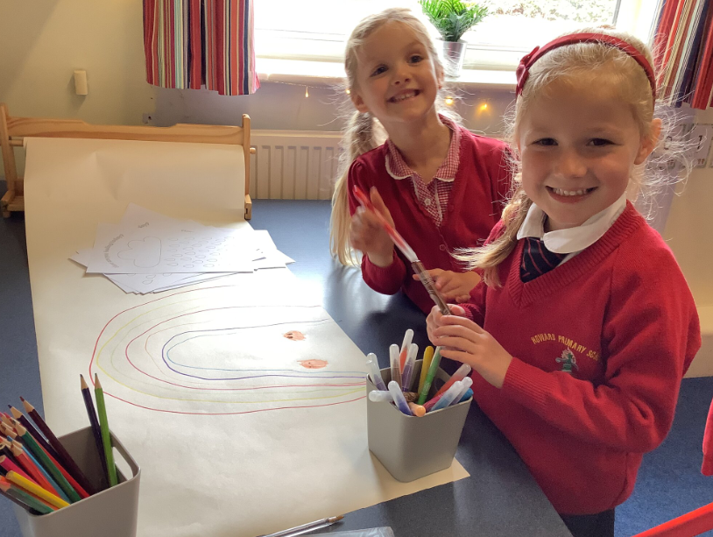
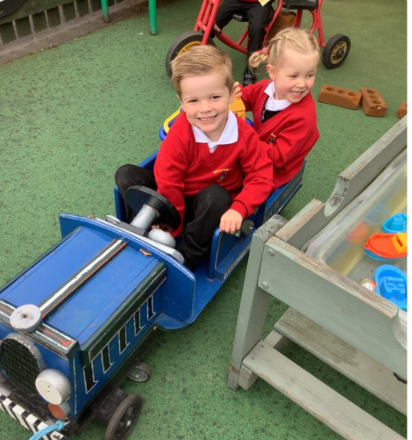
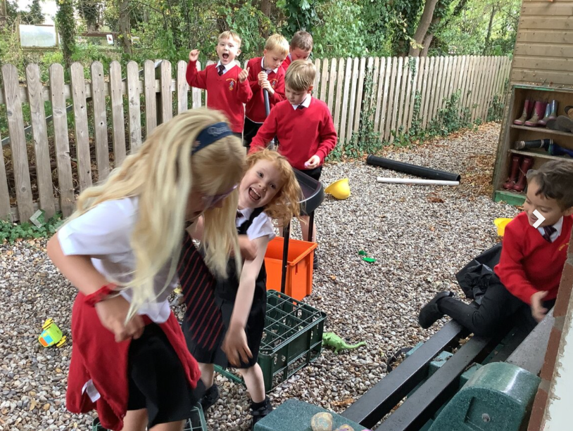

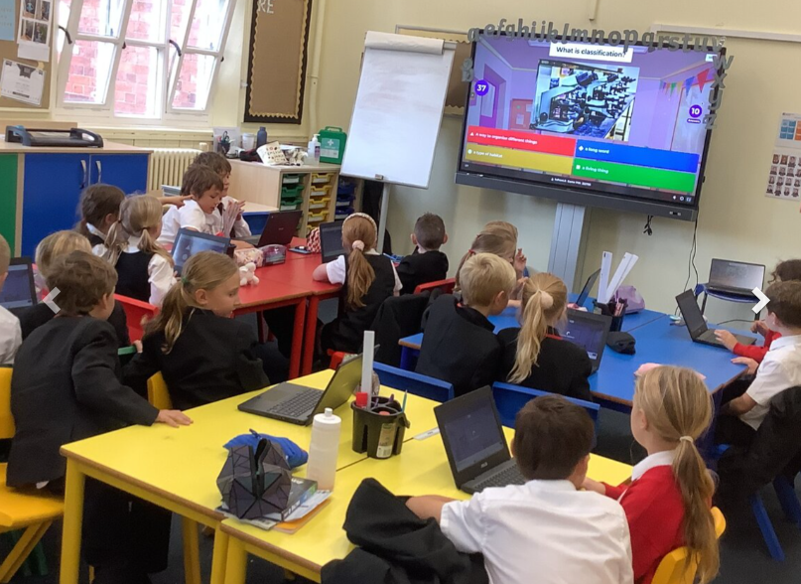
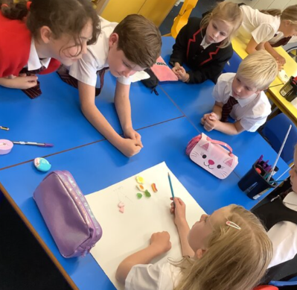
Class 3 have returned with the same great attitude towards their learning that they had before. They have dived into creative lessons, including a memorable science lesson where they used Kahoot and sweets to explore classification.
Class 4 have continued to be a wonderful example for the rest of the school, showing great responsibility and independence in their learning.

Our new PTA has been busy with Mr Wynn putting their heads together to plan and create exciting events to enhance the lives and experiences of the children at The Howard. There has already been a delicious and very popular bake sale and we know there are many more wonderful events to come! As always, we thank them for their hard work and care that they show our Howard family.
We would also like to thank all of the volunteers who looked after our beautiful sensory garden during the warm summer holidays- we appreciate your care and the time that you gave up.

We are all eager to see the children learn and grow over the upcoming academic year, which is set to be an exciting one! Mr Wynn & Mrs Fallows

