June 2021

Online Safety Newsletter

Omegle

You must be 18+ to use or 13+ with parental permission. Omegle is a social networking/chat website that connects two strangers together for either a text or a video chat. Chats are anonymous unless a user provides this information within their text or video chat. Omegle states that “Omegle video chat is moderated. However, moderation is not perfect. You may still encounter people who misbehave.”

What should I be aware of?
- No registration is required to access Omegle (therefore no age verification) and there are no reporting facilities.
- Users are given an option to save the chat's log and share the link. It is always possible for other users to take screenshots of text and video chats.

We recommend that Omegle is not used by children due to the potential imagery shared and language used which can be particularly explicit.

Net Aware rate the safety features of this app as very poor. https://www.net-aware.org.uk/networks/omegle/

This blog from UK Safer Internet Centre features further information including how to talk to your child about Omegle:

https://www.saferinternet.org.uk/blog/what-omegle-key-things-parents-and-carers-need-know

YouTube – new supervised experience (beta version)

YouTube have created a new ‘supervised experience’ for children who perhaps are ready to explore more than what is offered by YouTube Kids (YouTube Kids is still recommended for younger children) but are not old enough to use YouTube (you should be over 13 years of age). This new experience is managed by you by creating a supervised Google Account linking to your child’s account.

The supervised experience is still in beta version. It offers three content settings which are as follows:

- Explore: For children ready to explore content on YouTube, this setting will include content generally suitable for ages 9+.
- Explore More: Content generally suitable for viewers ages 13+, this setting will include more content as well as live streams.
- Most of YouTube: This setting will contain almost all YouTube content (except age-restricted content) so it will include sensitive topics that may only be appropriate for older teens.

Whilst YouTube have systems in place to block inappropriate content, no system is perfect so your child may still see something unsuitable. Talk to your child about how to stay safe online and what to do if they do come across anything unsuitable (they should talk to a trusted adult). There are reporting mechanisms within YouTube so make sure you and your child know how to report anything inappropriate.

YouTube, along with several partners have created this family guide to supervised experiences:

https://tinyurl.com/4k8hdasj
Users of this guide do so at their own discretion. No liability is entered into. Current as of the date released 1.6.21.

Gaming apps with adult themes you should know about

This article also includes tips to help you:

https://www.net-aware.org.uk/news/gaming-apps-with-adult-themes-you-should-know-about/

Your Digital footprint

What is a Digital Footprint?
A Digital Footprint is any information that is available online about you (even information shared by others), for example, photos, posts, and comments that you have made. We need to support children in developing a positive footprint by encouraging them to think about what they share and that they have appropriate privacy settings in place.

Further reading:
Childline provide further information as well as tips on how to protect your privacy and how to delete things online:

SEND Online Safety Hub

Net Aware have worked with Ambitious about Autism to create a hub featuring online safety tips, advice and activities for parents/carers of children with SEND.

https://www.net-aware.org.uk/send-online-safety-hub/

https://www.childline.org.uk/info-advice/bullying-abuse-safety/online-mobile-safety/taking-care-your-digital-footprint/
Screen time

What is screen time?
It is the amount of time that we spend on a phone, computer, watching television or on a games console. Often, we worry about how much screen time our children are having and unfortunately, there is a lack of research to determine how much screen time our children should have. Following guidance released in 2019 by the Royal College of Paeditrics and Child Health (RCPCH), Professor Russell Viner, President of RCPCH suggests:
What age can my child start social networking?

All social networks have age restrictions, it’s important to review these to check what your child is using is appropriate for them. Internet Matters provide further guidance here as well as listing the minimum age for many of the platforms we see being used:

https://www.internetmatters.org/resources/what-age-can-my-child-start-social-networking/

“that parents make decisions about screen time based on their child’s development and health, and whether they are getting enough exercise and sleep. It remains a question of balance, as it is when screen use gets in the way or restricts other activities that a child’s well-being can be negatively impacted.”

[https://www.rcpch.ac.uk/news-events/news/rcpch-responds-social-media-screen-time-guidance-chief-medical-officers Accessed 20.5.21]

Further information:
- https://parentinfo.org/article/screen-time-should-i-be-worried
- https://swgfl.org.uk/resources/young-people-and-screentime-a-good-start/
The Reverse Selfie by Dove

The Dove Self-Esteem Project have created this powerful video highlighting retouching apps and the pressure to post the perfect selfie. It’s worth a watch!

https://www.youtube.com/watch?v=z2T-Rh838GA

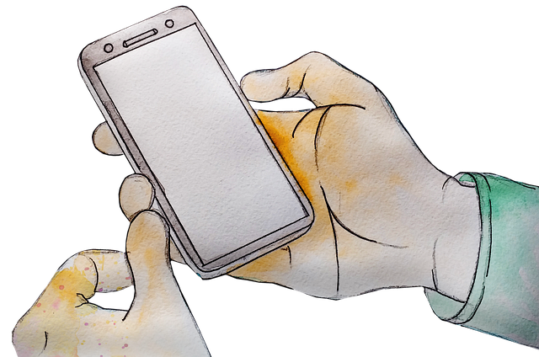
- https://www.childrenscommissioner.gov.uk/digital/5-a-day/

