September 2021

Online Safety Newsletter

Social Media Apps
What age should my child be to use these apps?
Discord
13+
Facebook
13+
Instagram
13+
Snapchat
13+
TikTok
13+
Twitter
13+
YouTube
13+
Twitch
13+

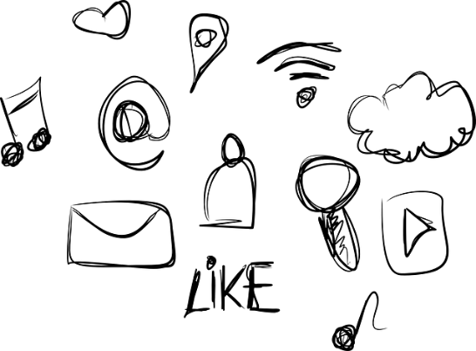

What risks are there of my child using these apps?
Whilst there are benefits to being online, there are risks too regardless of your child’s age. Risks include your child viewing inappropriate content, sharing personal information, cyberbullying and grooming.

Reporting functions
If your child is using any of the above apps then make sure you show them how to use the reporting facilities within each app and ensure your child knows that they must tell you or another trusted adult if they see anything upsetting online. Use the apps together and explore the different security and privacy settings.

Further information
Is your child too young to use the above apps but is still asking you if they can join social media? Then you could suggest an alternative option. Internet Matters list several apps that have been created for younger children, they are grouped for ages 6 – 10 and ages 11 – 13:
https://www.internetmatters.org/resources/social-media-networks-made-for-kids/

Net Aware provide further information about the most popular apps, games and social media sites: https://www.net-aware.org.uk/networks/
Users of this guide do so at their own discretion. No liability is entered into.
Current as of the date released 1.9.21.

Creating strong passwords

We need to create passwords for everything these days and it’s important that our children not only understand that they shouldn’t share passwords with others but also that they know how to create a ‘strong’ password to keep their information safe. Learn more here:

https://www.net-aware.org.uk/news/how-to-create-strong-passwords-online/

Snapchat
Focus on:
What is Snapchat?
Snapchat is an app used for messaging and sharing photos and videos. You must be 13+ to sign up.

How does it work?
Users can send messages (snaps) to others that can only be seen for a set time period e.g. 10 seconds. Users can also upload snaps to stories which then disappear after 24 hours.

What should I be aware of?

- Who is your child friends with – talk to your child about who they are friends with and why it is safer to be friends with only those they know in real life.
- Group chats - in a group chat there may be people that they’re not friends with on the app who can then communicate with them in the group. This also increases their risk of interacting with strangers.

- Snap Map - The map lets users see where ‘friends’ are. Location sharing via the map is optional and is off by default (we recommend that it remains off).
Monkey (rated 18+)

This a website and app (available only on Google Play) that allows users to make video calls to strangers. This is a very concerning app/website which has highly inappropriate content on it. The following link provides further information about it:

https://oursaferschools.co.uk/2021/07/06/safeguarding-alert-monkey-web/

We recommend not talking about this app/website by name with your child, so it doesn’t lead to your child searching for it out of interest. Instead, talk to your child about what they are doing online and if they have any concerns.
- Snapchat streaks - Streaks count how many consecutive days two people have been sending Snaps to each other, this can increase pressure to respond daily.
- Inappropriate content – due to the nature of the app your child may come across content that is inappropriate.
- Screenshots – whilst Snaps disappear, users may take screenshots before they do, potentially resulting in them losing control of what they have shared as it could be sent to other people.
- Bullying – there is a risk of bullying on all platforms so please ensure your child knows how to block and report other users if necessary.
  - https://snap.com/safety/safety-reporting/
  - https://support.snapchat.com/en-GB/a/remove-block-friends

Safety tips
It is important to talk to your child regularly about what they are doing online and make sure that they know that they should always talk to you or another trusted adult if they have any concerns. Please make sure the appropriate privacy settings are set up and your child knows how to block and report other users if necessary. We would recommend you explore Snapchat with your child and suggest why certain options are safer, for example, setting your account so only friends (rather than everyone) can see your content and only those you are friends with can contact you.

What if someone else posts a photo of your child on social media?
What can you do if somebody posts a photo of your child on social media? The UK Safer Internet Centre explores this question:

https://www.saferinternet.org.uk/blog/help-%E2%80%93-someone-else-has-posted-photo-my-child-social-media

- https://support.snapchat.com/en-GB/article/privacy-settings2

Further information
- Parents' Ultimate Guide to Snapchat: https://www.commonsensemedia.org/blog/parents-ultimate-guide-to-snapchat
- https://snap.com/en-GB/safety/safety-center

