11th May 2021

Dear Parents, Carers and Staff

I hope this letter finds you and your family safe and well? We have all faced a very difficult and challenging time over the past year. For the majority of people working and family life has been affected. As we move forward I know that we are all looking forward to a period of stability and life returning to normal.

From September 2021 we will revert back to our normal working week, with all schools finishing at 3.30pm on a Friday afternoon.

I would like to take this opportunity of thanking you for your continued support. I hope and pray that we can put Covid-19 behind us and enjoy the freedoms we enjoyed in the past, and that school can function as it did previously.

Yours sincerely

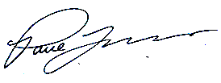

Mr P J Lovern
Chief Executive Officer

