

Park and Stride

Park well, stay safe

The Howard School has limited parking of its own, so of course, surrounding areas are used for the brief times of the day for dropping off and picking up children. Elford is a small village with only one access and exit point, also shared with large farm and commercial vehicles along Church Rd at key times. With safety and convenience in mind, your cooperation to achieve a positive experience for your child’s arrival/departure is important to us. Permission to park on ‘PRIVATE’ land has been negotiated but please respect that this may be withdrawn at any time if conditions are abused.

Should anyone have specific mobility or accessibility concerns, please mention these to the office in advance and every effort will be made to address additional needs.

This leaflet aims to offer you alternative areas of the village for parking and highlights some safe walkways where children can enjoy the beginning and end of their school day.

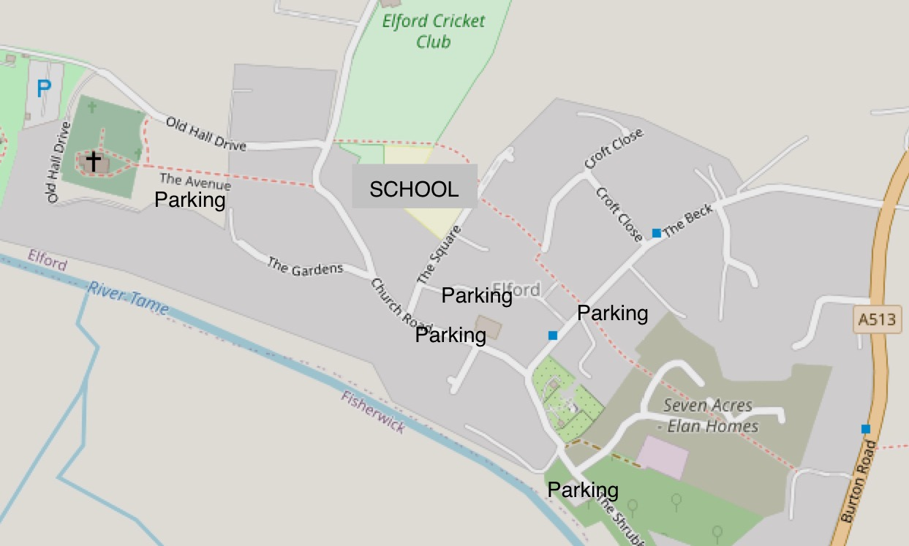

You might consider:

* **WALKING BUDDIES** Offer to walk a friend’s child in to school with your child. Adopt a ‘walking buddies’ culture.
* **PARK AND STRIDE.** Walk from sites on the outskirts of the village – Increases ‘steps’ and encourages healthy habits.
* **VILLAGERS ONLY.** Do you need to drive?
* **CAR SHARE** with your neighbours.
* **STAGGER** drop off times
* **CHILDREN TO EXIT** the car on the side next to the pavement.
* **DON’T HOG** the parking spaces, move on as soon as you can so someone else can park.
* **DON’T block residents’ driveways.**
* **DON’T leave engines running –** not only unlawful but pollutes atmosphere

AVAILABLE PARKING PLACES

The Crown, The Square

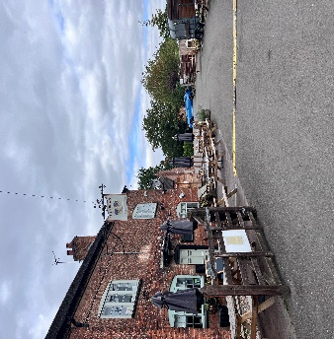PRIVATE: Management of The Crown will allow short term parking subject to the following conditions:

*Patrons of the pub have priority parking.*

*Park responsibly and be mindful of other users.*

*Give way to children and pedestrians.*

*Park is at owners’ risk. Management will not accept liability for accidental damage or loss incurred.*

The Picnic Area, The Shrubbery(Approx 4 min walk)

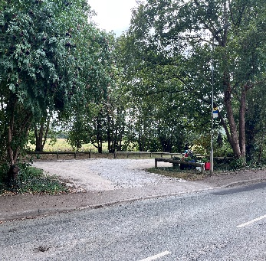PUBLIC parking so may be occupied by members of the public on occasions.

Church Road (Approx 2 min walk)

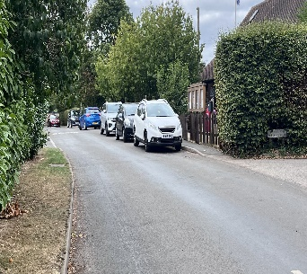PUBLIC parking

CAUTION - Heavy agricultural vehicles passing.

Please avoid parking opposite the exit from Victoria Meadow.

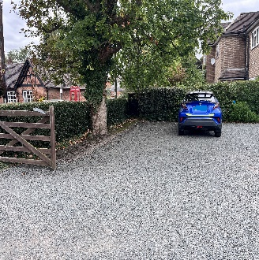Village Hall, Church Road

PRIVATE Car Park – Permission subject to the following conditions:

*2-3 allocated spaces ONLY available for short term parking on left hand side.* *Hirers of Village Hall have priority at all times.* *Facility may be restricted according to hall bookings without notice. Parking is at owners’ risk. The Village Hall Committee cannot accept liability for accidental damage or loss incurred.*

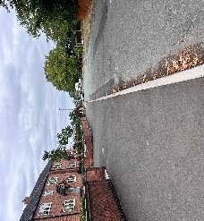The Beck (approx. 2 mins)

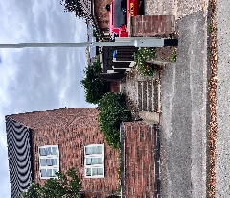 PUBLIC parking.

Access to school: Use the public path alongside Elizabeth Grove which will direct you to opposite the school gates.

Church Avenue (approx. 2.5 Mins)

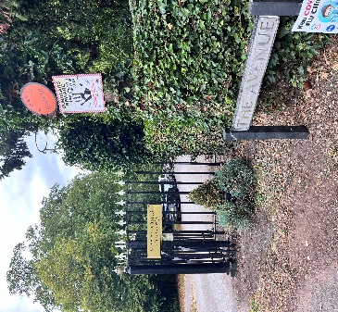PRIVATE: Permission has been granted for parking in Church Avenue under the following conditions:

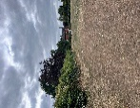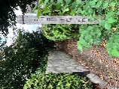*When exiting, please follow the road round to the right and drive down Church Road. i.e. no turning round in The Avenue. i.e. a one-way system in operation. Please don’t park on grass verges*. *Visitors to the Church have priority at all times. Please do not leave litter in the Avenue.*

Either 1. Walk down Church Road and turn left into a small path leading to The Square or 2. Walk to the Millenium playground and continue walking until reaching The Square and school gate.