20th May 2020

Dear Parent/Carer
After careful consideration, I am now able to inform you of our plans for the partial re-opening of The Howard Primary School from June 1st. As you know from the news and our prior communications, the school will be open for children from the following categories:
Reception, Year 1, Year 6 and Key Worker/Vulnerable children
It is an unsettling time for us all, but please be rest assured that we are doing everything that we can to make sure that we are ready to reopen for the specified groups. In this letter, I have detailed the steps that we have taken to ensure the safety of your children and our staff, as well as the key information you will need if you intend to bring your child back to school. Hopefully, this information, detailing what the Government recommendations will look like in practice, will set your mind at rest.
This letter provides a summary of our risk assessments for the partial reopening and there is a timetable to support you in organising your day. As you can imagine, a day in school will be different to what children have been used to, so I recommend talking through our actions with your child to prepare them for their return.

If your child is ill
Please do not send your child into school if they are displaying any of the following:
- Temperature above 37.5C
- Cough
- Stomach upset/pain
- Vomiting
- Diarrhea
- Eye infection
- Hay fever
- Headache
- Cold or flu like symptoms (sneezing, runny nose, etc.)
- Loss of taste or smell

You should not send your child to school if you or anyone in your household are displaying any identified symptoms of Coronavirus. If this is the case, please inform school immediately. The government has announced that once schools are open, staff and pupils will be eligible for testing if they become ill with Coronavirus symptoms, as will members of their household. If the test is negative, then children and young people can return to education, and parents/ carers can go back to work. A positive test will ensure rapid action is taken to protect all children and staff in school.
At this time, we will not be able to administer any medicines. Therefore, if your child requires medicine throughout the day, they should stay at home and continue with home learning until they have finished the course of treatment. However, this does not apply to inhalers.
In case of illness or emergency, parents must be contactable throughout the day. If you need to update your contact details, please email the school office.
If your child is clinically extremely vulnerable, or living with someone who is in this group, they should not come back to school and should continue home learning. If your child is clinically vulnerable (but not clinically extremely vulnerable), you should follow medical advice to decide if they should come back to school. Please refer to government guidance for further details of these groups.

Times for the school day
In order to meet our contractual obligations and to enable a deep clean, the schools across the MAT will close after lunch on Fridays. This will continue for the remainder of the academic year.

To adhere to social distancing guidelines, we are staggering the start and end times of the school day.

Start and collection times for each group are as follows:
Year/Group | Collection/Drop-off point | Start and end times | Fridays
Reception | Class 1 entrance | 9am - 3pm | 9am-12.40 pm
Year 1 | Class 1 entrance | 8.50am-3.15pm | 8.50am-12.50pm
Year 6 | Class 2 outside door (Red door)  Year 6 pupils are encouraged to walk to and from school unaccompanied. Please arrange a meeting point for your child. | 8.40am-3.20pm | 8.40am-1pm
Key Worker/Vulnerable children | Class 2 outside door (Red door) | 8.30am-3.30am | 8.30am-1pm

Siblings should be dropped off and collected at the time of the eldest child.

There is a strict one-way system in place when dropping off and collecting your child. Please enter the school grounds through the pedestrian gate, drop off your child and then exit through the car park gate. Children will be guided straight into their classroom and instructed to wash their hands.

To minimise social contact, only one adult should drop off and pick up their child/children each day. We ask that parents/carers adhere to social distancing by remaining at least 2m apart. There are markings on the playground to help you with this. To ease congestion outside school, we request that you do not bring dogs with you when you drop off or collect.
Once children are in school, the gates will be locked, and you will not be able to gain access between drop off and collection times, unless there is an emergency. If this is the case, you will need to ring or email the school office to arrange collection.

Unfortunately, at this time, it will not be possible to engage in conversation with the staff. Any important information should be communicated through the office email or via telephone.

For the foreseeable future, children will remain in their assigned group with their designated adults. They will remain separate to the other groups and there will be no crossover of adults. A timetable for break times and lunchtimes has been devised so that the groups do not mix.

Each child will have their own set of equipment which will be provided by school. These resources, which includes technology, will not be shared with others. Books and pencil cases from home are not to be brought into school.

Pupils will sit at separate desks at least 2m apart from each other. When younger pupils are not working at desks, they will be constantly encouraged to remain socially distant.

During the day, pupils will have the opportunity to read, however, home readers will not be sent home.

For the remainder of this year, there will be no school assemblies.

All pupils will be reminded to practice good hygiene principles. They will be encouraged to sneeze and cough into tissues, immediately throwing the tissue away and then washing their hands. As a minimum, pupils will wash their hands whenever they enter the school building, after using the toilet, before and after handling food, and before being dismissed at the end of the day.

Staff will be on hand to reinforce basic hygiene principles. They will regularly wipe all surfaces, door handles, toilet areas and equipment in the classroom and around the school. Every evening, the whole school will be thoroughly cleaned, and on a Friday afternoon, the school will undergo a deep clean.

Toilets
Pupils in Reception and Year 1 will have access to their own toilet facilities throughout the day, but the number of pupils using them at one time will be limited. Year 6 and the key workers/vulnerable group will have access to temporary portable toilets which will be located on the school playground, outside Class 2. These toilets will be supervised by a member of staff, who will ensure the toilet is cleaned after use.

Lunch
In order to minimise risk, it has been decided that all pupils must have a school lunch. As part of the Universal Free School Meals program, there will be no charge to pupils in Reception, Year 1 and Year 2. For pupils in Key stage 2, it will be at a subsidised cost of £1.50 per meal per day. This temporary price has been considerably subsidised by the Multi-Academy Trust.

Please do not send children in with water bottles from home. School will provide every child with their own cup and they will have access to fresh water throughout the day.

Uniform
We are asking that pupils come to school every day in fresh clean clothes and, as such, school uniform will not be required. The pupils will be accessing the outdoors whenever possible and taking part in daily physical activities, therefore, children should be dressed appropriately for sports and leisure. Children should only bring an outdoor coat and/or hat with them to school.

Curriculum
In school, we will be focusing upon the following:
- Year 6 will be focusing on transition and their wellbeing
- Reception and Year 1 will be revisiting early reading and early maths
- Key worker and vulnerable children will be working through the work set on Google Classroom
- We will be providing regular opportunities for outdoor learning
For the pupils not returning to school, they will have access to the same curriculum which will continue to be accessed via Google Classroom.

Key worker / vulnerable children
Thank you to those who have indicated that they wish to send their children back to school as part of the key worker / vulnerable pupil entitlement. Any child needing this service will be looked after in a key worker group, whether they are in year 2, 3, 4 or 5. When they are in school, they will be completing the work set by the class teacher on Google Classroom. Each child will have access to a Chromebook which will not be shared.

For those families who have indicated that they are key workers or have vulnerable children, and wish their child to access the care provision, email howardoffice@tssmat.staffs.sch.uk directly to book, indicating which days you require.

*Please note that these plans are subject change if the government directive alters.

I know that there is a lot of information in this letter but as a parent, I would want to know the exact details of the safety measures being put in place, so that I can make an informed decision about what is right for my child. If you have any further questions, then please do not hesitate to email the school office.

We would like to thank you for your continuous support in helping your child learn from home, and for your positive and supportive comments throughout these unprecedented times. We are looking forward to welcoming you all back soon as it is safe to do so, because we are missing our Howard Family.

Kind regards
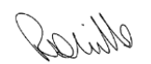

Miss R Mills
Headteacher

Home-school agreement
As a school we will: | As parents we will:
Open to children in Reception, Year 1 and Year 6 in addition to those pupils whose parents are key workers on Monday 1st June if the government states that it is safe to do so | Send our child to school in clean clothes every day and talk to them about the new measures outlined in this agreement.  I will ensure that my child comes to school with only a coat and/or sun hat, as necessary.  I will not send in any other items from home.  If necessary, I will apply suntan lotion to my child before the start of the school day
Stagger the start and end of the day from 1st June to reduce you being exposed to large groups of people. We will ask children to wash their hands at key points of the day and provide hand sanitisers | Bring and collect our child at the allotted times and stand at least 2m apart from other parents.  If we need to speak to a member of staff or the office, we will do so via phone or email.  I will adhere to social distancing measures and follow the one-way system
Ensure your child is in a group size of no more than 15 | Support the new class structure and talk to your child about the changes in school
Not use soft toys that are hard to clean | Talk to our child so that he/she understands the changes in school
Adapt the school day and provide at least 1 hour of safe exercise per day | Support the new measures to keep our children safe
Ensure your child remains in their group (maximum 15 children) during break times, with social distancing applying wherever possible. Staff will supervise this carefully | Support the new measures to keep our children safe
Ensure playtimes and lunchtimes are staggered with each group having their own outside space. Children will eat their lunch in their designated room | Support the new measures to keep our children safe
Ensure that hand sanitisers, soap, paper towels and other cleaning products are in plentiful supply at school | Encourage our child to follow good hygiene practices at home and school including washing their hands for at least 20 seconds and avoid touching their faces
Clean the school regularly and thoroughly throughout the day
Provide every child with a school meal every day | Not send in any food items, snacks or water bottles
Remind staff of the need to follow strict risk assessments in school including their own health and safety procedures | Appreciate the challenges facing staff
Care for your child and look after them as we always do | Support, as you always do, the school in its endeavours at this difficult time

Drop off and collection one-way system Fire Drill meeting points
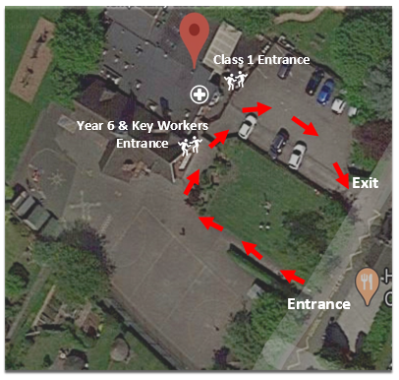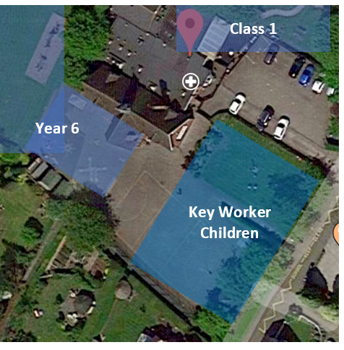

Useful government website links are as follows:

https://www.gov.uk/government/publications/coronavirus-covid-19-implementing-protective-measures-in-education-and-childcare-settings

https://www.gov.uk/government/publications/actions-for-educational-and-childcare-settings-to-prepare-for-wider-opening-from-1-june-2020/actions-for-education-and-childcare-settings-to-prepare-for-wider-opening-from-1-june-2020

https://www.gov.uk/government/publications/coronavirus-covid-19-implementing-protective-measures-in-education-and-childcare-settings/coronavirus-covid-19-implementing-protective-measures-in-education-and-childcare-settings

https://www.gov.uk/government/publications/guidance-on-shielding-and-protecting-extremely-vulnerable-persons-from-covid-19/covid-19-guidance-on-protecting-people-most-likely-to-get-unwell-from-coronavirus-shielding-young-peoples-version

https://www.gov.uk/government/publications/guidance-on-shielding-and-protecting-extremely-vulnerable-persons-from-covid-19

https://www.gov.uk/government/publications/our-plan-to-rebuild-the-uk-governments-covid-19-recovery-strategy

https://www.gov.uk/government/publications/coronavirus-outbreak-faqs-what-you-can-and-cant-do/coronavirus-outbreak-faqs-what-you-can-and-cant-do

https://www.gov.uk/government/publications/closure-of-educational-settings-information-for-parents-and-carers

https://www.gov.uk/guidance/coronavirus-covid-19-getting-tested

Vulnerable child definition:
https://www.gov.uk/government/publications/coronavirus-covid-19-guidance-on-vulnerable-children-and-young-people/coronavirus-covid-19-guidance-on-vulnerable-children-and-young-people

