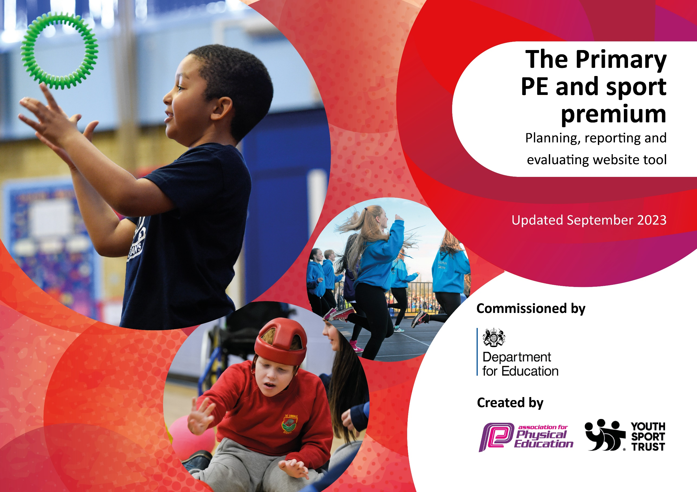

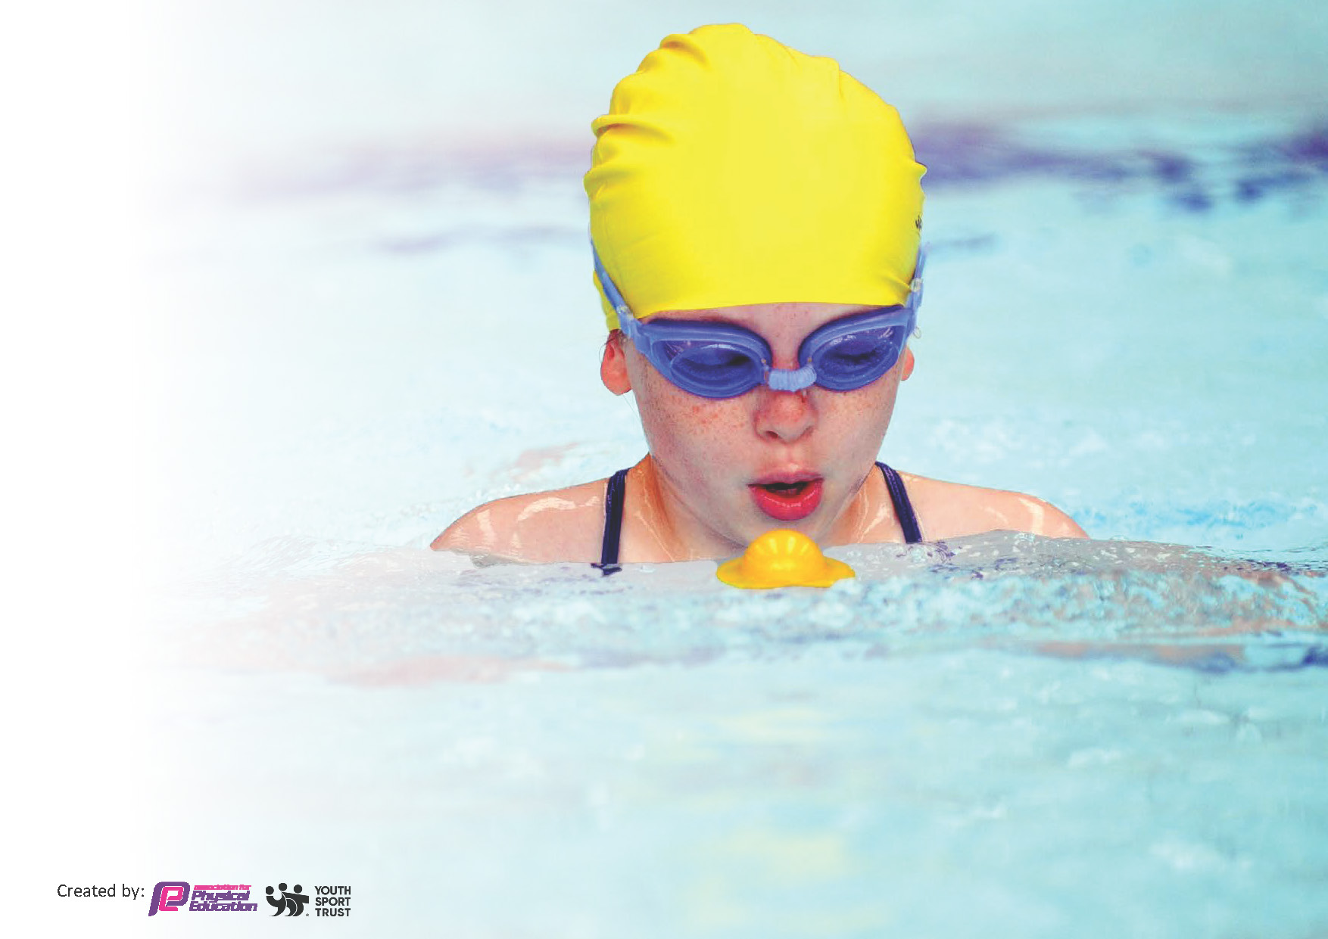
This template can be used for multiple purposes:
by:
- It enables schools to effectively plan their use of the Primary PE and sport premium
- It helps schools to meet the requirements (as set out in guidance) to publish information on their Primary PE and sport premium
- It will be an effective document to support Ofsted inspections enabling schools to evidence progress in Physical Education (PE) and evidence swimming attainment, which forms part of the PE National Curriculum. We would recommend schools consider
the Intent, Implementation and Impact of any spend, as examined within the Education Inspection Framework.

It is important that your grant is used effectively and based on school need.

Schools must use the funding to make additional and sustainable
improvements to the quality of the PE, School Sport and Physical Activity (PESSPA)
they offer. This means that you should use the Primary PE and sport premium to:

- Build capacity and capability within the school to ensure that improvements made now will benefit pupils joining the school in future years
- Develop or add to the PESSPA activities that your school already offers.

The Primary PE and sport premium should not be used to fund capital spend projects; the school’s core budget should fund these. Further detail on capital expenditure can be found in the updated Primary PE and sport premium guidance.

The Primary PE and sport premium guidance, outlines 5 key priorities that funding should be used towards. It is not

necessary that spending has to meet all the key priorities, you should select the priorities that you aim to use any funding towards.

Although completing this template is not a requirement for schools, schools are required to publish details of how they spend this funding. Schools must also outline what the impact this funding has had on pupils’ PE and sport participation and attainment and how any spending will be sustainable in the future. All funding must be spent by 31st July 2024.

The Department for Education has worked closely with the Association for Physical Education (afPE) and the Youth Sport Trust (YST) to develop this template and encourages schools to use it. This template is an effective way of meeting the reporting requirements of the Primary PE and sport premium.
Review of last year’s spend and key achievements (2022/2023)

We recommend you start by reflecting on the impact of current provision and reviewing your previous spend.

Review of 2022/23
In recognition of our achievements in PE and school sport we were awarded the school games mark gold award. This is a fantastic achievement for such a small school, and it is a credit to the hard work of staff and children. Our extracurricular provision was a key highlight with more sports being offered than ever before. Non-traditional sports were introduced such as nerf wars and zorbing and we found that this helped enthuse those who may not normally attend the more traditional clubs. Year six sports leaders had the opportunity to develop their skills while supporting class one children at lunchtime and during the daily mile. These were introduced as a means of increasing the daily physical activity of our children. Our inclusion policy ensured our curriculum met the needs of all our children by being a balance of traditional and non-traditional activities. Orienteering, parkour and boccia have been immensely popular. The curriculum was resource accordingly. Power of PE schemes of work continued to ensure a consistent approach to the teaching and learning of our children. Our involvement in the primary stars programme with Stoke City football club works very much alongside our values and vision in PE. The teacher CPD sessions have improved the confidence of staff, as has the opportunity to work alongside an approved coaching company. Reading programmes, healthy eating workshops, leadership and ground visits ensured the children across the key stages benefitted from the programme. We continue to subscribe to the DfE approved teach active as we strive to meet our aspirational target of one hour structured physical activity per day. Our active maths and literacy lessons have given our children the opportunity to learn outside the classroom, as has our forest school sessions that children also received on a weekly basis. Competition has increased this year with more children having the opportunity to compete at both inter and intra levels. Being crowned Tamworth schools’ tennis champions was a particular highlight as was being placed runners up in a mixed cricket tournament. A girl’s football team was developed and children had the opportunity to compete at cross country, football, indoor athletics and dodgeball.

Key priorities and Planning
This planning template will allow schools to accurately plan their spending.

Action – what are you planning to do | Who does this action impact? | KI | Impacts and how sustainability will be achieved? | Cost linked to the action
All teaching and support staff to take part in gymnastics training  Take the children on an aspirational visit to a professional football environment.  Employ ‘Progressive Sports’ to teach 1 PE lesson per week to each class – working alongside a TA to provide CPD  Every member of staff to attend two subject specific CPD courses to improve confidence levels and knowledge of the PE curriculum  Stoke City to deliver a Bronze Package of the Primary Stars programme  Deliver a structured Inter MAT festival calendar.  Ensure each child is receiving at least 2 hours of curriculum PE with a further 3 hours physical activity.  To include:  - Daily Mile  - Active Math’s  - Active Literacy  - Weekly Forest School  - Structured Breaktime/Lunchtime led by Playground Leaders  Specialist PE teacher employed to coordinate PE across the MAT. To include 1 day per term in each school to support planning, lesson observations, assessment etc.  High levels of after school provision for physical activity will be sustained  Ensure each child is receiving at least 2 hours of curriculum PE with a further 3 hours physical activity.  Opportunities for physical activities are increased with the use of the forest school area. | All those who are involved with the teaching of gymnastics on the floor and apparatus understand what constitutes a safe and ‘outstanding’ gymnastics lesson where children make good progress.  Year 5 and 6 will visit Stoke City Football Club for a ground tour and sports activities in the training dome. (Tuesday 5th December)  All children will receive a lesson taught by a PE specialist. More children will meet the national expectations for specific year groups and teaching staff will develop more mastery of the curriculum.  All children  Health Potters (KS1)  Playground Leaders (Year 5)  Minority Sports Curriculum Day (Whole School)  Reading Stars (reluctant readers)  English Programme (Year 5 and 6 Writing and SCFC media centre visit)  All children across the 5 schools in the Trust  Whole School  All staff  All Children (particular focus on girls and less sporty)  An active PSHE scheme to be used across the key stages.  Forest School is provided for all children on a rota basis. Range of OAA requirements are met. Families are invited to share in the experiences (termly). Each year group to continue to access Forest school each week. | 1  3  1,2,4  1  2,3,4  5  2  1  2 | Children will be able to work in a safe and developmental environment and develop a love of gymnastics. Local gymnastics clubs will be promoted as an exit route for those wishing to continue out of school.  Children will be inspired by visiting a professional club. The writing opportunities will prove invaluable as a tool for progress. All children will receive 2 hours of physical activity.  TAs to be upskilled in teaching PE and children to be taught high quality PE and physical activity.  All staff will have increased confidence when teaching the PE curriculum. Delivery of lessons will be rated good or above during observations.  Our links with SCFC have been in place for several years. The coaches are outstanding practitioners and our less confident staff have benefited tremendously from being involved with each unit of learning (both practical and classroom based)  More children will have the experience of representing the school and taking part in competitive sport. Calendar to include football, tag rugby, netball, cross country, boccia and athletics  Children will become fitter. Teaching will cater for all learning styles and will move us towards our target of 1-hour physical activity per day.  All staff will be observed and be set developmental targets to ensure we are moving towards all lessons being outstanding. Outside coaches will be moderated and quality assured. The coordination of PE will include both curricular and extra-curricular responsibility.  Children will be targeted through pupil voice.  Children will become fitter and PE will be regularly taught across the curriculum  Multi-sensory opportunities help improve concentration and the motivation to learn. Self-confidence, independence, reduced anxiety, improve resilience and concentration. | £500 for external trainer to carryout twilight sessions at hub school  £250 for transport costs (Trip included as part of the Bronze Primary Stars project)  £600 TA time  £1835 Coaches  £1500 for 3 staff to attend 2 courses each  £1500 to buy in the services of Stoke City  £1500 for medals, equipment, transport, supply cover and certificates.  £500 for subscription to Teach Active  £500 to resource break and lunchtimes  £1000 for equipment for active lunch time and breaktimes.  £3000 to cover supply costs.  £1000 for coaches to deliver high quality after school provision.  £975  £2000

Key achievements 2023-2024
This template will be completed at the end of the academic year and will showcase the key achievements schools have made with their Primary PE and sport premium spending.

Activity/Action | Impact | Comments

Swimming Data (see Impact report 2022-23 for current data)
Meeting National Curriculum requirements for swimming and water safety.
Priority should always be given to ensuring that pupils can perform safe self-rescue even if they do not fully meet the first two requirements of the National Curriculum programme of study

Question | Stats: | Further context  Relative to local challenges
What percentage of your current Year 6 cohort can swim competently, confidently and proficiently over a distance of at least 25 metres? | % | Use this text box to give further context behind the percentage.  e.g., 30% - we are struggling to get pool space due to our local pool closing so we have had to use a much smaller local school pool. We have had to limit the number of pupils attending swimming lessons during one term which means some pupils have attended fewer swimming lessons than others.
What percentage of your current Year 6 cohort can use a range of strokes effectively [for example, front crawl, backstroke, and breaststroke]? | % | Use this text box to give further context behind the percentage.  e.g., Even though your pupils may swim in another year please report on their attainment on leaving primary school at the end of the summer term 2024

What percentage of your current Year 6 cohort are able to perform safe self-rescue in different water-based situations? | % | Use this text box to give further context behind the percentage.
If your schools swimming data is below national expectation, you can choose to use the Primary PE and sport premium to provide additional top-up sessions for those pupils that did not meet National Curriculum  requirements after the completion of core lessons. Have you done this? | Yes/No
Have you provided CPD to improve the knowledge and confidence of staff to be able to teach swimming and water safety? | Yes/No

Signed off by:

Head Teacher: | Jonathan Wynn
Subject Leader or the individual responsible for the Primary PE and sport premium: | Stuart Challinor
Governor: | Lesley Bovington
Date: | September 2023

