Year 3 Spelling Summer 2- Spelling will be tested on a Friday
Test 1  11/06/2021 | Test 2  18/06/21 | Test 3  25/06/21 | Test 4  02/06//21 | Test 5  09/06/21 | Test 6  16/7/21
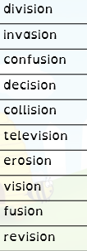 | 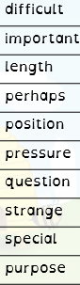 | 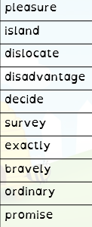 | 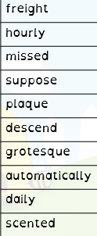 | 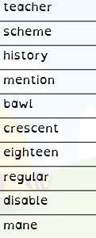 | 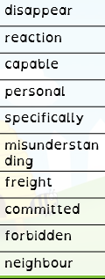

Year 4 Summer 1 Spellings will be tested on a Friday
Test 1  11/6/21 | Test 2  18/6/21 | Test 3  25/6/21 | Test 4  2/7/21 | Test 5  9/7/21 | Test 6  16/7/21
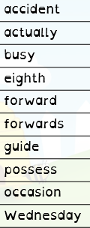 | 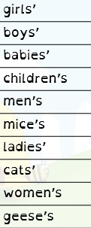 | 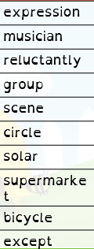 | 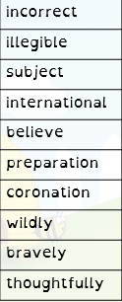 | 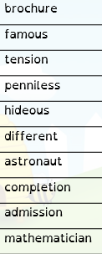 | 