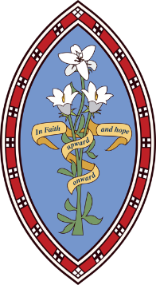
The Howard Primary School

New Year’s Greetings from everyone at The Howard!
At the Howard we are very lucky to have some amazing and supportive teachers and a community which helps us get through these challenging times. We are still enjoying learning at The Howard and this is what we are getting up to so far this term.

Class 1 are learning about the four countries of the UK and some facts about them in geography. They are also learning about London in English. They are really enjoying these subjects with Ms Stretton.

Class 2 are learning about Anglo-Saxons in History and doing dance in P.E. They are enjoying writing their non chronological reports. In French they are doing French Artists in France. They continue to learn to play the ukulele and they are learning Karate.

Class 3 have enjoyed doing Banksy drawings in Art and are looking forward to spray painting. Quite a lot of people have enjoyed the First aid too. In the past, Class 3 have taken part in a racing tournament against the other schools with Dr Allen and now we are getting into it again by building our own race cars. We are lucky to have the opportunity to make two cars. We have also enjoyed doing black-belt karate with their karate teacher.

Next term, we are really looking forward to going on a residential to York and Whitemoor Lakes. We will let you know how we get on.

Written by Amelie and Paige.
From the Howard

