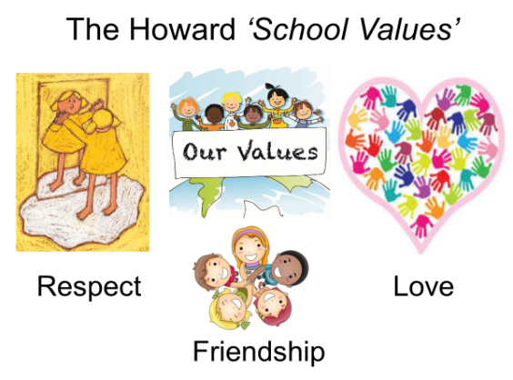

Our School Value this term is: Generosity

Autumn 2 Curriculum
English | We will be starting with the book ‘Around the World in 80 Days’’ retold by. We will practice writing diaries set in Victorian times and have lots of opportunities to develop our writing in order to write our own diary. After this, we will be focusing on Performance Poetry where we discover the talents of J
Maths  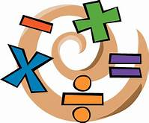 | Our key topic this term is Multiplication and Division for Year 3. Year 4 will also look at Length and Perimeter. We will be using the Government’s Ready-to-Progress criteria for guidance with Year 3 and 4. Miss Mills will be teaching Year 4 for maths.  Year 4s are expected to take a multiplication tables check in June, so it is important that they can rapidly recall their multiplication facts to 12x12. Remember to use Times Tables Rock Stars at home.
Geography | Our topic this term is Passport to the World. This topic looks at continents and countries. Also explored are the physical and human geographical features in various continents.
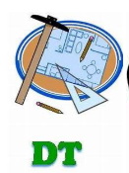 | In DT, we will be looking at ‘’. The focus across the unit will be to investigate, design, make and evaluate a products with a Christmas theme. We will begin by investigating a variety of designs. We will then design a ……..for a purpose and make the product from the design. The unit will be completed by evaluating the finished product.
Science | States of Matter We will be exploring the importance of the different states of matter. We will notice the properties of each of the three states; solid, liquid and gas. During this topic we will gather, present and record scientific data. The topic will end with an understanding that certain matter change be in different states for example, water can be ice, water or steam when they are at different temperatures.
 | In PSHE, we will be looking at ‘’ and completing activities such as……... We will also be looking at ‘Votes For Schools’ which is focusing this term on ‘Bullying’. Throughout the Autumn term there will be opportunities to practice Mindfulness with colouring activities and focused breathing sessions.
Computing | In computing, we will be learning word processing skills. We will enhance other areas of the curriculum by producing posters, letters, leaflets etc. which will be designed for specific audiences and purposes.
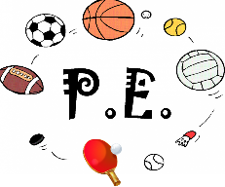 | This term, we are focusing on Basketball which will be led by Mrs Vincent Scuotto.
Religious Education  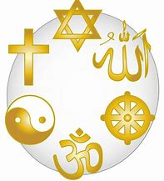 | Our RE topic is ‘Incarnation’ We will be exploring how Christians see God as the Trinity; The Father, The Son and The Holy Spirit. We will explore the symbolism of water in baptism together with ways in which Christians understand how God’s power is at work.

