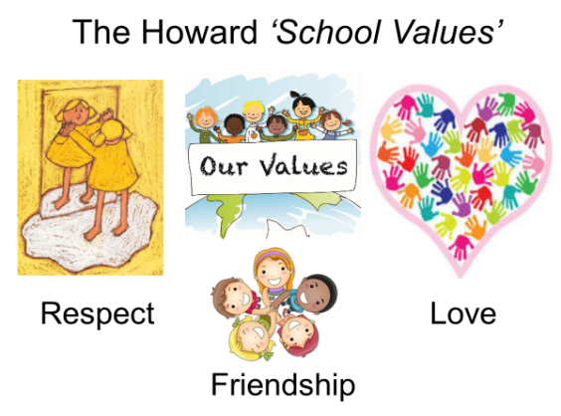

Our School Value this term is: Resilience

Autumn 1 Curriculum
English | We will be starting with the book ‘Egyptian Cinderella’’ by Shirley Climo. We will practice writing stories set in a different culture and have lots of opportunities to develop our writing in order to write our own story. After this, we will be focusing on reading and then writing our own newspaper report about the discoveries made by Howard Carter. We will end our term with a focus on poetry with the book ‘I don’t like poetry’ by Joshua Seigal.
Maths  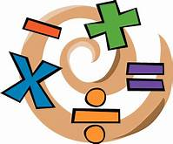 | Our key topic this term is Place Value followed by Addition and Subtraction. Year 4 will also look at Length and Perimeter. We will be using the Government’s Ready-to-Progress criteria for guidance with Year 3 and 4. Miss Mills will be teaching Year 4 for maths.  Year 4s are expected to take a multiplication tables check in June, so it is important that they can rapidly recall their multiplication facts to 12x12. Remember to use Times Tables Rock Stars at home.
 | Our topic this term is Ancient Egypt. This topic looks at the Egyptian way of life, understanding the importance of artefacts, tombs and pyramids. We will look at Tutankhamen, Howard Carter, hieroglyphics and how the Nile provided transport and water for farming. Finally we will learn how to recall, select and organise historical information.
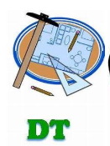 | In DT, we will be looking at ‘Lighting It Up’. The focus across the unit will be to investigate, design, make and evaluate a product that lights up. We will begin by investigating a variety of lights, how they are designed and used, including which metal components can be used in a simple circuit and how a switch controls a bulb. We will then design a light for a purpose and make the product from the design. The unit will be completed by evaluating the finished product.
Science | Light- We will be exploring the importance of light and that dark is the absence of light. We will notice which surfaces reflect light and that shadows are formed when the light source is blocked by an opaque object. During this topic we will gather, present and record scientific data. The topic will end with an understanding that shadows change because the Earth is spinning and how scientists are developing ways to harness the Sun’s energy.
 | In PSHE, we will be looking at ‘Getting on and Falling Out’ and completing activities such as co-operation jigsaws. We will also be looking at ‘Votes For Schools’ which is focusing this term on Racism. Throughout the Autumn term there will be opportunities to practice Mindfulness with colouring activities and focused breathing sessions.
Computing | In computing, we will be learning word processing skills. We will enhance other areas of the curriculum by producing posters, letters, leaflets etc. which will be designed for specific audiences and purposes.
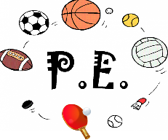 | This term, we are focusing on and Health Related Exercises which will be led by Miss Mills and Football which will be led by Mrs Vincent Scuotto.
Religious Education  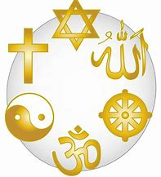 | Our RE topic is ‘What is it like for Christians to follow God?’ We will be exploring who the people of God are, the link between the story of Noah and the covenant, together with how the people of God try to live the way He wants. We will also be making links between the story of Abraham and the concept of faith and look at making suggestions about how ideas of covenant and promises to God might make a difference in the world today.

