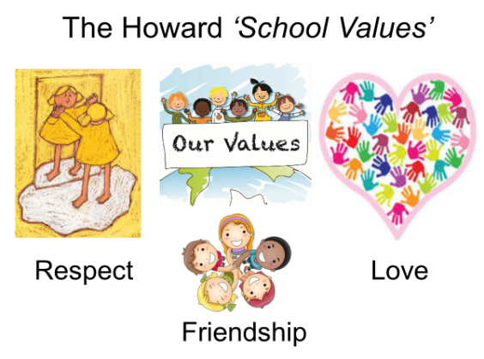

Our School Value this term is: Truthfulness

Spring 1 Curriculum
English | We will be starting by reading various Roman Myths. We will practice writing Roman myths and have lots of opportunities to develop our writing, in order to write our own myth. After this, we will be focusing on non-fiction and looking at Roman Soldiers. Non-chronological reports will be the focus for this unit of work. Finally, we will end our term with a focus on Classical poetry and we will be looking at ‘What is Pink’ by Christina Rossetti.
Maths  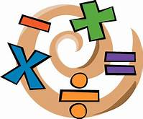 | Our key topic this term is Multiplication and Division followed by Money and then Statistics in Year 3 and Area then Fractions in Year 4. We will be using the Government’s Ready-to-Progress criteria for guidance with Year 3 and 4. Miss Mills will be teaching Year 4 for maths.  Year 4s are expected to take a multiplication tables check in June, so it is important that they can rapidly recall their multiplication facts to 12x12. Remember to use Times Tables Rock Stars at home.
 | Our topic this term is Romans. We will be looking at how and why the Romans invaded Britain and who was in Britain at the time of invasion. This topic looks at the Roman way of life, understanding the importance the formations that were used in the Roman Army and the weapons they used. Finally we will learn how to recall, select and organise historical information.
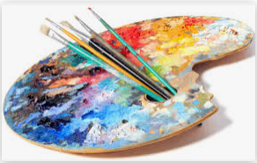  Art | In Art, we will be looking at Pastels. The focus across the unit will be to investigate different techniques such as blocking, smudging and dotting.
Science | Sound We will be exploring how sounds are made. We will notice that vibrations from sound travels through a medium into our ears. During this topic we will gather, present and record scientific data. The topic will end with an understanding that sound gets fainter as the distance from the sound source increases.
 | In PSHE, we will be looking at ‘Road Safety’. We will also be looking at ‘Votes For Schools’. Throughout the Spring term there will be opportunities to practice Mindfulness with colouring activities and focused breathing sessions.
Computing | In computing, we will be learning word processing skills. We will enhance other areas of the curriculum by producing posters, letters, leaflets etc. which will be designed for specific audiences and purposes.
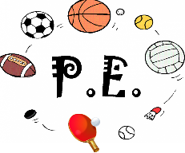 | This term, we are focusing on Dance and Gymnastics. We will be about points of balance and discovering different ways of moving to music.
Religious Education  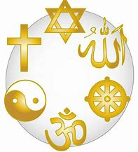 | Our RE topic is ‘What can I learn from a Synagogue?’ we will be able to describe how attending a synagogue makes a difference to Jews and discuss the different artefacts found in the synagogue explaining their meaning. We will look at the Torah and identify the impact of the words from the Shema on Jewish people’s lives and comment on connections between a synagogue and a church or between Jewish and Christian beliefs.

