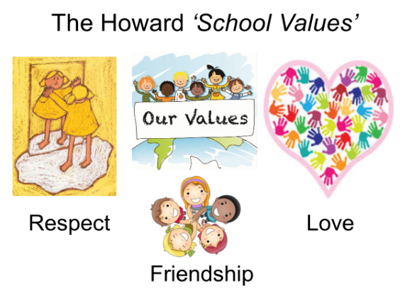

Summer 1 Curriculum
English  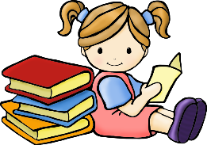 | We will be starting by reading a wordless picture book ‘The Flood’ by Alvaro F. Villa. We will have lots of opportunities to develop our writing, in order to write our own disaster story. After this, we will be focusing on explanation texts linked to the Geography topic of Lakes and Rivers. Our class reader is ‘Wind in the Willows’, which we will also be using for whole class reading sessions to be able to make use of the wonderfully wide range of vocabulary and sentence structures the book has to offer.
Maths  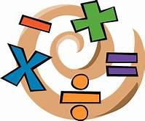 | Our key topic this term is Fractions followed by Time in Year 3 and Decimals, Money then Time in Year 4. We will be using the Government’s Ready-to-Progress criteria for guidance with Year 3 and 4. Miss Mills will be teaching Year 4 for maths.  Year 4s are expected to take a multiplication tables check in June, so it is important that they can rapidly recall their multiplication facts to 12x12. Remember to use Times Tables Rock Stars at home.
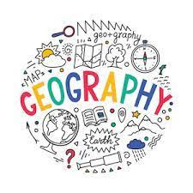 | Our topic this term is Lakes and Rivers. We will be looking at how rivers form, the different parts of a river and by the end of the unit, we will be able to explain how a river flows from source to mouth. We will be looking at rivers around the world and using atlases to help us. We will discover the difference between a map and an atlas.
Science | Rocks - We will be exploring how rocks are made. We will notice the different types of rock, how geologists categorise them by their characteristics and how they are formed. We will also discover how fossils are formed. During this topic we will gather, present and record scientific data. The topic will end with an understanding that rocks can be used in many building materials, some naturally occurring and others, manufactured.
 | In PSHE, we will be looking at Personal Safety. We will discover the differences between risk, hazard and dangers and how analysing risks are important for our development. Throughout the Summer term there will be opportunities to practice Mindfulness with colouring activities and focused breathing sessions.
Computing | In computing, we will be learning word processing skills. We will enhance other areas of the curriculum by producing posters, letters, leaflets etc. which will be designed for specific audiences and purposes.
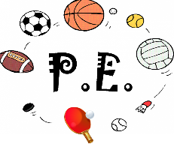 | This term, we are focusing on Rounders. We will be learning about short and long blocks when stopping the ball, practicing hitting the ball together with the rules of Rounders. We will end this unit with playing games of Rounders to develop our playing fairly, encouraging our peers to improve and group communication.
Religious Education  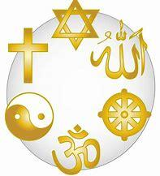 | Our RE topic is ‘The Kingdom of God’. We will be looking at Pentecost and the meaning of it. We will be looking at the impact and be able to explain the meaning of Pentecost to Christians.

