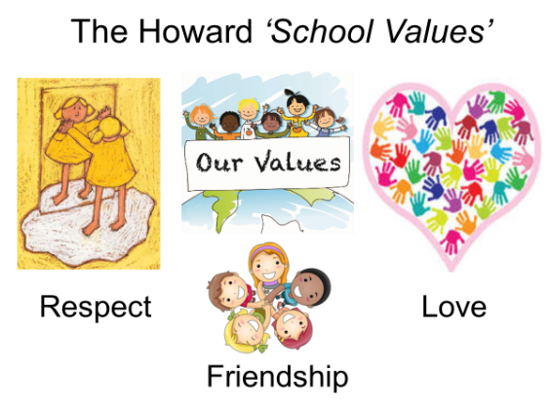

Summer 2 Curriculum
English  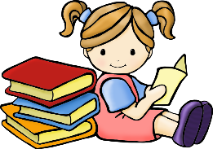 | We will be starting by reading a classic, ‘The Lion, The Witch and The Wardrobe’ by C.S.Lewis. We will have lots of opportunities to develop our writing, in order to write our own story. After this, we will be focusing on writing persuasive letters. Our class reader is ‘The Lion, The Witch and The Wardrobe’, which we will also be using for whole class reading sessions to be able to support our writing sessions. Read as a writer, and write as a reader!
Maths  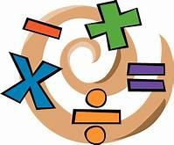 | Our key topic this term is Time, followed by Shape and Capacity in Year 3 and Time, Statistics and Geometry in Year 4. We will be using the Government’s Ready-to-Progress criteria for guidance with Year 3 and 4. Miss Mills will be teaching Year 4 for maths.  Year 4s are expected to take a multiplication tables check in June, so it is important that they can rapidly recall their multiplication facts to 12x12. Remember to use Times Tables Rock Stars at home.
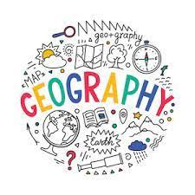 | Our topic this term is United Kingdom and the children will be able to name and locate countries and cities of the United Kingdom, geographical regions and their identifying human and physical characteristics, key topographical features (including hills, mountains, coasts and rivers) and land-use patterns; and understand how some of these aspects have changed over time.
Science | Working Scientifically- We will be looking at various investigations, and finding out what it means to plan, carry out and evaluate scientific experiments. During this topic we will gather, present and record scientific data. The topic will end with an understanding how scientists work when they investigate and carry out tests.
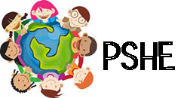 | In PSHE, we will be looking at SRE. This is a very important area to study and will help them with their understanding of what can be expected at their age. Throughout the Summer term there will be opportunities to practice Mindfulness with colouring activities and focused breathing sessions.
Computing | In computing, we will be learning word processing skills. We will enhance other areas of the curriculum by producing posters, letters, leaflets etc. which will be designed for specific audiences and purposes.
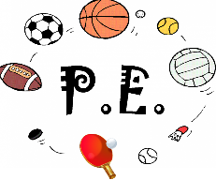 | This term, we are focusing on Tennis. There will be opportunities for them to develop how to play fairly, encourage their peers to improve and group communication. They will be learning and practising serving, hitting forehand and backhand strokes, and how to score.
Religious Education  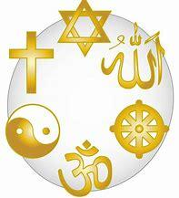 | Our RE topic is ‘Pilgrimages and Sacred Places ’. We will be looking at what is sacred about particular religious places of pilgrimage, identifying what pilgrims hope for from their religious journey and suggest ways in which this has an impact on their life. The children will be able to explain the meaning of pilgrimage for some believers and ask some thoughtful questions about why pilgrims choose to undertake a pilgrimage and suggest some possible answers. It is important for them to express their own ideas about the value of times of reflection, repentance, journey and remembrance and explain how taking part in pilgrimage can make a difference to how pilgrims choose to live the rest of their lives.

