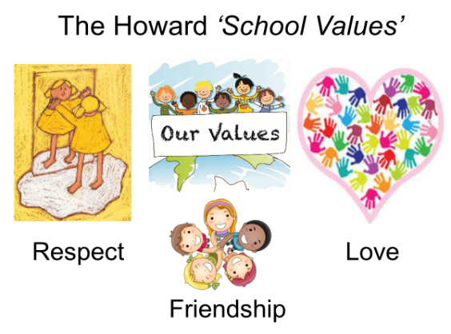

Our School Value this term is: Responsibility

Autumn 1 Curriculum
English | We have lots of exciting writing opportunities planned this term, starting with the book ‘How the whales became’ by Ted Huges. We will be inspired by the story to write our own stories in the style of Ted Hughes. We will then link our writing to our Science topic. We will use ‘Charles Darwin on the Origin of Species’ by Sabina Radeva as our core text, creating biographies, information texts and newspaper writing.
Maths  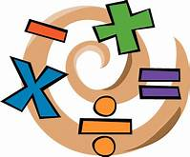 | For our Maths work, we will follow the ‘White Rose Maths’ scheme of work. Our first key topic will be place value, moving on to addition and subtraction and multiplication and division. Times tables continues to be a key area of learning so please remember to use Times Tables Rock Stars at home.
Geography  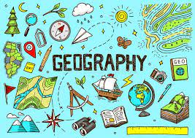 | Our Geography work this half term will focus on fieldwork where we will be learning about the eight points of a compass. We will also be using using four and six-digit grid references, symbols and keys (including the use of Ordnance Survey Maps) to build our knowledge of the United Kingdom and the wider world. In addition to this, we will use maps, atlases, globes and digital/computer mapping to locate countries and describe features studied. We will also be taking part in an orienteering field trip to Cannock Chase.
Art  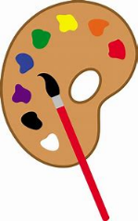 | In art, we will be developing our sketching skills. We will be learning all about textures and shading, perspective, using the local environment as our focus.
Science | Our key topic in Science this half term is evolution and inheritance. Here we will study how off-spring inherit certain characteristics from parents and how animals and plants adapt to their surroundings to ensure survival. We will also look at how plants and animals evolve over time, looking at the work of Charles Darwin and Alfred Russel Wallace.
 | In PSHE, we will be learning about votes for schools and financial capability.
Computing | In computing, we will be learning about how to stay safe online (e-safety).
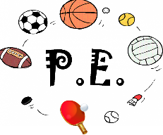 | This term, we are focusing on leadership and health related exercise, which will be led by Mr Challinor.
Religious Education  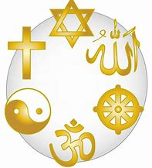 | Our RE topic is ‘Creation and Science: Contradicting or complementary?’. We will be studying the Creation story and thinking about the Christian belief as God the Creator. We will be thinking about why Christians find Faith and Science go together, and discuss how far the Genesis 1 creation narrative is in conflict, or is complementary, with a scientific account.

