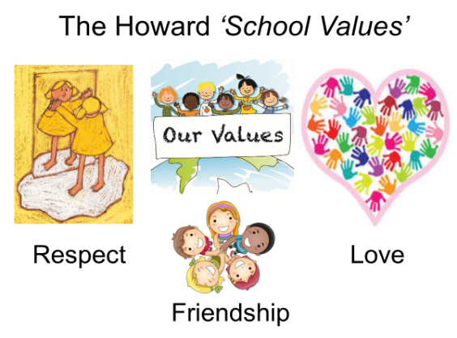

Our School Value this term is: Generosity

Autumn 1 Curriculum
English | We have lots of exciting writing opportunities planned this term, which are linked to our topic of World War Two. We will be completing lots of different writing tasks based on the story ‘Letters from the Lighthouse’ by Emma Carroll as well as looking at the diary and the life of Anne Frank.
Maths  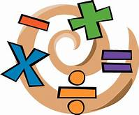 | For our Maths work, we will follow the ‘White Rose Maths’ scheme of work. We will continue with our topic of addition and subtraction and multiplication and division. After this we will move on to statistics and fractions. Times tables continues to be a key area of learning so please remember to use Times Tables Rock Stars at home.
History | Our History work this half term will focus on World War Two. We will be placing key events in chronological order, looking at why it was such a significant event in History and how people were affected by the war (including evacuees, the Blitz and rationing). We will be taking part in a trip to the National Memorial Arboretum.
DT | In DT, we will be exploring materials and developing our knitting skills.
Science | Our key topic in Science this half term is Earth and Space. Here we will:  - describe the movement of the Earth, and other planets, relative to the Sun in the solar system  - describe the movement of the Moon relative to the Earth  - describe the Sun, Earth and Moon as approximately spherical bodies  - use the idea of the Earth’s rotation to explain day and night and the apparent movement of the sun across the sky.
 | In PSHE, we will continue to learn about votes for schools and financial capability.
Computing | In computing, we will be developing our word processing skills.
 | This term, we are focusing on Netball and Basketball. We will be focusing on the range of skills needed to play the game and sessions will be led by Mr Challinor.
Religious Education  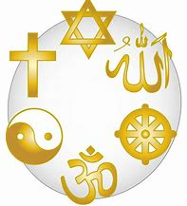 | In RE this half term, we are exploring the big question, ‘Was Jesus the Messiah?’. (Incarnation unit 2B.4)

