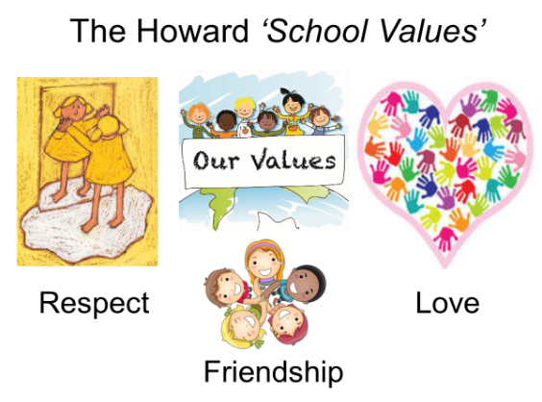

Our School Value this term is: Thankfulness

Class 3 Summer 2 Curriculum
English | We will be starting with the book ‘The Unforgotten Coat’ by Frank Cottrell Boyce. We will be using this as a basis for our writing, as well as developing our reading comprehension skills.  We will then be looking at the book ‘The Maya’ by Jon Richards and Jonathon Vipon to link in with our learning in History.
Maths  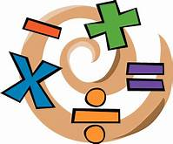 | In Year 6 we will be looking at the properties of shapes and angles (in triangles, quadrilaterals and polygons) and finishing our module on Statistics. In Year 5 we will studying angles, co-ordinates, symmetry and reflection, before moving on to converting units and volume.  We will also continue to teach Big Maths.  Remember to use Times Tables Rock Stars at home.
Our topic this term is the Maya Civilization.
We will be finding out who the Maya were, where their cities were located and the buildings they constructed. We will also be learning more about their beliefs, education, society, food and leisure.

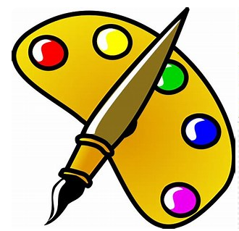 Art | In Art, we will be using oil pastels to create artwork with a Mayan theme.
Science | We will be ‘Working Scientifically’ in our Science lessons and looking at the scientific process. We will be planning investigations, conducting fair tests, taking measurements, recording data, using results to make further predictions, and reporting and presenting findings.
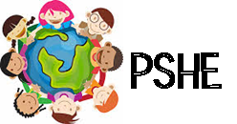 | Our PSHE this term will be based around: “Sex and Relationship Education.”  We will also be using “Voting for Schools” within our classroom.
Computing  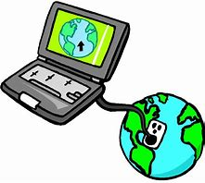 | In computing, we will be ‘Learning to be Creative’. We will enhance other areas of the curriculum by producing posters, letters, leaflets etc. which will be designed for specific audiences and purposes.
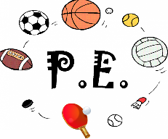 | This term, we are focusing on rounders and tennis.
Religious Education  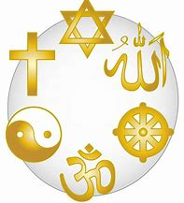 | Our RE topic is ‘Global Christianity’. We will be exploring what it means to be a Christian around the world and looking at the similarities and differences between different cultures, whilst having the same core beliefs.

