Monday Week 1
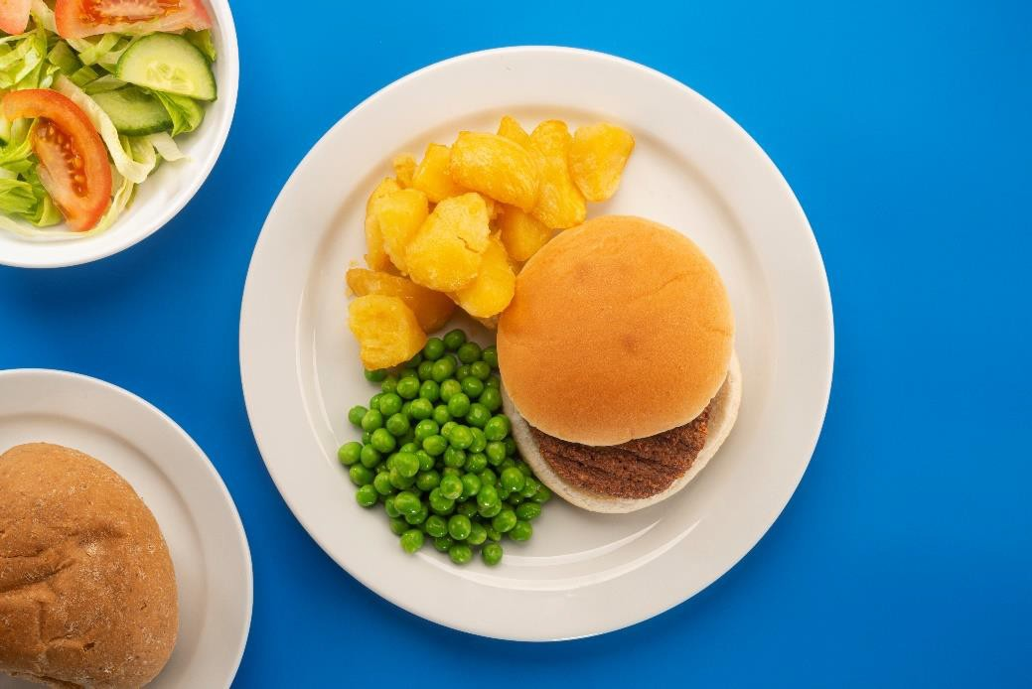

Meat-free option
Plant-based burger in a bap with diced potatoes (Vg) Served with vegetables of the day or salad and bread of the day
Yoghurt, fruit and freshly baked mini shortbread biscuit
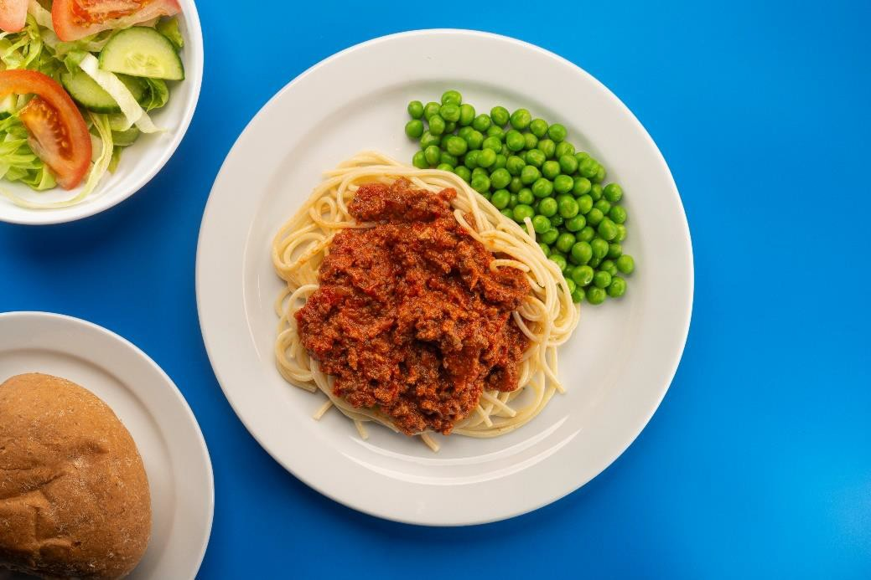

Meat option
Spaghetti bolognaise (beef)
Served with vegetables of the day or salad and Garlic bread of the day Yoghurt, fruit and freshly baked mini shortbread biscuit

Tuesday Week 1
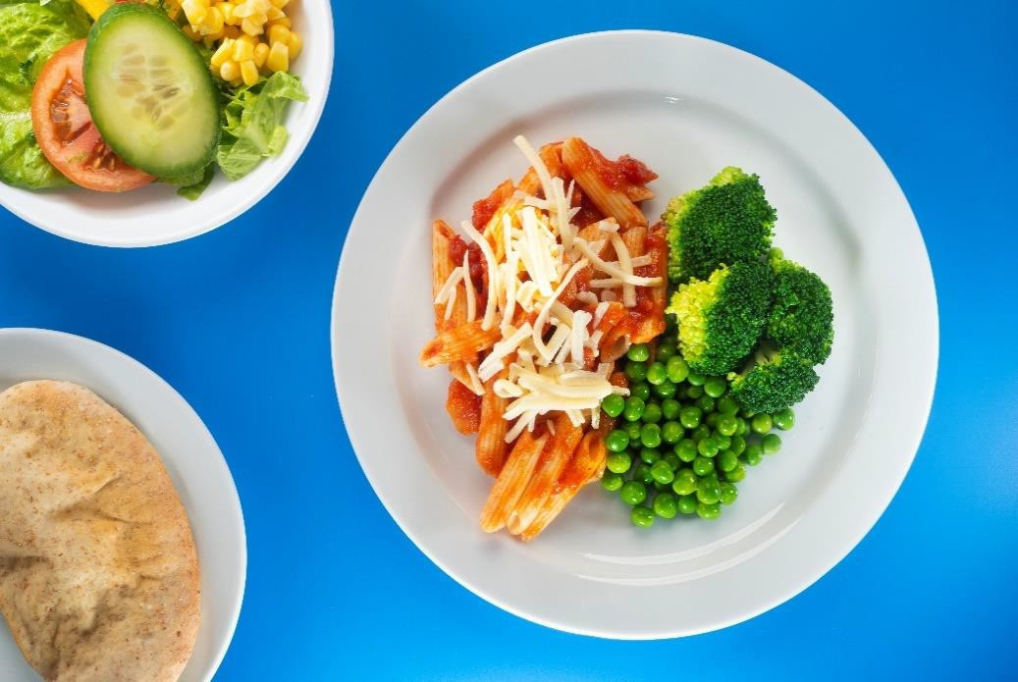

Meat-free option
Tomato pasta (V)
Served with vegetables of the day or salad and bread of the day Chocolate brownie

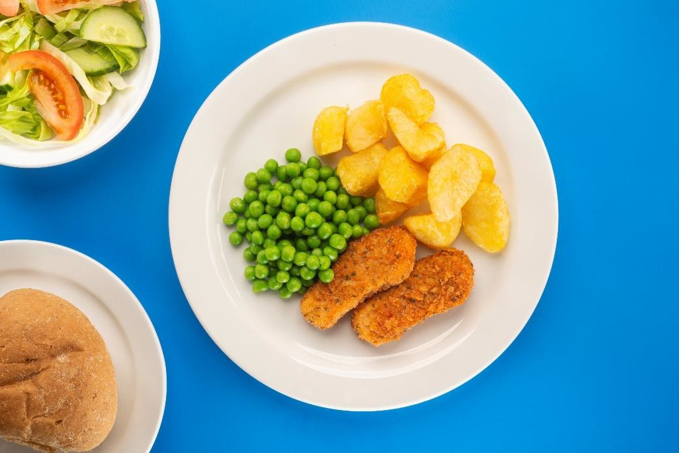

Meat option
Italian style chicken goujons with diced potatoes
Served with vegetables of the day or salad and bread of the day Chocolate brownie

Wednesday Week 1
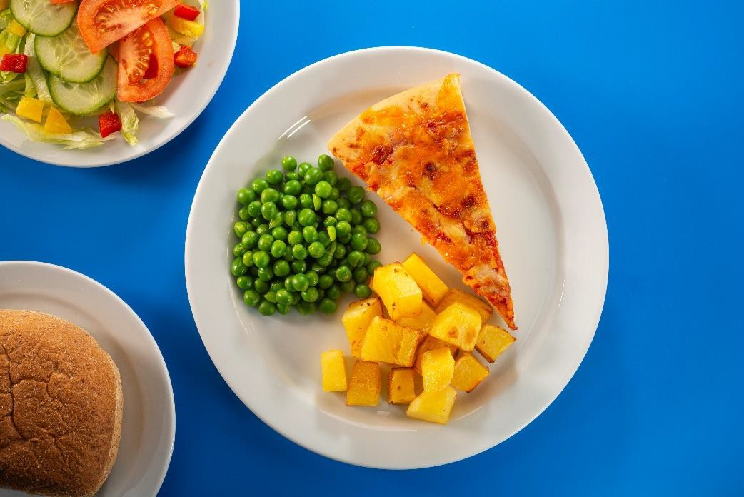

Meat-free option
Margherita pizza and crinkle cut wedges (V)
Served with vegetables of the day or salad and bread of the day Fruit and jelly
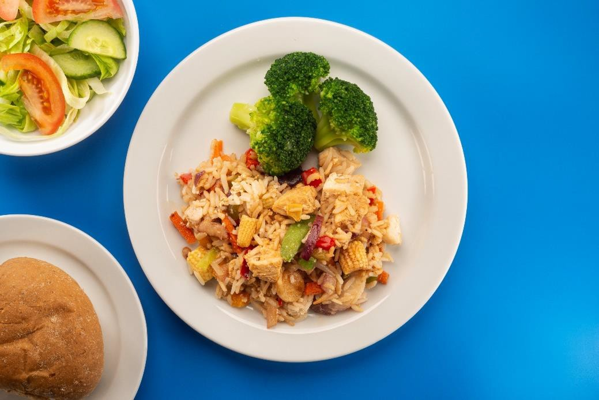

Meat option
Chicken and oriental style vegetable rice
Served with vegetables of the day or salad and bread of the day Fruit and jelly

Thursday Week 1
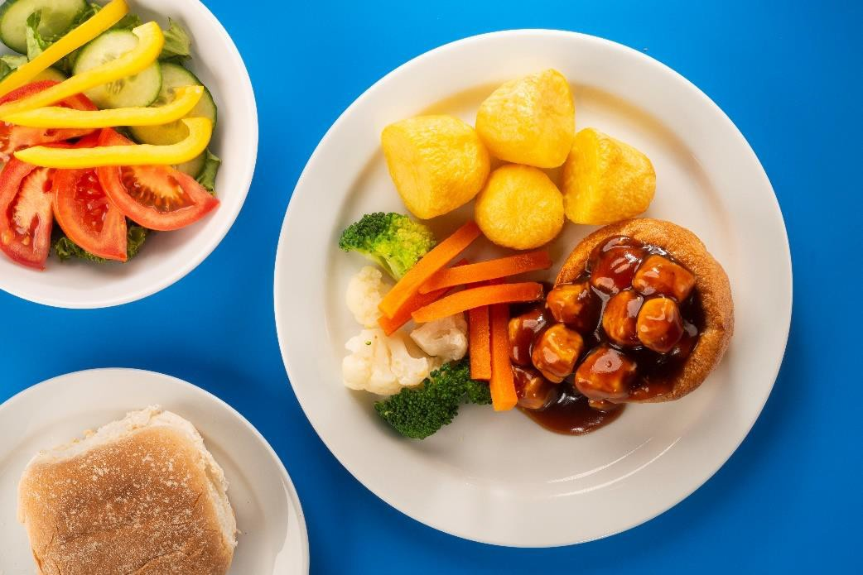

Meat-free option
Quorn chicken pieces in a Yorkshire pudding (V)
Served with roast potatoes, vegetable of the day, gravy and bread of the day Lemon drizzle sponge
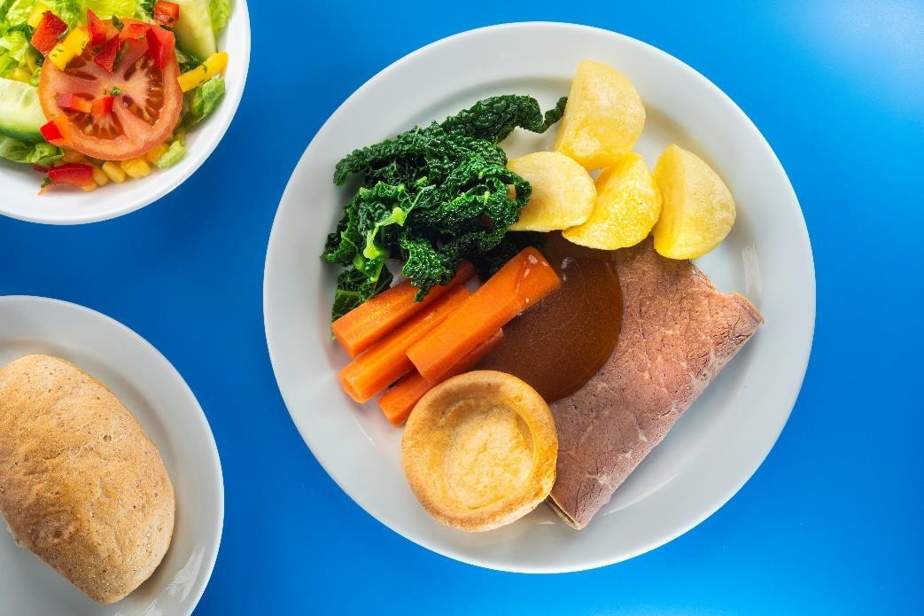

Meat option
Sliced beef and Yorkshire pudding
Served with roast potatoes, vegetable of the day, gravy and bread of the day Lemon drizzle sponge

Friday Week 1
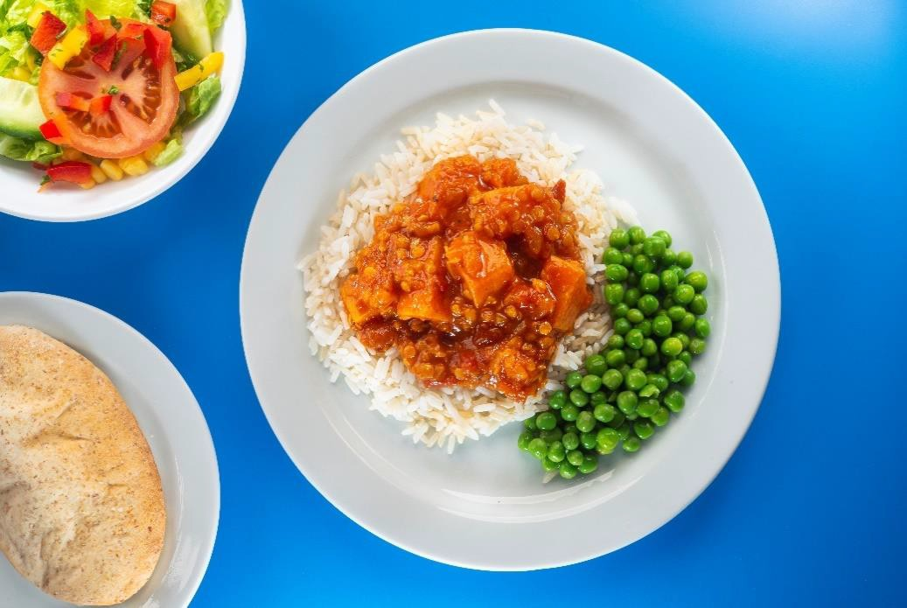

Meat-free option
Sweet potato and lentil curry with a blend of brown and white rice (Vg) Served with chips and vegetables of the day or salad and bread of the day ice cram topped with cream
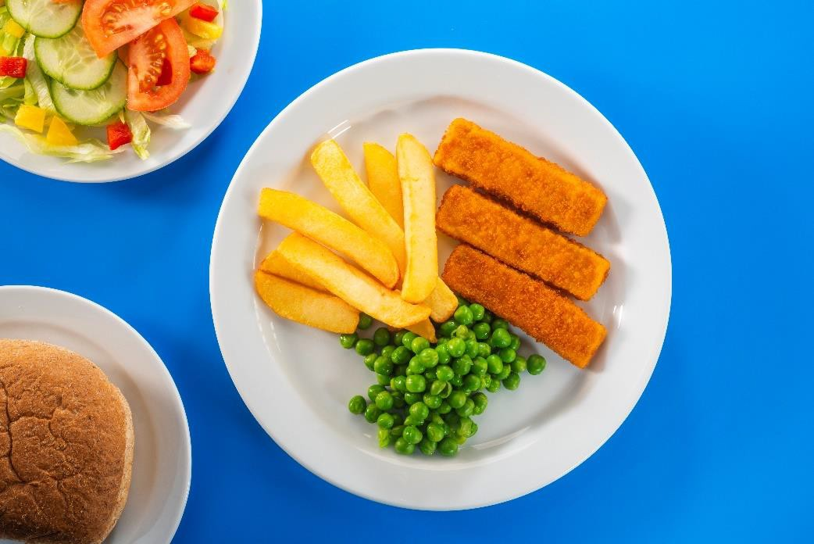

Meat option
Baked fish fingers
Served with chips and vegetables of the day or salad and bread of the day ice cream topped with cream

Monday Week 2

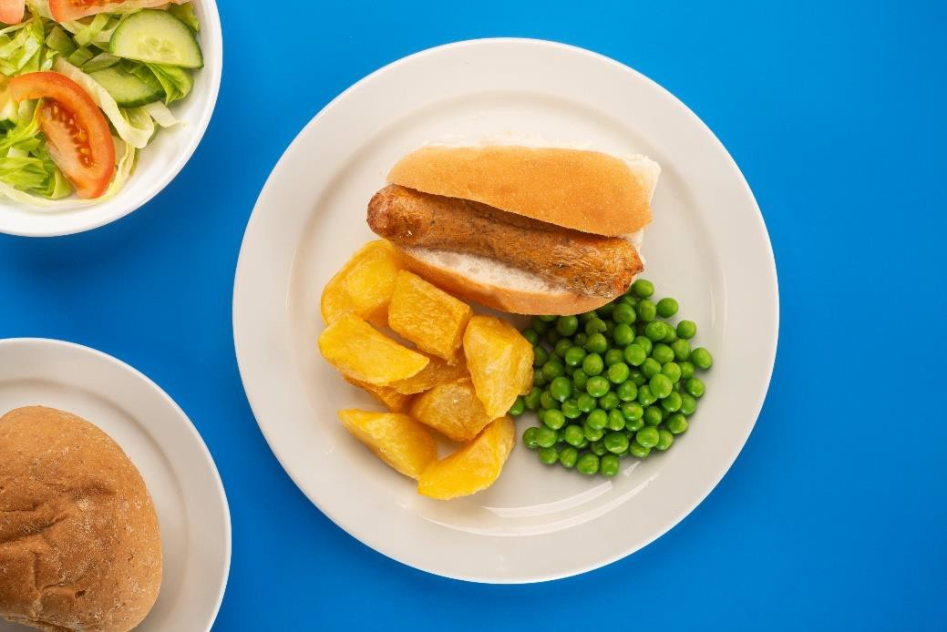

Meat-free option
Meat-free hotdog with diced potatoes (Vg)
Served with vegetables of the day or salad and bread of the day Yoghurt, fruit and freshly baked mini shortbread biscuit
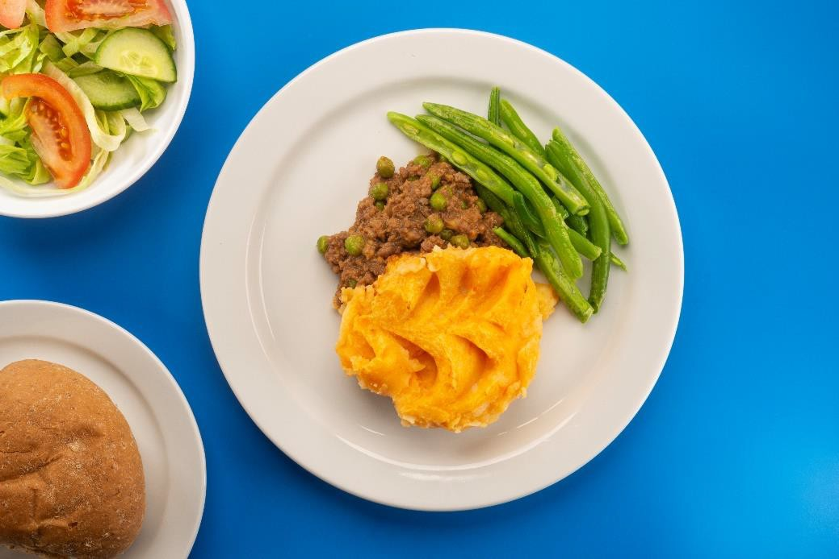

Meat option
Cottage pie (beef)
Served with vegetables of the day or salad and bread of the day Yoghurt, fruit and freshly baked mini shortbread biscuit

October 23 to
March 24

Tuesday Week 2
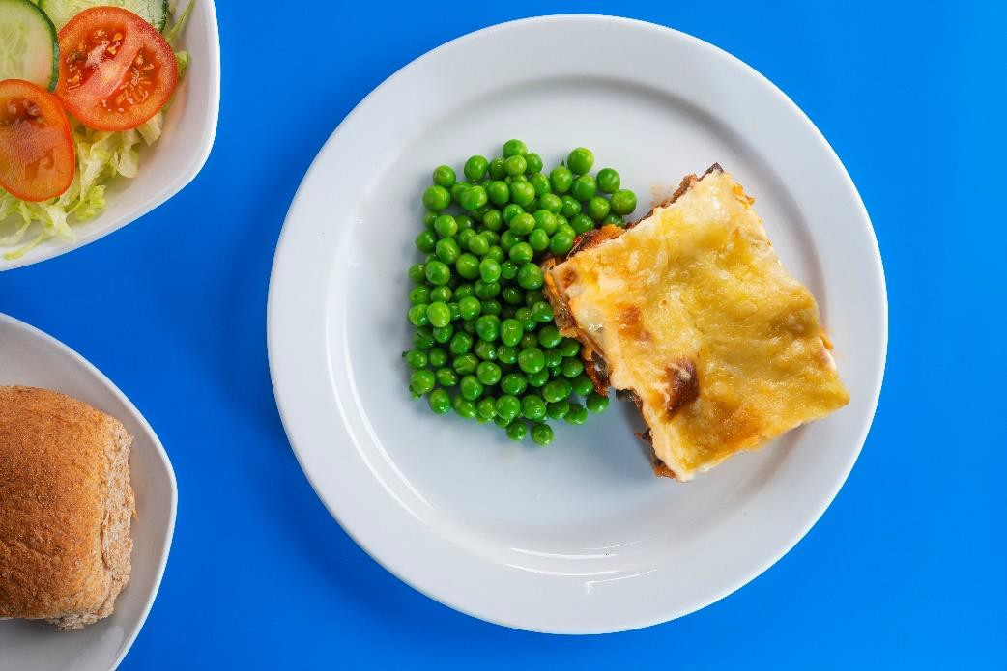

Meat-free option
Roasted vegetable lasagne (V)
Served with vegetables of the day or salad and bread of the day Apple flapjack
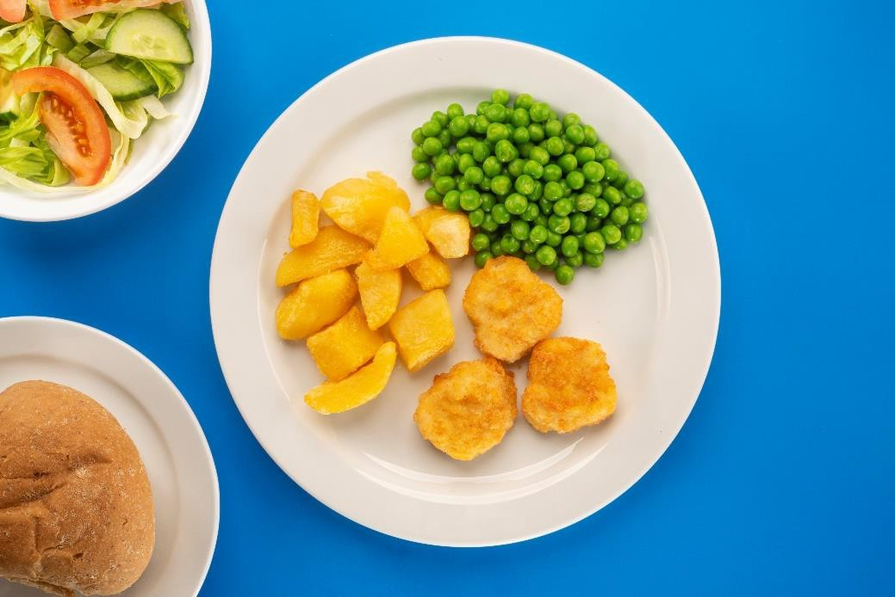

Meat option
Chicken nuggets with diced potatoes
Served with vegetables of the day or salad and bread of the day Apple flapjack

October 23 to
March 24

Wednesday Week 2
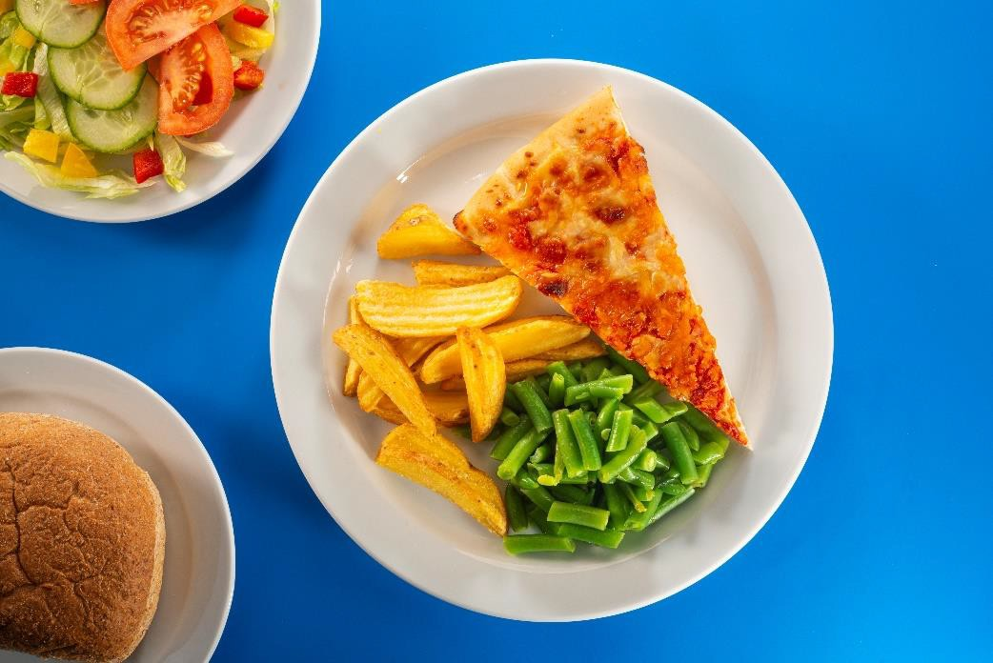

Meat-free option
Margherita pizza with crinkle cut wedges (V)
Served with vegetables of the day or salad and bread of the day Fruit and jelly

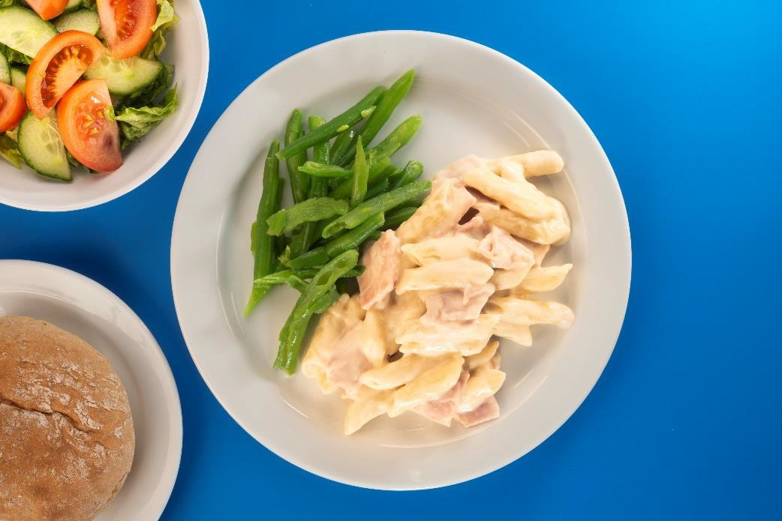

Meat option
Ham carbonara with penne pasta
Served with vegetables of the day or salad and bread of the day Fruit and jelly

October 23 to
March 24

Thursday Week 2
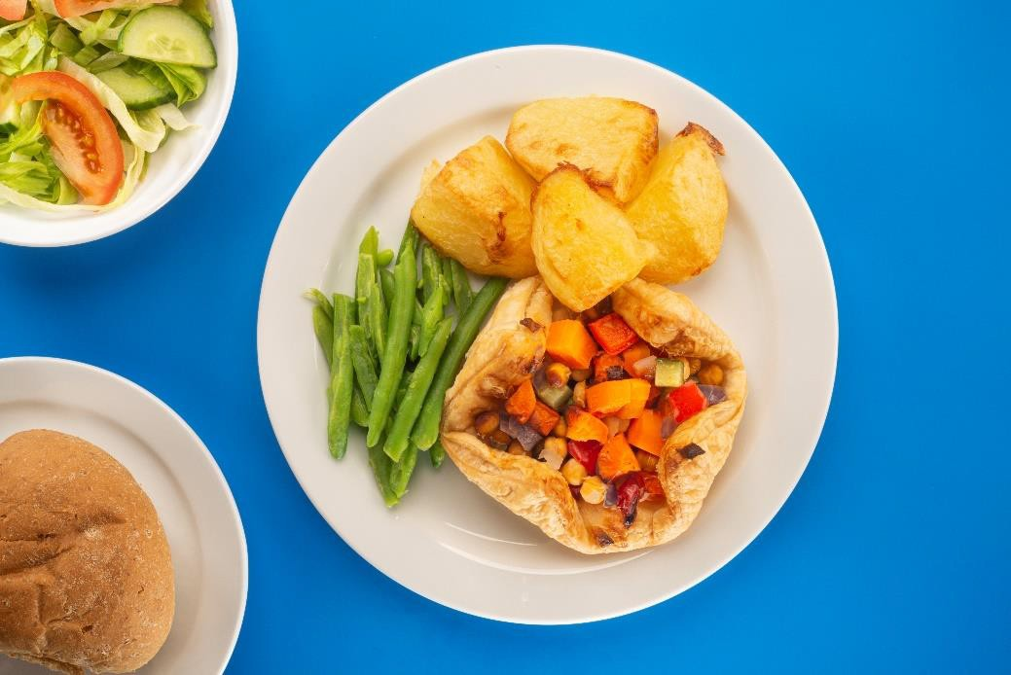
Meat-free option Vegetable pastry crown (Vg)
Served with roast potatoes, vegetables of the day, gravy and bread of the day Victoria sponge
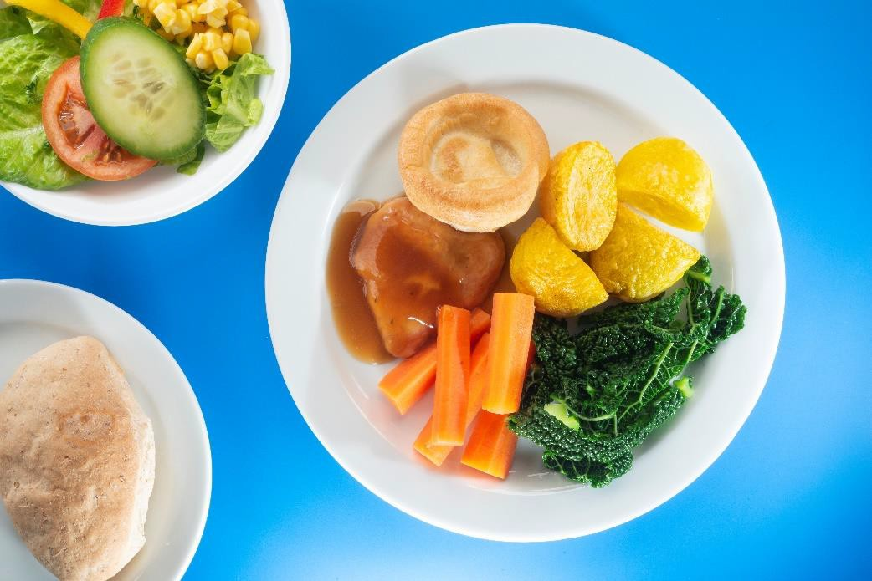
Meat option
Roast Chicken and Yorkshire pudding
Served with roast potatoes, vegetables of the day, gravy, and bread of the day Lemon drizzle sponge

October 23 to
March 24

Friday Week 2
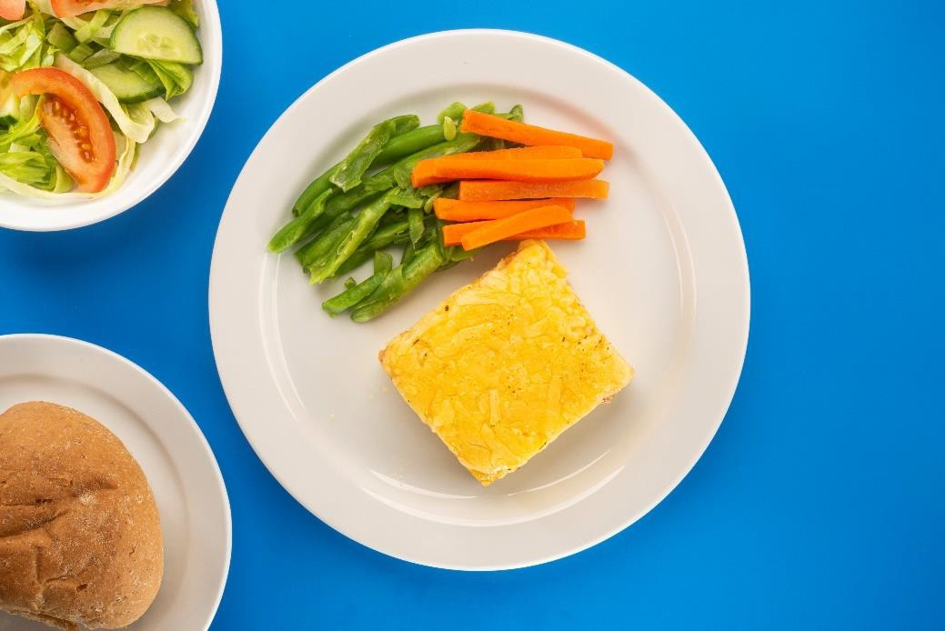

Meat-free option
cheddar cheese and potato frittata (V)
Served with vegetables of the day or salad and bread of the day home made cookie
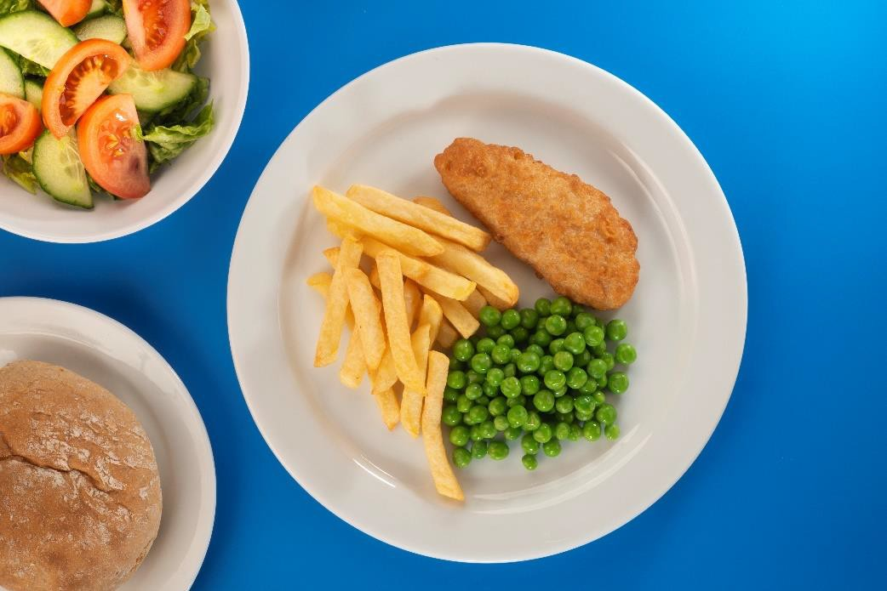

Meat option
Baked battered fish and chips
Served with vegetables of the day or salad and bread of the day home made cookie

October 23 to
March 24

Monday Week 3
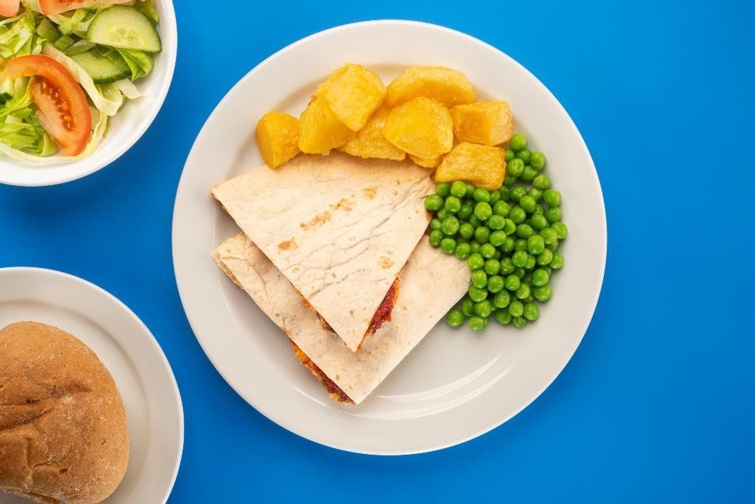

Meat-free option
cheddar cheese and tomato quesadilla with diced potatoes (V) Served vegetables of the day or salad and bread of the day
Yoghurt, fruit and freshly baked mini shortbread biscuit
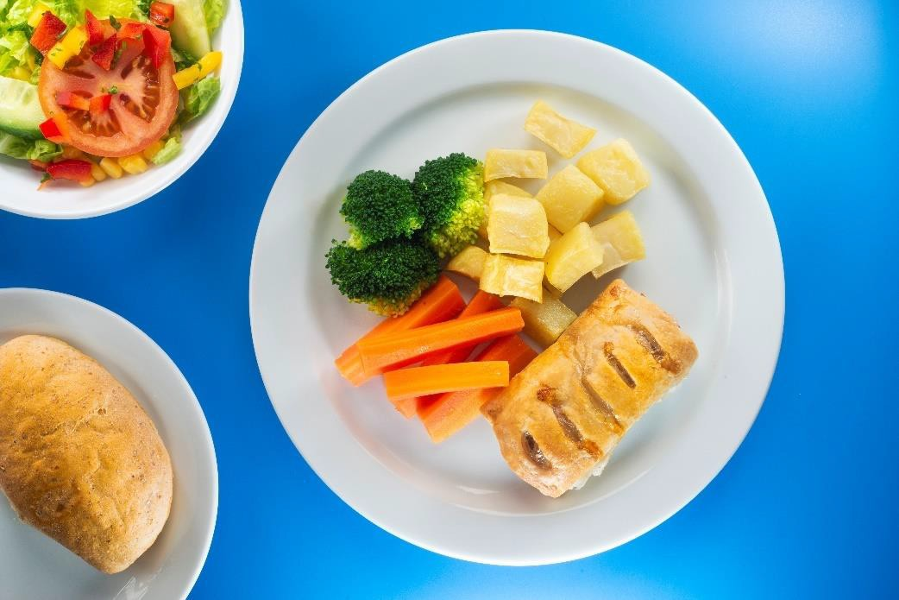

Meat option
Pork sausage roll with diced potatoes
Served with vegetables of the day or salad and bread of the day Yoghurt, fruit and freshly baked mini shortbread biscuit

October 23 to
March 24

Tuesday Week 3
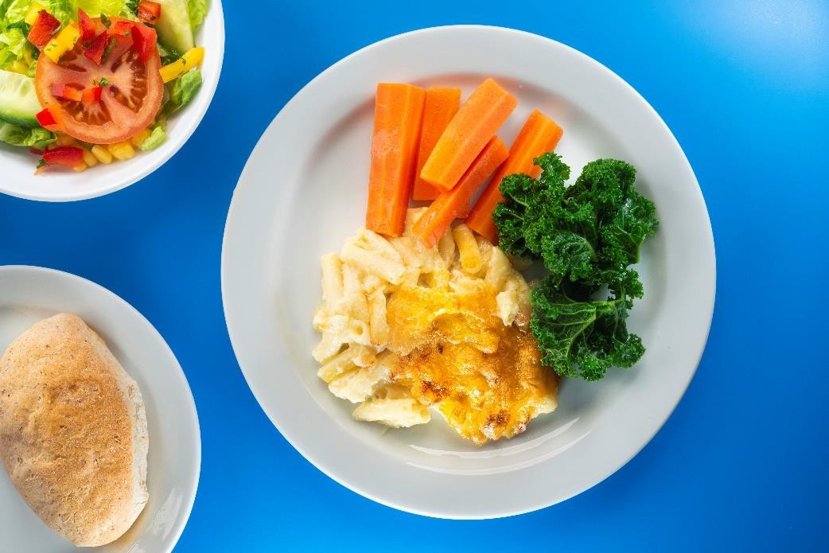

Meat-free option
Macaroni cheese with cheddar (V)
Served with vegetables of the day or salad and bread of the day
jam sponge
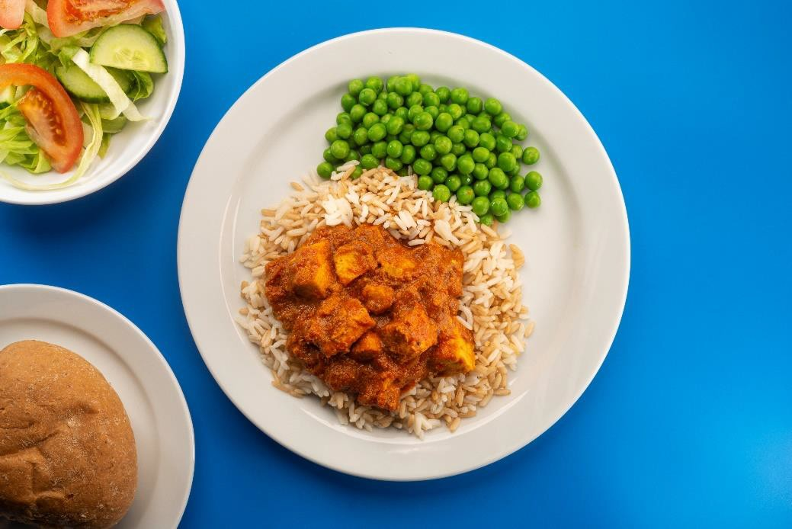

Meat option
Chicken curry with a blend of brown and white rice Served with vegetables of the day or salad and bread of the day
jam sponge

October 23 to
March 24

Wednesday Week 3

Meat-free option
Margherita pizza with crinkle cut wedges (V)
Served with vegetables of the day or salad and bread of the day Fruit and jelly
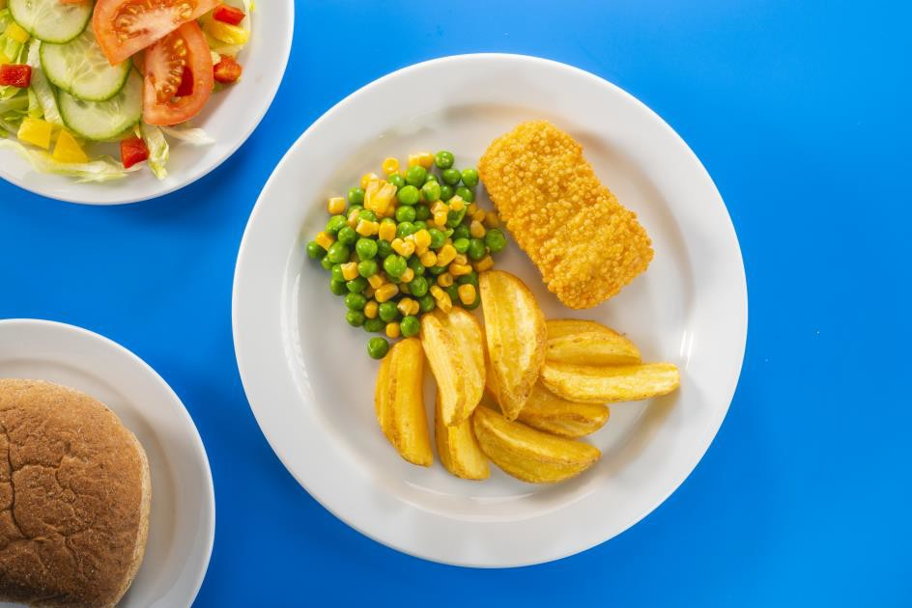

Meat option
Bubble salmon with crinkle cut wedges
Served with vegetables of the day or salad and bread of the day Fruit and jelly

October 23 to
March 24

Thursday Week 3
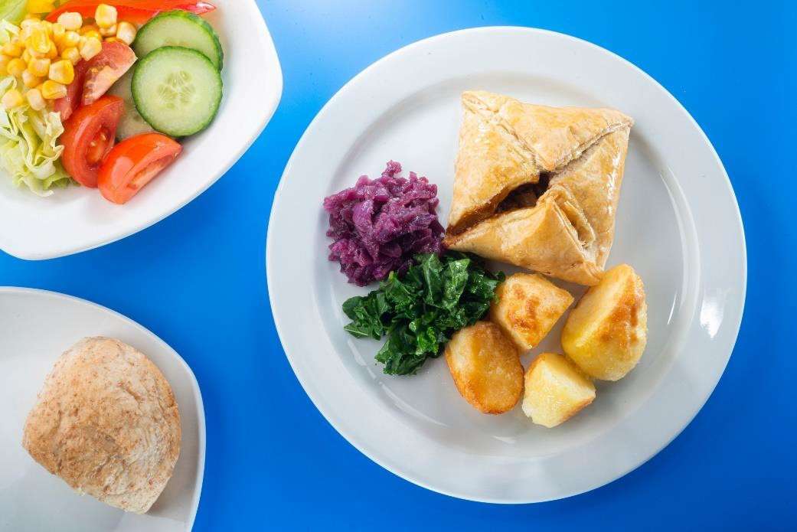

Meat-free option
cheddar cheese and tomato pastry puff (V)
Served with roast potatoes, vegetables of the day, gravy and bread of the day Chocolate orange sponge

Meat option
Roast chicken and Yorkshire pudding
Served with roast potatoes, vegetables of the day, gravy and bread of the day Chocolate orange sponge

Friday Week 3
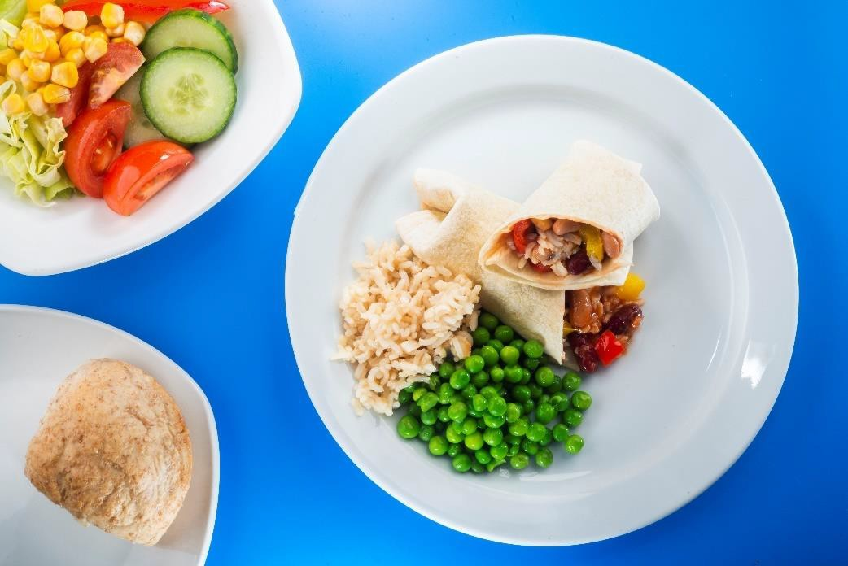

Meat-free option
Vegetable and bean burrito (Vg)
Served with vegetables of the day or salad and bread of the day Freshly baked marble shortbread
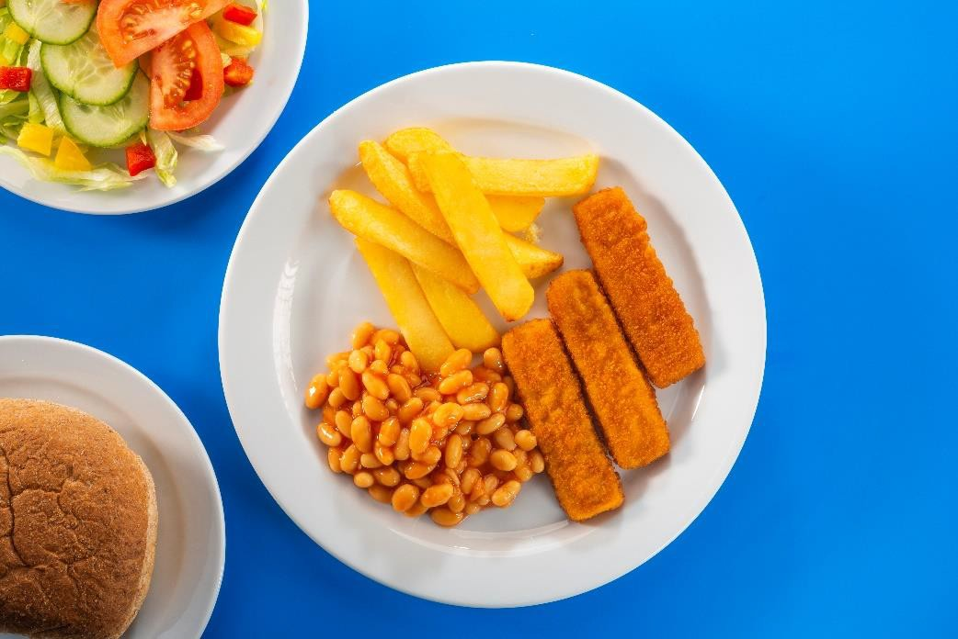

Meat option
Baked fish fingers and chips
Served with vegetables of the day or salad and bread of the day Freshly baked marble shortbread

