Behaviour and Pastoral Support

“Parents have overwhelming confidence in the support leaders and staff give their children, academically and emotionally. Comments such as ‘I am so happy that my children come to this school’ are common.” Ofsted Jan 2017
.

Behaviour and Pastoral support introduction
Our behaviour policy and the pastoral support we give our pupils has two main aims. Firstly to ensure every pupil feels safe, secure and supported so that they can focus on their learning. The second is to set the foundations for the pupil’s future; the next stage of their education, the world of work and to ensure they can adapt and thrive in an ever changing environment.
All staff undertake a pastoral role which in essence means supporting a child in all areas of well-being. It means listening, watching and sharing knowledge about individuals. We do this to make sure we address the needs of the whole child and not just the education element. This is a hugely important aspect of our work and can only be accomplished with the support of parents.
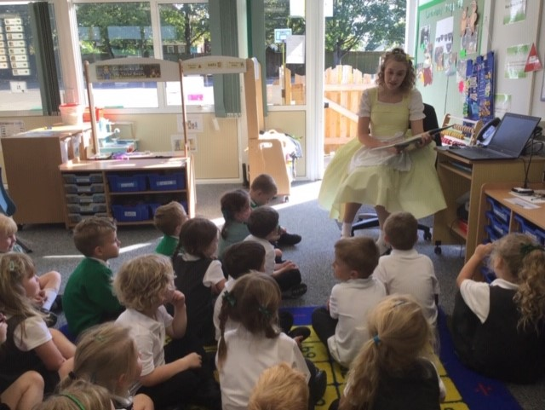
Goldilocks telling her story to Foundation pupils
We follow a staged approach
(Levels 1, 2 and 3) that are more fully explained in this document. If home and school work closely together then the children can be happy, thrive and make excellent academic progress.
Rewards
Everyone enjoys the following rewards for positive behaviour and application to learning- not in any particular order (some staff have additional in their own classrooms)-
We always praise the learning process, not the child, and the praise is proportional to the achievement.
Individual praise from staff.
Positive comments on work in books/ or on the shared “Big Feedback Form”
Positive feedback from other pupils.
Good work assembly with certificate.
Triers cup award with certificate and cup for one week.
Visit to Mrs Spruce with the good work and text home; plus a small gift.
Home reading reward system.
End of Year achievement assembly.
Team points for good behaviour and good work leading to whole team chanting “We are the Champions” in assembly on a weekly basis.
Work displayed on “Busy Being our Best” boards.
Work displayed in group topic books.
Principal’s Award- for something that is exceptional.
School Rules
The first step in establishing a good behaviour policy is to decide upon simple school rules. We have only two-
When we are asked to do something we do it the first time.
We are kind to everyone (that includes managing ourselves physically and verbally) with younger children we speak of “kind hands and feet”.
It is recognised that children sometimes need help in order to keep these rules. Some children with significant special educational issues may need specific support plans. (Miss Kophazy Special Educational needs and Disability Co-ordinator)
Pastoral support
All of our staff support pupil’s pastoral needs continuously to ensure they are settled and able to focus on learning.
Level one
Teachers, nursery staff and teaching assistants address low level issues in the classroom and outside at break-times. Staff always explain what the correct behaviour is and what is expected at an age appropriate level. On occasion if a pupil does not settle in lessons they are send for “time-out” to a partner class. Staff may children in instead of allowing them to go out to play. This is also used if a child has not applied themselves well in a lesson and need to “catch-up”. A pupil’s individual normal level of output is the measure that staff use to decide upon whether catch up is appropriate.
We will deal with the simple issues and only contact you if there is an ongoing pattern or there no improvement after support and/or sanctions have been used.
Level One- more complex
Sometimes the problem may be more complex and need more time to reach a good conclusion and this can’t be dealt with whilst staff have classes to teach; therefore these are picked up by Mrs Atkin-responsible for Personal, Social and Health Education.
If you have a family situation that may impact on your child in school please contact us in confidence and we will be watchful and support as necessary.
Level 2
Occasionally, incidents occur that require an immediate firm approach. If a pupil(s) temper results in a physically or verbally attack on another pupil(s) then staff will thoroughly investigate the incident. Staff will ensure all of the pupils involved, and the witnesses, to the incident have the opportunity to talk freely about what has happened. All mitigating circumstances will be investigated and taken into account. Once it has been established who broke the school rule(s) the pupil’s parents will be contacted. Sometimes the pupil(s) will phone home to tell their parents what they have done themselves. Our expectation is that parents will support the school and that together we will discuss the next steps to ensure the behaviour that occurred is not repeated; this may include sanctions in school, at home or both. The incident will be recorded in CPOMS, which is an online, encrypted, reporting system. All CPOMS reports are seen by Mrs Spruce who will look for patterns in behaviour and decide upon any changes that need to be made in school systems, PSHE inputs and work with individual pupils.
Lunchtime
Pupils that play sports at lunchtime should ask for the support of dinner staff if they are unable to manage the play themselves. Any pupil that uses bad language or becomes violent will not be allowed to join in sports at lunchtime for one week; they may be required to telephone their parents. After the suspension week they will be allowed to play again. After the second suspension the pupil will not be chosen to represent the school in competitions for that term. All lunchtime incidents are investigated by Mrs Curtis and recorded in CPOMS.
Level 3
In the most extreme behaviour cases, as per government guidelines, a pupil can be excluded either for a short period or permanently. This can occur as a result of repeatedly poor behaviour after all other sanctions have been exhausted or for a first/ one off offence. This is not something that is done lightly but is something that Principals can legally use if the breach of the behaviour policy is serious. ( Please see Enquire Learning Trust Exclusion Policy- for further detail)
Behaviour off school site- To and From School
Under the 2006 Act, schools have a statutory power to regulate the behaviour of pupils when off school premises and not supervised by school staff e.g. behaviour whilst wearing school uniform and on the way to or from school. If a pupil is observed by a member of staff misbehaving, the staff member will make it clear to the pupil that he/she has been seen and the matter will be dealt with when the pupil is in school. The sanctions applied will be reasonable and in a staged approach as already described.

On a day to day basis the vast majority of pupils behave well and create excellent learning environments in the classrooms and outside. We thank you for your support in making school a very pleasant place to work and learn and look forward to your continuing support.
“Leaders articulate their moral values clearly and pupils know what is expected of them and why. Leaders and staff carefully plan for and support pupils who have a wide range of needs.” Ofsted Jan 2017

