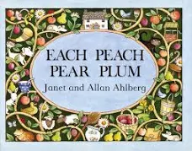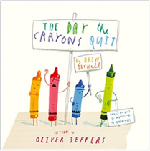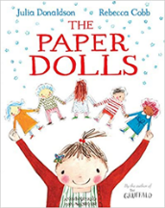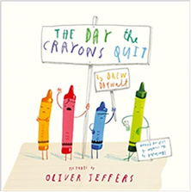

Parent Map: Tell me a story: Foundation Stage

Enquiry Question: What’s the best way to tell a story?

Key Questions

1. How does a fairytale usually begin and end?
2. Are all the characters kind?
3. What was Cinderella’s shoe made from?
4. What materials did the 3 little pigs use to build houses?
5. How do fairytales usually end?

Literacy

Children will be reading the book Each Peach Pear Plum and will then read other related stories. Children will develop a deeper understanding for rhyme and expression within their voice.

Children will begin to read a few simple sentences and practise spelling some common expectation words. Children will be taught how use finger spaces between words in sentences.

Children will build vocabulary up through exploring the stories they are exposed to.

Expressive Arts and Design

Children will set up role play areas based on the fairytales they have listened to. They will be given props to encourage them to act out the stories in character. Children will be introduced to different types of materials and textures. They will have an opportunity to make a spoon puppet and a paper doll.

P.E

Children will have P.E on a Monday morning with Mr Playford. He will be encouraging children to build on ball skills along with improving co-ordination and balance.

Maths

In maths we will be learning how to represent, compose and sort numbers nine and ten. We will then order and compare numbers within ten.

We will begin to look at 3D shapes and their properties and also learn about repeating patterns.

PSED

Children will recognise common themes from stories, such as bravery, difficult choices and kindness, and talk about children’s experiences with these themes.

Understanding the World

Through sharing texts and images and retelling stories in various ways children will begin to develop an understanding of the past and present. Children will talk about their own past experiences and things they see similar and different when comparing their own lives to the lives of others in stories.

Communication and Language

As always, learning areas within the classroom will be designed to encourage children to talk to each other and ask questions. Teaching staff will model and introduce new vocabulary to children. During the fairytales topic children will talk about characters and events that happen during the stories they read.

Please send any photos to Tapestry!