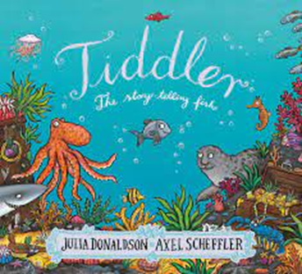

P.E

We will be encouraging children to work as part of a team competing in races and challenges against one another.

Understanding the World

Through sharing texts and images and retelling stories in various ways children will begin to develop an understanding of sea life. Through photography and tales they will learn about some famous pirates and how they once ruled the sea. They will have a look at maps and discover how they are needed to get to a destination.

Parent Map: Tell me a story: Foundation Stage

Enquiry Question: Is it just sailors that spend time at sea?

Maths

Children will begin to look at patterns in numbers to assist them to work with numbers to 20 and beyond and develop an understanding of odd and even numbers. They will also learn to complete addition and subtraction calculations and solve problems including doubling, halving and sharing.

Expressive Arts and Design

Children will use recycled materials to create representations of their favourite sea creatures. They will make their own delicious ice cream. They will learn musical songs relating to the sea and sailing.

Literacy

Children will be reading the book Billy’s bucket and Tiddler. They will focus on alliteration and write their own sea riddles.

Children will begin to read a few simple sentences and practise spelling some common expectation words. Children will be taught how use finger spaces between words in sentence and a full stop at the end of a sentence.

Children will build vocabulary up through exploring the stories they are exposed to.

PSED

Children will learn the importance of keeping safe whilst at the seaside. Such as staying in sight of an adult, never entering the sea alone and wearing sun cream. They will discover what they can do to care for the beach and sea life.

Key Questions

1. Can you name 5/10 sea life animals?
2. What does a coast guard do?
3. How do we keep safe at the seaside?
4. What might you do at the beach?

Communication and Language

As always, learning areas within the classroom will be designed to encourage children to talk to each other and ask questions. Teaching staff will model and introduce new vocabulary to children. During the footprints in the past topic children will talk about their experiences of going to the beach and paddling in the sea.

Please send any photos to Dojo.