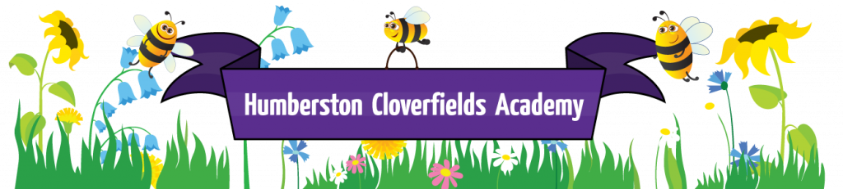
What does Art look like at Humberston Cloverfields?

Curriculum Intent
At Humberston Cloverfields Academy, we value Art and Design as an important part of the children’s entitlement to a broad and balanced curriculum. Art and Design provides the children with the opportunities to develop and extend skills and an opportunity to express their individual interests, thought and ideas. The principles and purposes of Eisner shows us how to teach the art curriculum. The way to make sure that it is taught effectively, with relevance, and that space is made for it in the timetable, is to have a clear and shared vision at whole-school level.

Art, craft and design embody some of the highest forms of human creativity. Our high-quality art and design education engage, inspire and challenge pupils, equipping them with the knowledge and skills to experiment, invent and create their own works of art, craft and design. As pupils progress, they should be able to think critically and develop a more rigorous understanding of art and design. They should also know how art and design both reflect and shape our history, and contribute to the culture, creativity and wealth of our nation.

Aims
The national curriculum for art and design aims to ensure that all pupils:
- produce creative work, exploring their ideas and recording their experiences
- become proficient in drawing, painting, sculpture and other art, craft and design techniques
- evaluate and analyse creative works using the language of art, craft and design
- know about great artists, craft makers and designers, and understand the historical and cultural development of their art forms.

Curriculum Implementation
The Art and Design Curriculum at Humberston Cloverfields Academy is linked where possible to other aspects of the curriculum. Detail can be found in our Long Term plan.

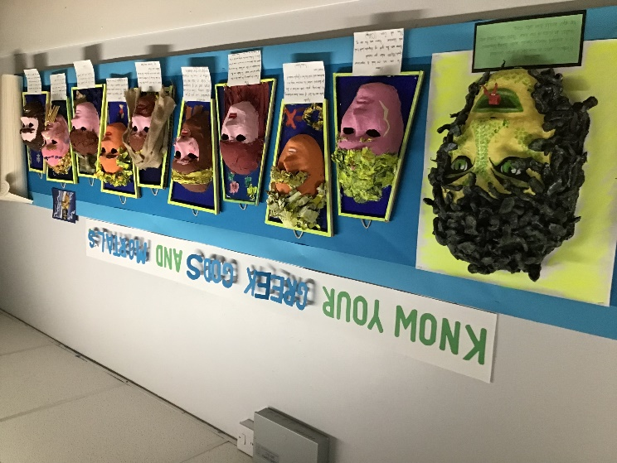

The children's learning is further enhanced with a whole school art focus in the summer term where the children have the opportunity for collaborative working and exploring the different styles and techniques of a range of artists. A whole school gallery is created and parents are invited to attend.

Early Years Foundation Stage
Pupils explore and use a variety of media and materials through a combination of child initiated and adult directed activities. They have opportunities to learn to:
- Explore the textures, movement, feel and look of different media and materials
- Respond to a range of media and materials, develop their understanding of them in order to manipulate and create different effects.
- Use different media and materials to express their own ideas
- Explore colour and use for a particular purpose
- Develop skills to use simple tools and techniques competently and appropriately
- Select appropriate media and techniques and adapt their work where necessary

Key stage 1
Pupils are taught:
- to create sketch books to record their observations and use them to review and revisit ideas.
- to use a range of materials creatively to design and make products
- to use drawing, painting and sculpture to develop and share their ideas, experiences and imagination
- to develop a wide range of art and design techniques in using colour, pattern, texture, line, shape, form and space
- about the work of a range of artists, craft makers and designers, describing the differences and similarities between different practices and disciplines, and making links to their own work.

Key stage 2
Pupils are taught to develop their techniques, including their control and their use of materials, with creativity, experimentation and an increasing awareness of different kinds of art, craft and design.

Pupils are taught:
- to create sketch books to record their observations and use them to review and revisit ideas.
- to improve their mastery of art and design techniques, including drawing, painting and sculpture with a range of materials [for example, pencil, charcoal, paint, clay]and printing
- about great artists, architects and designers in history.
Impact
Pupils will be able to talk about art, understand its historical context, be able to question art and think like artists. Art aims to provide students with the chance to give their views on life.
Art is a form of self-expression and through engaging with their emotional side pupils have better mental health and well- being.
Art teaching improves cognition and improves academic performance across the whole curriculum. The practical skills that may be applied in many workplaces and the ability to question and probe are aspirations for our pupils when they are with us and are taken forward to the next stage in their education. We would want to instil in our pupils a love and appreciation of art in all its forms. Some pupils may have art as a hobby or career as an outcome of excellent foundation in art teaching in our school.

.

