Humberston Cloverfields Curriculum
Cloverfields is a school where we are always “Busy Being our Best.”
We are Ready, Respectful and Safe
Humberston Cloverfields Academy is a member of the Enquire Learning Trust. It is situated on a shared tree lined, green campus which is also occupied by a High School and a Special Education School in Humberston, Grimsby, N.E. Lincs.
The school is coastal, predominantly white British within a high level of deprivation unemployment and long term sick statistics than the rest of Great Britain. There is a significant lower percentage of professional workers and has only 22.8% of adults with an NVQ4+ compared to 39.3% nationally. Although the school is situated in a “leafy suburb” of Grimsby we have a wide mix of social backgrounds and parental expectations.

Intent
We have designed, an engaging and ambitious curriculum that is the driver that ensures parent involvement and development of the whole child through cultivating their curious minds to ensure they have a love of learning. This
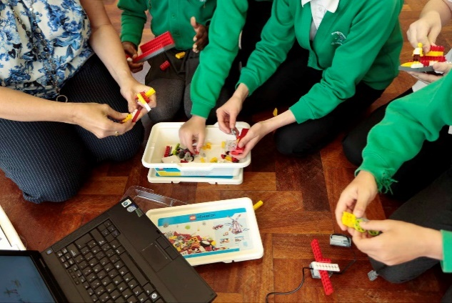

Computing using lego

begins in the Nursery and continues through to Year 6. The focus on cultural capital throughout our broad curriculum raises aspirations for life- long learning within our hometown and beyond. (see separate documents for subject details )

Regardless of need our curriculum gives all pupils the opportunity to learn within a coherent and progressive framework and explore a rich and deep subject specific knowledge that encompasses and goes beyond the National Curriculum. Every pupil understands the purpose and value of their learning and can see its relevance to their past, present and future.
Implementation
(Further detail in individual subject documents)
The curriculum has an emphasis on becoming a great communicator through speaking, listening, reading, writing and performing. We have used the excellent training we have had through the Trust with the Centre for Literacy in Primary Education (CLPE) to place quality literature at the heart of our curriculum.
All pupils have a rich Mathematics curriculum which aims to create numerate and competent mathematicians. Teaching is through a combination of Big Maths and White Rose packages. Pupils are keen to learn their multiplication tables using Times Tables Rock Stars which challenges everyone to improve their competency and speed.

Our learners develop great pride in creating “beautiful”, unique outcomes. Pupils are encouraged to ask questions and the curriculum is adjusted accordingly; going beyond and deeper than the expectations of the national curriculum.

We bring the world to our pupils through curriculum enhancement; educational visits/visitors and workshops.

A unique features of our school is an Immersive classroom which enhances our capacity to deliver the curriculum by bringing the world into our school.
Our whole school teaching philosophy is based strongly on the work of Ron Berger. One of the main principles of Ron Berger’s approach is that pupils are supported and challenged to create something that is new and “beautiful” in the world that didn’t exist before. Pupils apply the “Austin’s butterfly “ approach to all of their tasks- “We are busy being our best” We combine this with a deep knowledge and understanding of the all National Curriculum subjects. The most recent Ofsted commentary on our curriculum- Jan 2017
“You and your team are rigorous in your approach to delivering teaching in the basic skills, but you balance this effectively with a vibrant and practical curriculum which provides memorable learning for pupils. Strong teacher subject knowledge and an ambition for preparing pupils well for future careers results in pupils gaining wide curriculum experiences which they speak animatedly about. “
Long term plan
The structure of our long term plan enables us to deliver a coherent and meaningful approach across a wide range of subjects that delivers on our curriculum intent.
Subjects are taught separately but are linked e.g. Year 1 Geography topic Routes and Journeys teaches pupils how to use a map to travel to places locally. This takes us to the local church where our history work examines the church memorial and why it is there and in Design Technology we create a 3 D model of the church based on photographs and ground plans thus linking back to geography. This provides tight connections between different cognitive processes for children. Where individual subject topics do not link in they are taught separately.
We teach pupils specifically about the unique nature of different subjects but also describe how they can be linked to other subjects so that the learning is enhanced. In order to achieve this, the first time a subject is taught in the year, pupils have a session on what it means to be an expert in the subject ( at their development level ) they are then set for success by knowing- “I am a geographer…etc
Staff continually refer to subject specific skills, knowledge and pedagogy throughout the year and make meanful links continuously.
The display of “beautiful work” is zoned throughout the school with” I am a ……”
added to deepen pupils understanding by showcasing subject outcomes.
In developing our curriculum we also take account of the questions/ direction that pupils want to take their learning. (Which is often additional to NC requirements)

Through our exciting curriculum and “Discovery RE” and “Jigsaw PSHE” programmes ( linked closely to or behaviour policy) we ensure that our pupils are socially responsible and confident British citizens with a high degree of empathy and tolerance. There are opportunities to take part in democratic activities and be active citizens building respect for themselves and others. All pupils have the opportunity to make a
positive contribution to the school and to grow in their understanding and appreciation of their place within the local community. Through the schools International connection we broaden our pupils’ knowledge and understanding of the culture and citizenship in another country.

We use individual staff expertise in support of the curriculum. A French speaking member of staff teaches the language from Y3 onwards ( and dips into Spanish and German) enabling pupils to look outwards towards being global citizens.
Science is enjoyed by our pupils and especially when linked with the Immersive Classroom and the insights 3D video can bring to understanding concepts.
Music has a high importance in our curriculum through deploying staff with expertise to teach this aspect along with opportunities for whole school singing, peripatetic music opportunities and termly productions.
Computing is led by our Microsoft Innovative Educator Expert (MIEE) using the iCompute programme which is developed across the curriculum. There are plans for a Trust wide curriculum for Computing.

Our highly successful PE/Sports curriculum, taught by our own sports coach results in high achievement in numerous sporting events locally. There is a strong focus on physiology and healthy diet with the PE curriculum.
Art and DT are connected to the wider curriculum with a talented member of staff supporting lessons and display.

How we teach the content is very much dependent on the knowledge, skills and concepts to be delivered.
There is often an engagement activity which “hooks “pupils into the learning through memorable experiences. These can be just a short activity, visitors in school or trip to a specific place. Our Immersive classroom is used substantially to provide a starting point for learning. Pupils then develop knowledge, understanding and skills using a detailed mind map as a springboard to the deeper work. They will then respond in numerous ways to show they understand and can apply their knowledge and understanding.
At this point a wide variety of outcomes are achieved that can be individually or collaboratively created.
The final element to this curriculum is that pupils have the opportunity to reflect on their learning and their next steps. They proudly share their outcomes with other pupils and with their families enabling them to further develop purposeful communication through public speaking.
Pupils have the opportunity to work individually, in pairs and small collaborative groups
Assessment
Assessment is ongoing with a wide range of POP (Proof of progress activities) that are created against Rising Stars Progression grids. Staff also assess English and Maths at objective level and these are returned termly to our Trust. These then form the basis of Trust professional development decisions.

Impact
A child leaving Cloverfields will have a clear sense of their own uniqueness that enables them to be confident, independent learners with a high level of self-esteem. They will be happy, well balanced and socially adaptable. They will be highly motivated with all the tools they need for the next steps in their learning journey.

