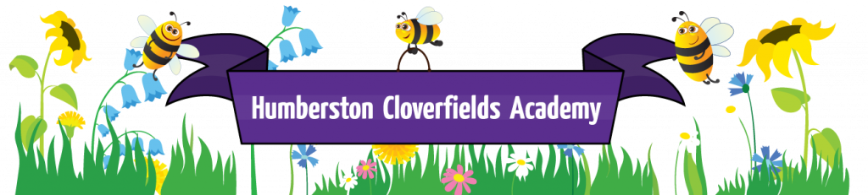
What does Early Years like at Humberston Cloverfields?

Intent
At Humberston Cloverfields Academy, we are committed to providing a high quality early years’ education, which gives children a secure and confident start to their school life and nurtures a lifelong love of learning. We are fully committed to the purpose and aims of the Early Years Foundation Stage Framework.

The Early Learning Goals are the knowledge, skills and understanding which young children should have acquired by the time they reach the age of five. There are three prime areas of learning:

Communication and Language
Physical Development
Personal, Social and Emotional Development

In addition, there are four core areas of learning:

Literacy
Mathematics
Understanding the World
Expressive Arts and Design

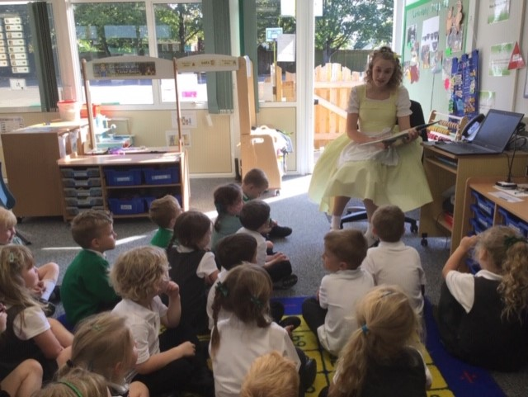
Story time with Goldilocks
Implementation
Our planning has a sharp focus on the children’s needs, their interests and their stages of development. We recognise that the seven areas of learning cannot be delivered in isolation and seek opportunities to make links between them. We aim to deliver the curriculum through planned, purposeful play and present new concepts in meaningful contexts that enable the children to build on what they already know.

Planning

Our planning shows our aims and values, demonstrates how our continuous provision meets the EYFS requirements and promotes learning within the areas of learning and development, tracks the learning objectives that have been covered and highlights any key events to be included.
At Humberston Cloverfields Academy, we deliver a creative curriculum, which is based around a new topic each half term. Many topics are built around good quality children’s books as recommended by CLPE. Challenge at all levels is built into all aspects of learning.

Effective Teaching and Learning

We encourage the children to play an active role in shaping their learning experiences. Adults engage in discussion with the children about what they are interested in, which skills they would like to develop further and which resources they need to support their learning. Each term, the children invite parents in to look at the work they have been doing.

We aim to provide an attractive, challenging learning environment that offers high quality opportunities for the children to learn through play, both indoors and outdoors. There is a range of “continuous provision” available in the classroom, that is designed to offer open-ended, practical learning opportunities. Children are supported to think creatively and imaginatively and explore how resources can be adapted. Each week, the provision is enhanced with additional resources.

Adult led activities are practical in nature and based on first hand experiences wherever possible. The children are supported to develop problem-solving skills through open-ended tasks and opportunities to share their thinking with others. The number of adult led activities that the children take part in increases throughout the year, as their concentration develops.

Observation and Assessment

At Humberston Cloverfields Academy, we use a range of strategies to gather information about the children’s learning and development and use this information to ensure that our planning meets the needs of all learners. During child initiated activities, practitioners make ‘snapshot’ observations to add to our online journal Tapestry. Notes about guided activities are recorded on planning sheets. Each child in reception has a writing book and a folder containing work completed.

From the first half of the Autumn term onwards, the staff use their knowledge of each child to decide which band of ‘Development Matters’ they are working on in each area of the curriculum. This allows learning opportunities to be pitched appropriately and also provides a baseline of the children’s attainment. This information is closely monitored to ensure that all children are making at least good progress and where this is not being achieved steps are put in place.

Working in Partnership

We recognise that children may access EYFS provision through other providers throughout the week and that all providers have an equally important role to play in their early years experiences. We seek information about the other settings that our children attend so that we can establish communication about their learning and development.

Parent Partnerships

We value the contribution that our parents and carers make to their child’s learning and take every opportunity to work in collaboration with them. Each half term, we send home a curriculum organiser showing what their child will be learning and how they can support them at home. In the Autumn term we hold parents’ consultations and in the Summer term we send home detailed reports. The children take reading books home to share and can also choose a resource each week from our lending library.

Community Links and the Wider World

Over the year, we arrange visits from members of the local community to support our topic work. The children take part in several educational visits linked to their topic work. Film clips, non-fiction texts and artefacts are also used to introduce new concepts in real-life contexts. We aim to develop the children’s awareness of other cultures by exploring different countries and celebrations.

Impact
In the Summer term, practitioners consider the 17 ELGS in the EYFS Profile to decide whether each child is working at the expected levels, exceeding the levels or have not yet met the levels. Judgements against the ELGs are based on ongoing observation, working children have produced and most importantly practioner knowledge.
The results of the Profile are shared with parents and/or carers, and there are opportunities for them to meet their child’s class teacher to discuss this information.

At the end of the year, Year 1 teachers are given a copy of the Profile report together with a short commentary on each child’s skills and abilities in relation to the three key characteristics of effective learning. This helps to create a smooth transition and assists with the planning of activities in Year 1.

The EYFS profile results are reported to the local authority, who monitor and moderate the judgements made.

