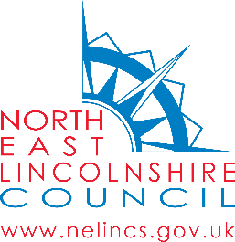
September 2020

Dear Parent/Carer

Flu Vaccination – Online Consent Form

During October - December the School Nursing Service will be offering your child the influenza vaccination in school. Please be reassured that the staff will always be wearing the appropriate personal protective equipment (face masks and shields).

The flu vaccine is given as a simple spray up the nose. It is painless and very quick, and side effects are uncommon. This vaccination programme is designed to protect your child against flu which can be an unpleasant illness and can sometimes cause serious complications.

To consent to your child receiving the vaccination please complete the online consent form by clicking on the link below:

Your School URN code is 117966 (you will need this to complete the consent form)

www.nelincs.gov.uk/schools-immunisation-consent

If you have any queries, please email the service on schoolnursingadvice@nelincs.gov.uk or phone 01472 323660.

Yours sincerely

Leisa Gaskell
Immunisation Coordinator

Please tell us if you need us to communicate with you in a different format, for example if you find it hard to read our letters or if you need someone to support you at appointments.

