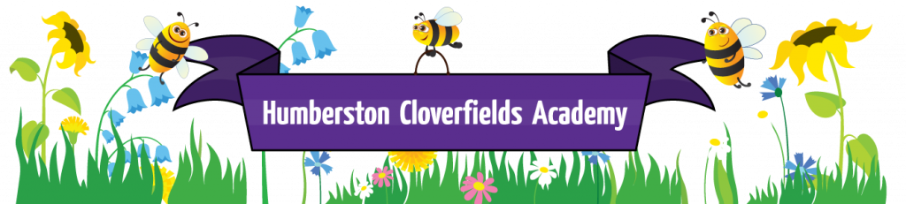
What does Geography look like at Humberston Cloverfields?

Big Ideas
Human Kind, Comparison, Significance, Change and Investigation
Intent

At Humberston Cloverfields, our Geography curriculum equips pupils with knowledge about diverse places, people, resources and natural and human environments, together with a deep understanding of the Earth’s key physical and human processes. As pupils progress, their growing knowledge about the world should help them to deepen their understanding of the interaction between physical and human processes, and of the formation and use of landscapes and environments. Geographical knowledge, understanding and skills provide the frameworks and approaches that explain how the Earth’s features at different scales are shaped, interconnected and change over time.
Curriculum Implementation

Our geography curriculum covers all aspects of the national curriculum, as detailed below. In many year groups geography is closely aligned to other NC subjects especially history. The emphasis is on practical field work and having a strong sense of knowing our local area before we look further afield.

Early Years
Understanding the world
Understanding of the world develops as children take notice of everything around them including places and all the things within them such as trees in the natural environment and roads and traffic in the built environment. Finding out about places begins initially when a child learns about their own home and the things nearby, then later

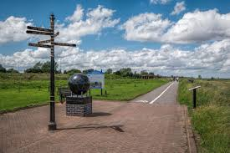

as children notice things on journeys to and from home – such as the sequence of the traffic lights or names on street signs. This awareness is
extended by visiting places and finding out about different elements of environments in books, on TV and through using other technology. This aspect also focuses on learning about cause and effect and is developed through having conversations with adults and other children about the things they observe.

Key stage 1
Pupils should develop knowledge about the world, the United Kingdom and their locality. They should understand basic subject-specific vocabulary relating to human and physical geography and begin to use geographical skills, including first-hand observation, to enhance their locational awareness.
Pupils should be taught to:
Locational knowledge
- name and locate the world’s 7 continents and 5 oceans
- name, locate and identify characteristics of the 4 countries and capital cities of the United Kingdom and its surrounding seas
Place knowledge
- understand geographical similarities and differences through studying the human and physical geography of a small area of the United Kingdom, and of a small area in a contrasting non-European country
Human and physical geography
- identify seasonal and daily weather patterns in the United Kingdom and the location of hot and cold areas of the world in relation to the Equator and the North and South Poles
- use basic geographical vocabulary to refer to:
  - key physical features, including: beach, cliff, coast, forest, hill, mountain, sea, ocean, river, soil, valley, vegetation, season and weather
  - key human features, including: city, town, village, factory, farm, house, office, port, harbour and shop
Geographical skills and fieldwork
- use world maps, atlases and globes to identify the United Kingdom and its countries, as well as the countries, continents and oceans studied at this key stage
use simple compass directions (north, south, east and west) and locational and directional language [for example, near
- and far, left and right], to describe the location of features and routes on a map
- use aerial photographs and plan perspectives to recognise landmarks and basic human and physical features; devise a simple map; and use and construct basic symbols in a key
- use simple fieldwork and observational skills to study the geography of their school and its grounds and the key human and physical features of its surrounding environment

Key stage 2
Pupils should extend their knowledge and understanding beyond the local area to include the United Kingdom and Europe, North and South America. This will include the location and characteristics of a range of the world’s most significant human and physical features. They should develop their use of geographical knowledge, understanding and skills to enhance their locational and place knowledge.
Pupils should be taught to:
Locational knowledge
- locate the world’s countries, using maps to focus on Europe (including the location of Russia) and North and South America, concentrating on their environmental regions, key physical and human characteristics, countries, and major cities
- name and locate counties and cities of the United Kingdom, geographical regions and their identifying human and physical characteristics, key topographical features (including hills, mountains, coasts and rivers), and land-use patterns; and understand how some of these aspects have changed over time
identify the position and significance of latitude, longitude, Equator, Northern Hemisphere, Southern Hemisphere, the Tropics of Cancer and Capricorn, Arctic and Antarctic Circle, the Prime/Greenwich Meridian and time zones (including day and night)
Place knowledge
- understand geographical similarities and differences through the study of human and physical geography of a region of the United Kingdom, a region in a European country, and a region in North or South America
Human and physical geography
- describe and understand key aspects of:
  - physical geography, including: climate zones, biomes and vegetation belts, rivers, mountains, volcanoes and earthquakes, and the water cycle
  - human geography, including: types of settlement and land use, economic activity including trade links, and the distribution of natural resources including energy, food, minerals and water
Geographical skills and fieldwork
- use maps, atlases, globes and digital/computer mapping to locate countries and describe features studied
- use the 8 points of a compass, 4- and 6-figure grid references, symbols and key (including the use of Ordnance Survey
- maps) to build their knowledge of the United Kingdom and the wider world
- use fieldwork to observe, measure record and present the human and physical features in the local area using a range of methods, including sketch maps, plans and graphs, and digital technologies

Curriculum Impact
As pupils move on from Cloverfields they will take with them a wide body of geographical knowledge and understanding that will give them a strong basis for further study at Secondary level. They will have strong set of practical geographical skills. Pupils will have acquired a strong understanding of how to personally “save the planet” and take responsible action to reduce their carbon footprint. It is hoped that some pupils will go on to pursue careers related to geography, at the very least they will be able to use the skills in everyday life and have a desire to visit some of the most geographically interesting and beautiful places on our planet.

