What does handwriting look like at Humberston Cloverfields Academy?

Intent
Our aim is to facilitate all pupils to be able to write legibly and in the cursive style
At Cloverfields, all pupils are on a journey towards achieving neat, legible and cursive handwriting, with opportunities to publish their writing across the curriculum.

The Teaching of Handwriting

- From Nursery, the correct pencil grip is taught and pencil control is taught through the use of patterns.
- In Term 1, in Reception, Dough Disco is used in order to develop pupils’ fine motor skills.
- In Reception, handwriting booklets are used by all pupils to aid pencil control and support their handwriting practice.
- In Reception, a cursive style of letters with a finishing join is taught.
- In KS1, Letter Join is used for handwriting practice, including the use of an interactive program on the interactive whiteboard.
- Children are taught the correct formation of letters and digits, using Join It handwriting.
- Children are taught when lowercase and uppercase letters should be used.
- Across the curriculum, teachers and TAs model correct formation and insist on the correct size, formation and shape of letters, according to purpose.
- A display of the correct letter formation is on display in the classroom to support all children, with display labels sometimes being handwritten by teachers as a model of excellence.
- As appropriate, children use handwriting books to practise their handwriting, but can practise in ordinary books if they need to transfer skills onto ordinary lines.
- Handwriting sessions are used to practise letter formation, spelling patterns and weekly spellings. 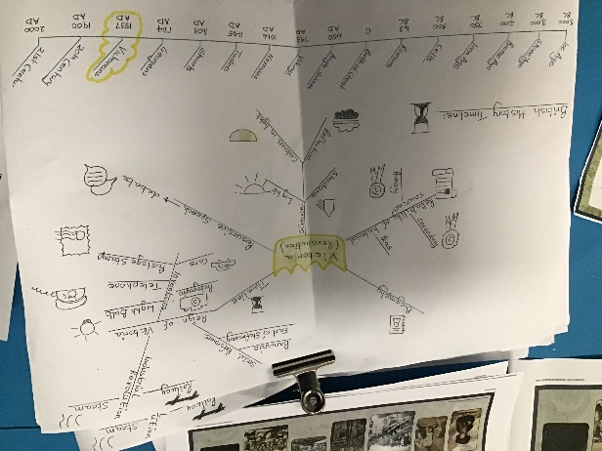
- Once children have consistently neat handwriting, they can have a black pen. This is usually in Years 3 & 4. Pens are only given when pupils are consistently writing neatly, legibly and in cursive throughout all of their learning.
- Black pens are used by all pupils in Years 5 & 6, with extra practice sessions for those pupils who initially find it difficult to write with a pen.
- In Year 6, pupils begin to have their own neat legible style of handwriting, fitting the criteria given in the writing standards document for Y6 expectations.
- There is an insistence on neat correctly formed handwriting in all lessons.
- If handwriting is a problem for specific pupils, then extra practice is done in school and extra sheets may be sent home to complete.

