What does History look like at Humberston Cloverfields?

Big Ideas

Human Kind, Comparison, Significance, Change and Investigation
Intent
We offer a high-quality history education that will help pupils gain a coherent knowledge and understanding of Britain’s past and that of the wider world. It will inspire pupils’ curiosity to know more about the past. History helps pupils to understand the complexity of people’s lives, the process of change, the diversity of societies and relationships between different groups, as well as their own identity and the challenges of their time. History provides a sense of identity and belonging. Children learn about who they are because history study provides a context from which to understand ourselves and others. It anchors the individual in a timeline of all that has gone before. It provides models of good and responsible citizenship as well as learning from the mistakes of others.

Implementation
Generally History at Humberston Cloverfields is taught through discrete subject topics but links are made to geography, English and other subjects as appropriate. The subject is taught so there is a focus on developing perseverance and determination by studying significant events and key historical figures. Skills taught in history e.g. investigating and analysing sources of evidence motivate and create enquiring minds. Through interesting history contexts and activities pupils begin to understand change and societal development.

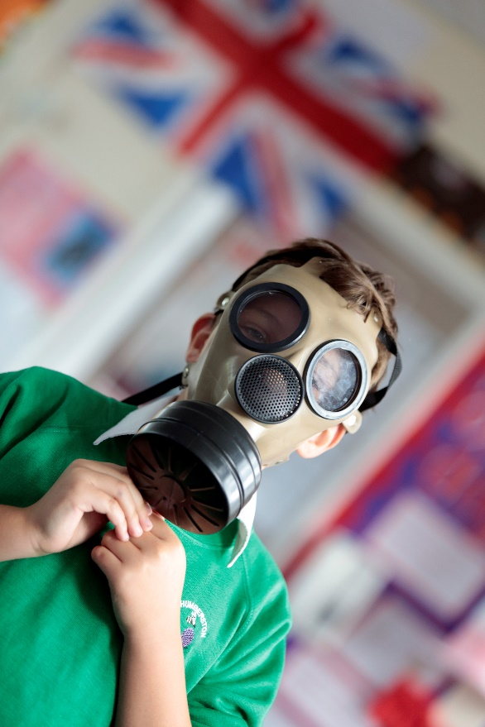

Early Years
Peoples and Communities-As children learn about the world around them they find out about the past through talking to parents, grandparents and
friends and they develop an interest in their own story as well as the stories in their family – this is the beginning of developing an understanding of the past and helps them to learn about how other people are different from them, yet share some of the same characteristics and ideas.

Key stage 1

Pupils develop an awareness of the past, using common words and phrases relating to the passing of time. They know where the people and
events they study fit within a chronological framework and identify similarities and differences between ways of life in different periods. They use a wide vocabulary of everyday historical terms. Teaching equips pupils to ask perceptive questions, think critically, weigh evidence, sift arguments, and develop perspective and judgement. They ask and answer questions, choosing and using parts of stories and other sources to show that they know and
understand key features of events. They understand some of the ways in which we find out about the past and identify different ways in which it is represented.

Key stage 2

Pupils continue to develop a chronologically secure knowledge and understanding of British, local and world history, establishing clear narratives within and across the periods they study. They note connections, contrasts and trends over time and develop the appropriate use of historical terms. They regularly address and sometimes devise historically valid questions about change, cause, similarity and difference,

and significance. They construct informed responses that involve thoughtful selection and organisation of relevant historical information. They should understand how our knowledge of the past is constructed from a range of sources.

Impact
Pupils have a strong understanding of all of the key expectations in history. The knowledge base of the areas of history covered are comprehensive. They can place key events on a timeline. Through our history teaching at Cloverfields pupils will be prepared for further in-depth historical study at Secondary school. We also want to instil a personal love of history for life and a possibility that some children will choose to pursue a career in pure history or with the subject as a core element.

Throughout our teaching of history we develop strong pupil engagement.

