What does Mathematics look like at Humberston Cloverfields?

Intent

At Humberston Cloverfields we provide a high-quality mathematics curriculum that recognises that Mathematics provides a foundation for understanding the world, gives pupils the ability to reason mathematically and to have an appreciation of the beauty and power of mathematics. It is essential to everyday life, critical to science, technology and engineering, and necessary for financial literacy and most forms of employment. We want our children to be successful mathematicians and to have a sense of enjoyment and curiosity about the subject.

Curriculum Implementation

The national curriculum for mathematics aims to ensure that all pupils:
- become fluent in the fundamentals of mathematics, including through varied and frequent practice with increasingly complex problems over time, so that pupils develop conceptual understanding and the ability to recall and apply knowledge rapidly and accurately.
- reason mathematically by following a line of enquiry, conjecturing relationships and generalisations, and developing an argument, justification or proof using mathematical language
- can solve problems by applying their mathematics to a variety of routine and non-routine problems with increasing sophistication, including breaking down
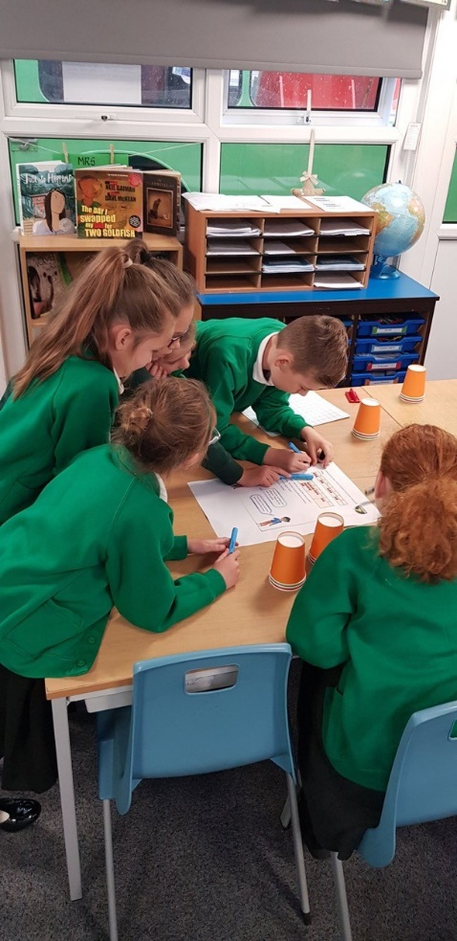
Y3 Maths collaboration

- problems into a series of simpler steps and persevering in seeking solutions.
At Humberston Cloverfields we have the equivalent of at least 5 hours of maths teaching a week but from Y1 onwards staff have the choice of daily lessons or half day blocks of teaching or a mix of both. In these lessons we cover a broad and balanced mathematical curriculum including elements of number, calculation, geometry, measures and statistics. We focus not only on the mathematical methods but also on the development of mathematical vocabulary.
- To allow adults to effectively support pupils in real time, marking occurs in lessons. This could be adult-led or pupils can self-mark their work. This allows pupils to consider their errors carefully and discuss ways to avoid them in future.
- Within each lesson, children are given time to talk through their thinking with their peers whilst also having the opportunity to work independently.

We use Big Maths online, that encourages enjoyment, confidence, mastery of maths and meets all national expectations. We also use White Rose materials to ensure a curriculum that is specific to each child’s learning needs. Visual calculations and Fractions policies provide further consistency to the Cloverfields Maths Curriculum.
Mathematics is also integrated into other subjects across the school e.g. science , PE and DT
Maths Working Walls:
- Relevant aspects of our visual calculations policy and visual fractions policy are displayed on working walls as a model for children to refer to.
- Key vocabulary is displayed.
- Examples of children’s work, photographs and examples of teacher-led problem solving are also displayed to prompt and remind pupils.
From the 2020/21 academic year onwards, schools in England will be required to administer an online multiplication tables check (MTC) to year 4 pupils. The purpose of the MTC is to determine whether pupils can recall their times tables fluently, which is essential for future success in mathematics. It will help schools to identify pupils who have not yet mastered their times tables, so that additional support can be provided. To support the children with their multiplication practice we use ‘Times Table Rockstars’ as an online and fun learning platform which also offer resources to be used in the classroom.

EYFS
In Early Years, Mathematics involves providing children with opportunities to develop and improve their skills in counting, understanding and using numbers, calculating simple addition and subtraction problems; and to describe shapes, spaces, and measure.
Pupils are taught to-
Number
- count reliably with numbers from 1 to 20
- place them in order and say which number is one more or one less than a given number
- add and subtract two single-digit numbers and count on or back to find the answer using quantities and objects
- solve problems, including doubling, halving and sharing
Shape, space and measure
- use everyday language to talk about size, weight, capacity, position, distance, time and money to compare quantities and objects and to solve problems
- recognise, create and describe patterns
- explore characteristics of everyday objects and shapes
- use mathematical language to describe them.

Key Stage 1
The National Curriculum (2014) states that:
The principal focus of mathematics teaching in key stage 1 is to ensure that pupils develop confidence and mental fluency with whole numbers, counting and place value. This should involve working with numerals, words and the four operations, including with practical resources [for example, concrete objects and measuring tools].

At this stage, pupils should develop their ability to recognise, describe, draw, compare and sort different shapes and use the related vocabulary. Teaching should also involve using a range of measures to describe and compare different quantities such as length, mass, capacity/volume, time and money.
By the end of year 2, pupils should know the number bonds to 20 and be precise in using and understanding place value. An emphasis on practice at this early stage will aid fluency.
Pupils should read and spell mathematical vocabulary, at a level consistent with their increasing word reading and spelling knowledge at key stage 1.

Lower Key Stage 2
The National Curriculum (2014) states that:
The principal focus of mathematics teaching in lower key stage 2 is to ensure that pupils become increasingly fluent with whole numbers and the four operations, including number facts and the concept of place value. This should ensure that pupils develop efficient written and mental methods and perform calculations accurately with increasingly large whole numbers.
At this stage, pupils should develop their ability to solve a range of problems, including with simple fractions and decimal place value. Teaching should also ensure that pupils draw with increasing accuracy and develop mathematical reasoning so they can analyse shapes and their properties, and confidently describe the relationships between them. It should ensure that they can use measuring instruments with accuracy and make connections between measure and number.
By the end of year 4, pupils should have memorised their multiplication tables up to and including the 12-multiplication table and show precision and fluency in their work.
Pupils should read and spell mathematical vocabulary correctly and confidently, using their growing word reading knowledge and their knowledge of spelling.

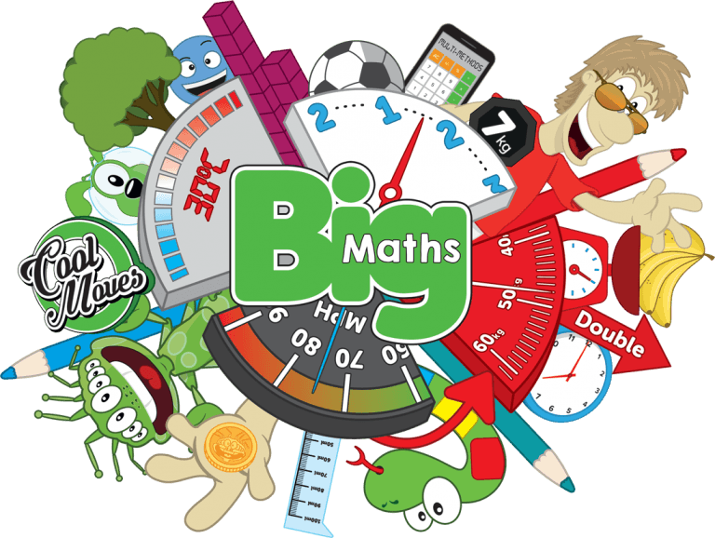
Upper Key Stage 2
The National Curriculum (2014) states that:
The principal focus of mathematics teaching in upper key stage 2 is to ensure that pupils extend their understanding of the number system and place value to include larger integers. This should develop the connections that pupils make between multiplication and division with fractions, decimals, percentages and ratio.

At this stage, pupils should develop their ability to solve a wider range of problems, including increasingly complex properties of numbers and arithmetic, and problems demanding efficient written and mental methods of calculation. With this foundation in arithmetic, pupils are introduced to the language of algebra as a means for solving a variety of problems. Teaching in geometry and measures should consolidate and extend knowledge developed in number. Teaching should also ensure that pupils classify shapes with increasingly complex geometric properties and that they learn the vocabulary they need to describe them.

By the end of year 6, pupils should be fluent in written methods for all four operations, including long multiplication and division, and in working with fractions, decimals and percentages.
Pupils should read, spell and pronounce mathematical vocabulary correctly.
Impact
Our pupils to enjoy maths and rise to ever increasing challenge. Pupils are confident in their yearly objectives and develop their ability to use this knowledge to greater depth understanding. They are able to solve varied fluency problems as well as problem solving and reasoning questions.
We want them to be able to use maths in everyday life as soon as they enter Nursery and continue to develop this. Each child will have a strong and confident grasp of Mathematics to take forward to their Secondary school.

