
What is Music like at Humberston Cloverfields?
Intent
At Humberston Cloverfields the intention is that children gain a firm understanding of what music is through listening, singing, playing, evaluating, analysing, and composing across a wide variety of historical periods, styles, traditions, and musical genres. We are committed to ensuring children understand the value and importance of music in the wider community, and are able to use their musical skills, knowledge, and experiences to involve themselves in music, in a variety of different contexts.
Implementation
The music curriculum ensures pupils sing, listen, play, perform and evaluate. Whilst in school, children have access to a varied programme, which allows students to discover areas of strength, as well as areas they might like to improve upon. This is embedded in the classroom activities as well as the weekly whole school singing assembly. We put on various concerts and performances, his includes the popular Talent contest where individual pupils and small groups perform in front of the school. The elements of music are taught in the classroom lessons by staff with a high level of expertise so that children are able to use some of the language of music to dissect it, and understand how it is made, played, appreciated and analysed.

Early Years and Foundation

Children in EYFS follow the foundation stage profile, with a focus on singing a range of well

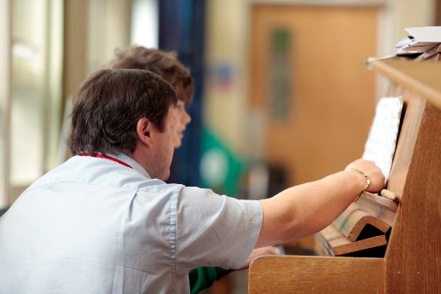

known nursery rhymes and songs and they also perform songs and rhymes with others. Children also dance and move along in time to a wide range of songs from various cultures from around the world. Children are also given opportunities, both inside and outside the classroom, to experience a range of tuned and untuned percussion. Children are assessed termly against the profile statements.
KS1
In key stage one children use their voices expressively and creatively by singing songs, speaking chants and rhymes. They play a range of tuned and untuned instruments. We use a wide range of live and recorded music to maximise engagement with the children. Children are taught musical vocabulary and the skills needed to create, select and combine sounds.
KS2
In KS2 a wide range of music is listen to and pupils are taught the language that enables them to discuss and appreciate different types of music. In the classroom, during their time at Cloverfields, pupils learn how to play an instrument, from all four main instrument groups of wind, strings, percussion and keyboards. In doing so understand the different principle of each method of creating notes, as well as how to read basic music notation. They also learn how to compose focussing on different dimensions of music, which in turn feeds their understanding when listening, playing, or analysing music. Composing or performing using body percussion and vocal sounds is also part of the curriculum, which
develops the understanding of musical elements without the added complexity of an instrument. Various peripetic staff teach individual and group sessions throughout the year. The Wider Opportunities scheme provides sessions on the recorder, beginning in Year 3. The school choir performs out of school; singing and playing for various local organisations.

Productions
Throughout their time in school all pupils will have the opportunity to take part in a major production on an annual basis. Most of these are musicals.
Nursery and Reception/ KS1 do separate Nativity Productions. Y3/4 put on a production at Easter and Y5/6 do a Leavers Production in the summer.

Impact
The integral nature of music and the learner creates opportunities for achievement, self-confidence, interaction with and awareness of others, and self-reflection. Music will also develop an understanding of culture and history, both in relation to students individually, as well as ethnicities from across the world. We aim to ensure that children are able to enjoy music, in as many ways as they choose- either as listener, creator or performer. We intend that pupils may go onto Secondary school to build on the good level of music input they have received at Cloverfields and as many as possible take music forward at a personal enjoyment or professional level.

