What is reading like at Humberston Cloverfields?
Intent
Our aim is that every child will be a reader and have a life-long love of reading.
At Humberston Cloverfields, we promote, celebrate and nurture a passion for reading. By engaging with, interrogating and expressing a personal response to the language, authors and themes of a wide range of fiction genres and non-fiction texts, pupils are enabled; they can access the wider curriculum, experience empathy, gain insight into other time periods and diverse cultures as well as express well-supported opinions. Daily reading activities are designed to systematically train children to decode, dissect and deduce. Children are empowered by employing a range of strategies and skills which act as catalysts on their journey to becoming fluent, astute, ardent readers in their adult life.

All children will develop their reading skills to become competent, independent and enthusiastic readers; achieving mastery of the reading skills and strategies necessary to access and engage with the broad curriculum.

Implementation
Phonics
We use the Monster Phonics programme from Nursery with attached reading books and additional books that parents can share with their children in the early stages of reading. The colour-coded grapheme system is unique to Monster Phonics; each coloured grapheme is

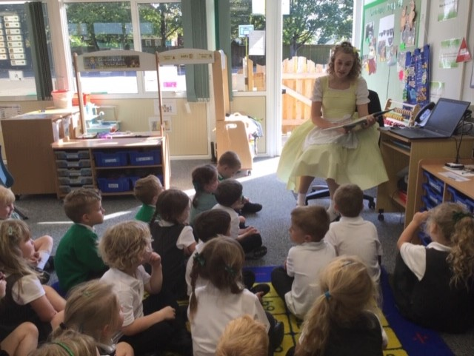

paired with a monster character that makes the same sound to give audio-visual prompts that help children ‘see’ each sound within a word and pronounce it correctly. The monsters are really sound cues to help children remember how to read and pronounce graphemes. Equipment that builds the sounds into words and additional visuals are used in the classroom.

Reading

Staff choosa suitable books from CLPE and built these into the curriculum with links to other subjects as much as possible. These can be fiction or non-fiction; related to the topic or for high pupil interest. The books or texts are selected so that children are reading, discussing

and writing in response to books/texts that are above the level of their current individual reading book.
Pupils interrogate the texts looking for different aspects- vocabulary, infer, predict, explain, retrieve, sequence or summarise; this is known as reading VIPERS. Staff fit these flexibly into their teaching sequences. Teaching Assistants are timetabled to support teachers in some of these sessions, they lead or support groups or individuals by using the teacher’s planning, focusing upon and modelling the skills exemplified by the teacher.

Teachers use the following, to plan, teach and assess reading skills strategies: daily Reading VIPERS, phase books, the class story, individual reading book, audio books, CLPE text, Question stem cards, Reciprocal Reading tools, Reading task cards and PEEL posters, Book Talk and book reviews.
As appropriate, pupils are given the opportunity to pre-read the text read before the session in order to extend their understanding and discussion of books.
Within Y2, Y5 and Y6, these reading skills sessions are also used to focus on: past SATs papers, question styles and mark schemes.
Across the school, children participate in a discrete comprehension - sometimes linked to the topic, use guided reading strategies and respond to unseen texts.
All pupils investigate texts independently.
Pupils are taught the strategies to enable them to participate in a self-led reading discussion group.
ERIC is integrated into the weekly timetable.
All classes have a weekly, dedicated library session on our Library Bus where pupils read and discuss books.
Teachers use this library session to discuss the selection of books in order to engage and challenge.
Reading nights are monitored, with reading records collected in weekly by the class teacher. Classroom rewards such as a weekly prize draw and team points are a feature. Pupils are rewarded for reaching 30, 50, 150 and 250 nights with a prize from the class prize box. Pupils are rewarded in assembly with bronze, silver and gold reading pins for achieving: 100, 200, 300 nights and a plaque for reading for 350 nights (5 team points are awarded per award).

