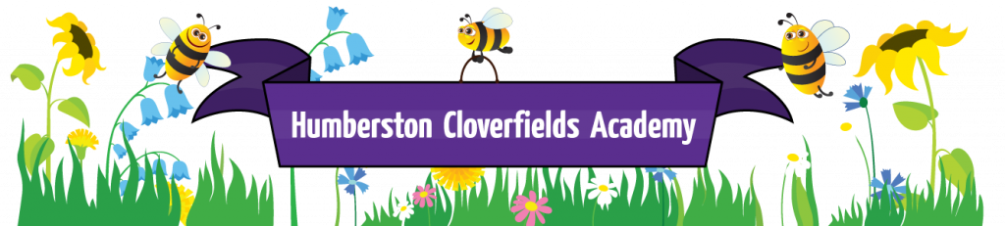
What does Spiritual, Moral, Personal, Social and Cultural ( and Health Education) like at Humberston Cloverfields?

Cloverfields is a school where we are always “Busy Being our Best.”
We are Ready, Respectful and Safe.
Intent
Through our curriculum , behaviour policy and whole school PSHE teaching we ensure that we support every child so that when they leave
Cloverfields they will have a clear sense of their own uniqueness that enables them to be confident, independent learners with a high level of self-esteem. They will be happy, well balanced and socially adaptable. They will be highly motivated with all the tools they need for the next steps in their learning journey.
In order for this to be a reality we-
- create a climate in school where pupils feel valued, are listened to and trusted;
- build and maintain a welcoming, friendly, bright and lively happy place where learners feel secure;
- teach social, cultural, and wider British Values and lead by example to create children who are tolerant of differences and actively promote an inclusive school community. We expect and foster highly developed sense of respect and tolerance that is evident in pupils behaviours in the wider society.
- ensuring that all pupils’ develop self-discipline appropriate for their stage of development.
- by provide well for learners’ care, health and safety.

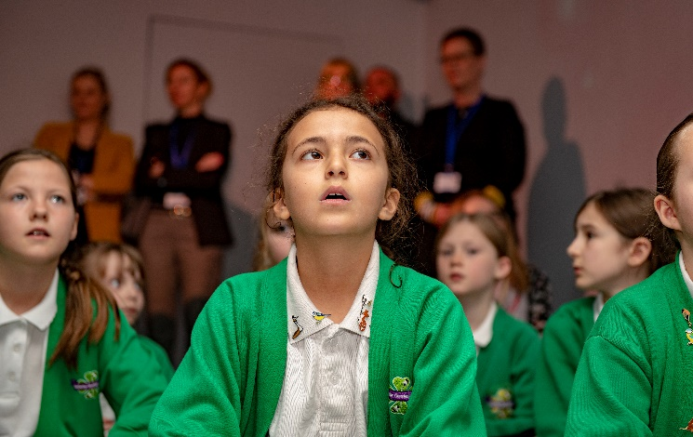
Launch day-The awe and wonder of learning in our Immersive Classroom
Implementation
Our broad and balanced curriculum provides for the spiritual, moral, social and cultural learning of our children and the extra-curricular activities we provide, extend and consolidate this learning.
We use the Jigsaw programme as our PSHE curriculum as it is a whole school approach with all year groups working on the same theme Puzzle(topic) at the same time. This enables each Puzzle to start with an introductory assembly generating a whole school focus for all. It is based on a ‘mindful’ approach to PSHE covering Personal, Social, Health Education alongside emotional literacy, social skills and spiritual development enabling children to take more responsibility for their responses to situations.

Through the taught curriculum each Piece (Lesson), helps children explore their thoughts and feelings, expand their emotional vocabulary, explore thoughts-feelings-consequences sequences, build their confidence and express themselves in a safe environment.
Through the ‘Calm Me’ time in each Piece which consists of breathing techniques, awareness exercise and visualisations, enabling the children to quiet their minds and become aware of the activity within them and manage it positively. Through the ‘Pause Points’ in lessons which ask children to ‘Stop, look inside and reflect’ in order relax bodies and calm their minds to reach a state for learning. The jigsaw chime is used with Calm Me activities.

There are 6 Puzzles or Themes/Units of work to cover throughout the year.
Term 1: Being Me
Term 2: Celebrating Differences (Including Bullying)
Term 3: Dreams and Goals
Term 4: Healthy Me
Term 5: Relationships
Term 6: Changing Me (Including Sex Education)
Each Puzzle has 6 Pieces (lessons) which work towards an ‘end product’ in the first Puzzle it is a School Learning Charter. Each piece aims to teach children to choose their response to a situation, rather than reacting with an emotion driven response, will reduce behaviour issues, help concentration and lessen stress and anxiety.
For each class/ year group there is:
A soft toy puzzle piece, these are different for each year group and are used as the ‘talking object’ during circle time activities.

Our behaviour policy built on the work of Paul Dix dovetails with the Jigsaw programme to create coherence to the holistic approach to SMSC across the whole school.

