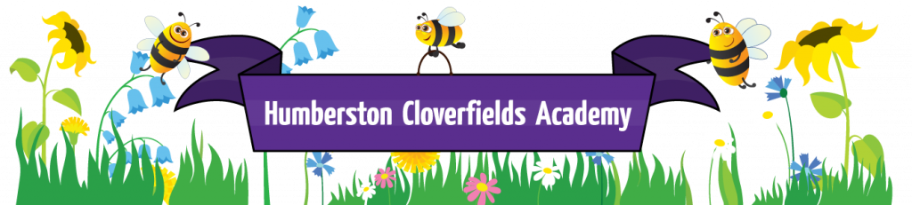
What does Science look like at Humberston Cloverfields?

Big ideas
Nature, Humankind, Processes, Comparison, Creativity, Investigation, Materials, Change, Significance, Place (environmental)
Intent
Our science curriculum is ambitious and designed to inspire all pupils to thrive in an increasingly scientific/technological world. We aim to equip children with the knowledge and skills to think independently and develop an enquiring scientific mind. The Scientific area of learning is concerned with increasing pupils’ knowledge and understanding of our world, and with developing skills associated with Science as a process of enquiry. It will develop the natural curiosity of the child, encourage respect for living organisms and the physical environment and provide opportunities for critical evaluation of evidence.
Implementation
Teachers use the national curriculum and skilfully deliver sequenced and progressive lessons throughout the year and across all year groups through a variety of contexts from nursery through to Year six. Where possible science is linked to other subjects especially Design Technology. The subject is hands-on thought-provoking, stimulating and fun. Working scientifically begins in the Early Years and progresses throughout the entire school. Planning involves teachers creating engaging lessons, often involving high-quality resources to aid understanding of conceptual knowledge. Teachers demonstrate how to use scientific equipment, and the various Working Scientifically skills in order to embed scientific understanding. Teachers find opportunities to develop children’s understanding of their surroundings by accessing outdoor learning.
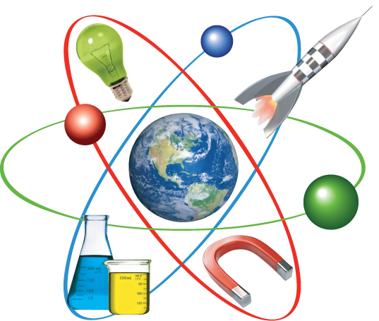

Pupils develop the following skills through science- questioning, observing, predicting, investigating and experimenting, understanding
and setting up fair testing, estimating and measuring, analysing, sorting and classifying, recognising patterns, interpreting, recording and communicating results.
Key in all of these skills is effective questioning which is fundamental to learning; science is an excellent example of where this can be modelled and taught to great effect as teachers use precise questioning in class to test conceptual knowledge and skills. Children are encouraged to ask their own questions and be given opportunities to use their scientific skills and research to discover the answers. This curiosity is celebrated within the classroom. Scientific knowledge and understanding is secured and demonstrated in practical, written and verbal situations. A great deal of maths and English are required within science.
Our Immersive learning classroom enhances the teaching of science through 360 degree video e.g. a bee flying and gathering pollen, the inside of the human body etc

Impact
The manner in which we teach science positively impacts on the motivation and “love” of the subject. Pupils are inspired to research and carry out their own experiments at home and also suggest ideas to enhance the learning in the classroom. Science impacts on the way pupils think and their approach to other subjects and life in general.
As pupils move on from Cloverfields they will take with them a wide body of knowledge and scientific skills that will give them a strong basis for further study at Secondary level. The future is uncertain and ever-changing, the world’s natural resources are diminishing so we are to creating the foundations for scientist who can improve the world for the future generations.

