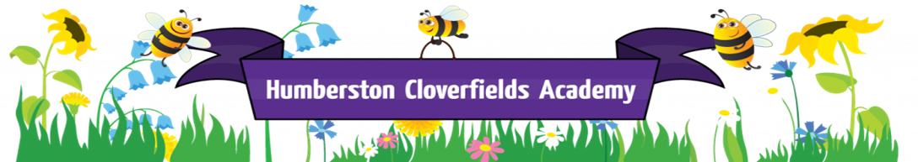

What does writing look like at Humberston Cloverfields Academy?

Intent

Our aim is to facilitate all pupils to develop a life-long love of writing

At Cloverfields, all pupils are on a journey towards achieving mastery of the skills within writing and the strategies necessary to access and engage with the broad curriculum. All children develop their writing content in order to become competent, independent and enthusiastic authors.

Implementation
There are Golden Threads running throughout the school.
Working Walls are made up of work in progress, ideas from pupils, visual stimuli and examples of skills learned and applied. The wall is a teaching tool for everyone to access and use.
Initial Stimulus – any type of stimulus is used, eg. book, picture, film clip, Immersive Classroom, drama, memorable experiences, educational visits etc. Ideas are gathered in any format the teacher wishes (eg. post-it notes, large sheets of paper etc).

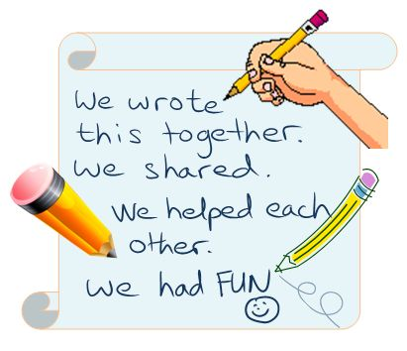

Purpose - Children know the purpose and the audience for their writing across the curriculum.
Talk for learning – a range of techniques are used as appropriate across the curriculum.
Text interrogation – links with grammar, vocabulary, literary techniques and punctuation skills are made. Aspects of inference training and Power of Reading are also utilised.
Scaffolding -Timelines are used for planning the structure of the narrative – a variety of timelines are used and are suitable for the age group and the complexity of the writing. A limited number of scaffolds are initially provided from which children can make informed choices.
Modelled/ shared writing -Teacher/TA model writing to the class and/or a specific focus group, involving the adult demonstrating the writing stages, sharing their thoughts & questions out aloud and responding to pupil input. Pupils and adults discuss reasons for choices, using learning partners.
Paired / group writing - Pupils work together to produce a piece of writing.
( Age and writing stage appropriate)
This could be a phrase, a sentence or two, a paragraph, chapter or whole piece of narrative.
Independent application- Author’s book The children write for a real purpose e.g to inform, persuade, to report on an experiment outcome, create fiction for a known audience etc. Pupils write individually and apply skills and techniques practised and learned throughout the writing sequence. Children have their ideas in front of them and are encouraged to use the working wall and any other scaffolds.
Drafting – As children progress through the school, pupils draft and re-draft elements of their writing, until it is the best that they can do, acting upon all peer critique. The “Best finished piece is written at the end of the editing process in the pupils Author’s Book. Copies may be made for display. The writing can also be performed depending on genre e.g. writing a film script and then filming it; performing poetry; creating a book, presenting and performing in the Immersive Classroom, etc
Examples of “best” work can be displayed on a celebration ‘Busy Being our Best’ board with teachers commenting on specific things in the writing that showcases high quality work and progress made.
SELF, PEER AND TEACHER ASSESSMENT
Pupils are encouraged to read through each other’s writing at the paired proof-reading and editing stage.
In KS1, when they are ready, pupils are taught how to look for specific things within the writing, eg. capital letters at the beginning of a sentence; a final stop; an adjective, etc. In KS2, peer assessment is an integral element of writing sessions.
Purple pens are used in KS1 and KS2 personal and peer editing and the use of the agreed proof-reading symbols are used in KS2.
Pupils are encouraged to give verbal feedback as well as written feedback, using the BE KIND and BE HELPFUL bookmarks and sentence openers.
Adults provide feedback within the lessons, with either verbal guidance, notes on the work or post-its. This enables all adults to know what the focus is for the pupil.
On the final piece of work, teachers make an overall positive comment.

