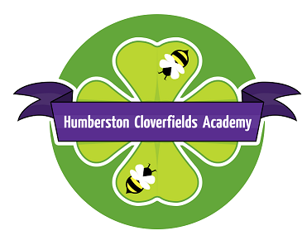Humberston Cloverfields Academy
St. Thomas Close, Humberston, Grimsby,
North East Lincolnshire, DN36 4HS

Telephone: (01472) 500217 Fax: (01472) 500218
Email: office@cloverfields.org.uk

Acting Principal – Mrs L Holness

12.11.21

Upcoming changes – message from Mrs Patterson
As you know, I will be working as Executive Principal at Elliston and Humberston Cloverfields from January. I have been spending some time at Cloverfields over the past couple of week and I cannot wait to start working with you officially. It is an exciting time for us all; your children are just delightful and I am enjoying getting to know them. I know it won’t be long before they, and you, get to know me too. I am absolutely committed to your children being happy and settled at school while having access to high quality learning everyday. Together, the two schools are very much focussed on developing a culture of excellence and I know this will shine through in everything we do.
I am delighted to inform you that Mrs Holness has been appointed as Head of School for Cloverfields; she obviously knows the school extremely well and is passionate about the children getting the very best in every way, this will ensure that the academy will continue to grow and flourish under this new style of working. Mrs Holness will be available to support staff, children and parents on a daily basis although I will also be able to respond to any queries/concerns as and when I am needed. Please do not hesitate to contact me via the school office at any time.
Miss Nicholson – the Y5/6 leader and Assistant Principal at Elliston - has been appointed as Executive Vice Principal for Elliston and Cloverfields and will work across both academies with me. Miss Nicholson is a very talented practitioner and will be supporting both teams with continuing to develop excellent teaching and learning.
I hope you feel reassured that Cloverfields will remain a great place for learning with a committed and dedicated leadership structure in place.
Thank you with your continued support with everything we do.
Kind regards
Mrs Patterson

