Technology

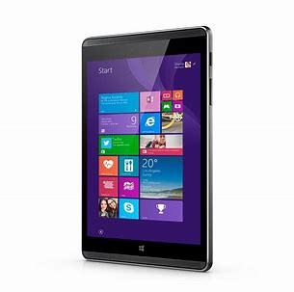
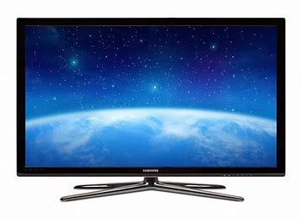
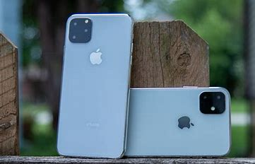
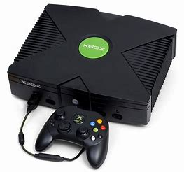
I would like you to think about how technology has shaped your experiences in lockdown. For example, how have you used various forms of technology, ranging from consoles to mobile phones to catch up TV. It would be great for you to list the range of technology and social media platforms you have used and write about how your lockdown would have been different if you didn’t have any access to technology or social media. You can either present your work in word, PowerPoint, or even as a poster.

