Clamps are a versatile part of any tool kit, they can be used to secure a workpiece to a work surface, to secure a straight edge across a work piece for sawing or routing, or to hold a workpiece during gluing.
Rules for clamping:
- Always use a piece of scrap wood between each jaws of the clamp and the workpiece to prevent damage.
- When a clamp is positioned, close the jaws until the clamp feels tight, when gluing, some will be squeezed out around the joint, a sign that it is tight enough.
- Clamping pressure should be applied at right angles to the glue line otherwise slippage may result.
- Do not overtighten, if the fit is accurate only moderate pressure is required, the purpose of a clamp is only to maintain uniform pressure between the two surfaces, not to force them to fit.

G Clamp
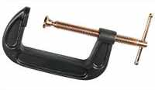Sometimes referred to as 'C-clamps'. Probably the most widely used and versatile clamp. It can be used to clamp a workpiece to a work surface or two parts of a workpiece together. Jaw openings range from about one inch to over 8 inches.. The end of the screw section normally has a swivel head which enables the clamp to sit on irregular surfaces.

Hand Screw Clamps
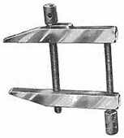Metal Hand Screw Clamps (known as 'Toolmaker's clamps') are mainly used in metalwork, however they do have a use to clamp small items. Wooden Hand Screw Clamps are ideal for furniture repairs; the adjustable jaws will also fit angled material.

Sash Clamp
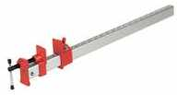The clamp has a flat bar with a fixed jaw that adjusts with a screw action and a sliding jaw that is locked in positioned along the bar to suit the job being undertaken.
These clamps are for big tasks such as sash windows, table tops, doors etc. Usually several such clamps are required.

Bench Clamps
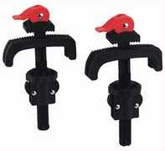2 piece bench clamp which are designed to fit workbenches with holes 18-38mm. Clamping range 0-80mm. Those shown include quick release clamping action.

Web Clamp
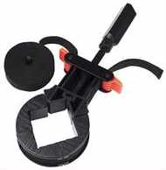Ideal for frames. The Nylon band wraps around the object and is tightened with a ratchet. Can be used with (or without) corner gripping pieces (as shown) so that pressure is evenly distributed.

Mitre Clamp
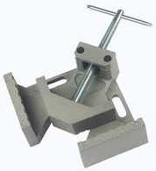

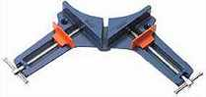
Used for gripping two pieces with mitred ends at right angles. Two types are available, internal (upper) or external (lower).

Quick Action Clamp
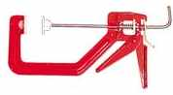One hand operated clamp (operates like sealant guns) ideal for quickly and easily clamping all kinds of workpieces. Simple single finger release.

For the above clamps research online the cost for each one | Cost in £
G clamp
Hand screw clamps
Sash clamp
Bench clamp
Web clamp
Mirer clamp
Quick action clamp

Quick Grip
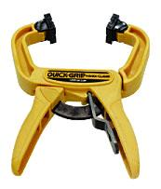Features one-handed operation with adjustable pressure, best for thin pieces as the jaws do not close square.

Power Clamp
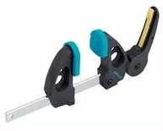Exact application of force and maximum power in a single movement.

Screw Clamp
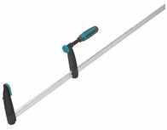Fast and powerful closing / opening due to special thread and handle grip.

Speed Clamp
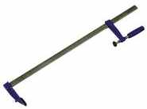A metal bar with serrations. As the clamping pressure is applied the serrations lock & secure the sliding head.

Work Bench
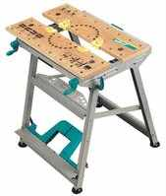These versatile benches normally include a top which can be used as a vice or clamp. With two independent adjustment handles, the jaws allow for tapered workpieces to be gripped.
How many different makes do you know or can research online

Teacher feedback

