Inspire Academy DESIGN AND TECHNOLOGY
The Disk Sander

NAME……………………………… DATE…………………………..
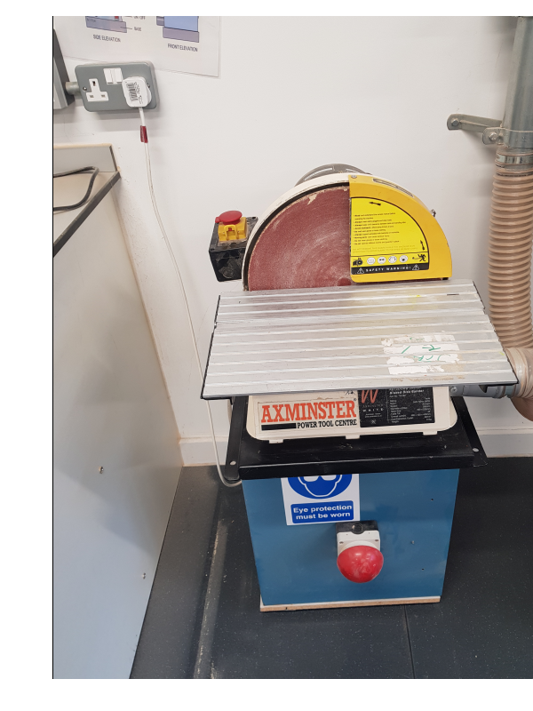
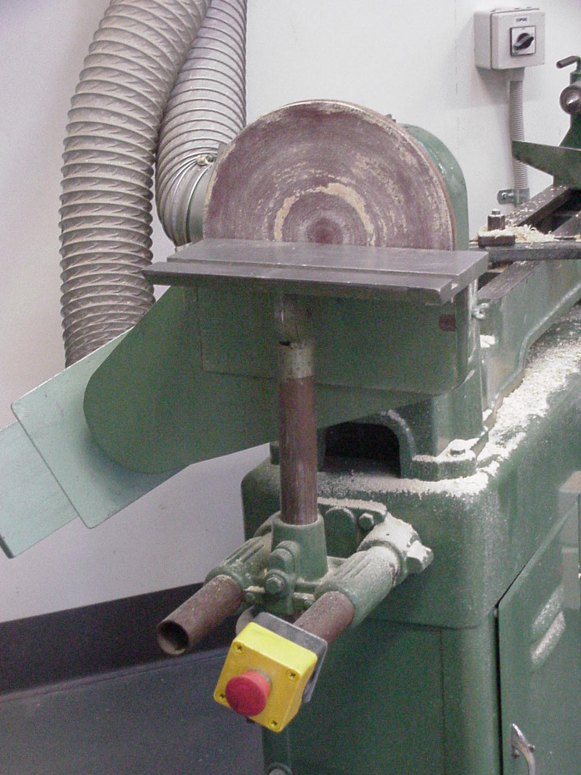
DESCRIBE THE USES FOR THIS MACHINE:

………………………………………...

………………………………………...

………………………………………...

………………………………………..

LABEL THE PARTS OF THIS MACHINE IN THE BOXES

LIST 3 SAFETY RULES SPECIFIC FOR THIS MACHINE

- ……………………………………………………….

- ……………………………………………………….

- ……………………………………………………….

WHICH SIDE OF THE DISC MUST YOU USE WHEN SANDING?

……………………………………………………………………………………

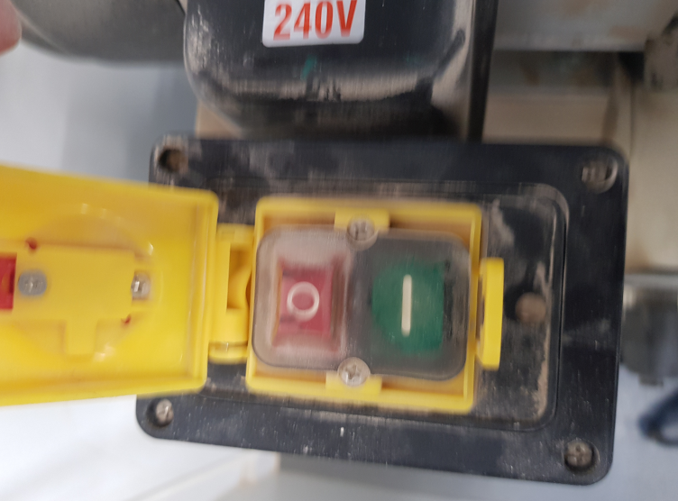
Name the buttons:

………………………………………………………………………………………………………………………………………………………………………………………

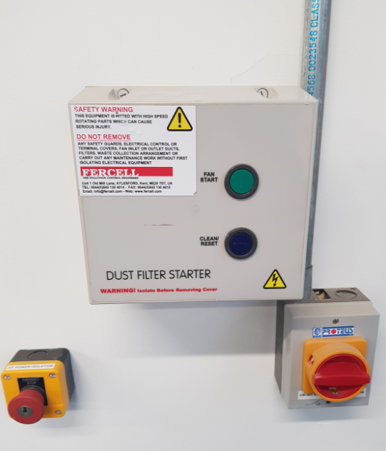
What is this for:

………………………………………………………………………………………………………………………………………………………………………………………
…………………………………………………………………………………………………………………………
Teacher feedback:

