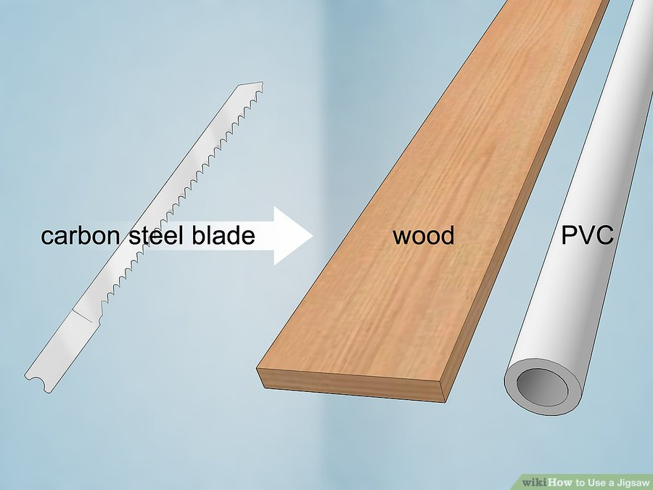
- Choose a carbon steel blade to cut through wood and PVC. Carbon steel blades are the standard material used in a jigsaw. If your project requires you to cut through wood, PVC, or laminate, find a hardened carbon steel blade.
  - Most blades will be labeled with the type of material they can be used on. Look on the packaging or on the label printed directly on the blade.
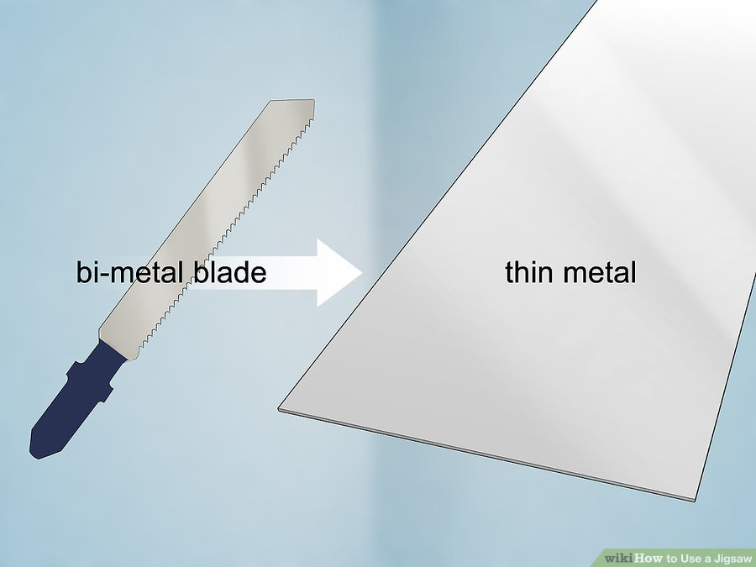
- Use a bi-metal blade to cut through thin metals. Since metal is a harder material, you need a tougher blade to cut through it. Bi-metal blades have hardened steel teeth to make the cut and a softer, flexible body so they don’t break. Find a blade or set of blades meant for metal cutting.
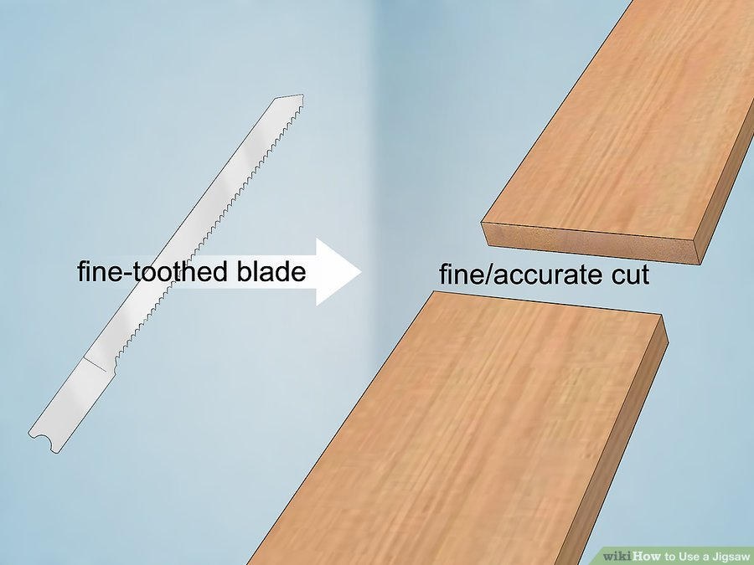
- Pick a fine-toothed blade for making clean and accurate cuts. Fine-toothed blades have more teeth on the blade per 1 inch (2.5 cm). Fine-toothed blades are standard for cutting metal or making a clean edge on wood.
  - Wood blades tend to have as many as 12 teeth per 1 in (2.5 cm), while metal blades can have up to 36 teeth per 1 in (2.5 cm).
  - Fine-toothed blades work best when they’re used at a slower speed so they don’t break.
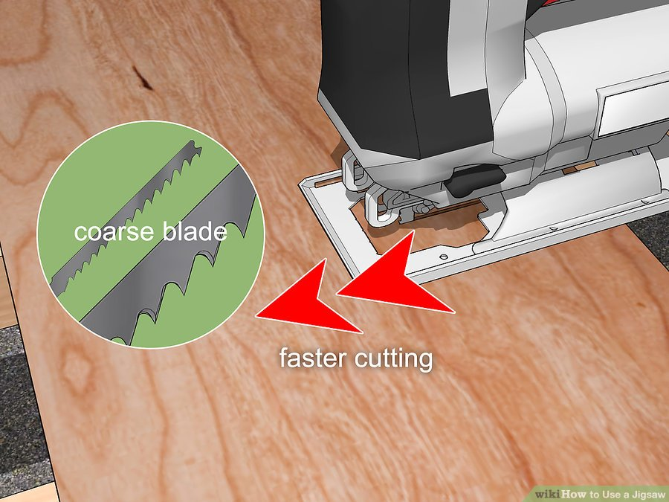
- Use a coarse blade to cut through wood faster. Coarse-toothed blades have fewer teeth per 1 inch (2.5 cm) and are mostly used to cut wood. If you need to make cuts quickly for a project, opt for a coarse-toothed blade to finish faster.
  - Coarse-toothed blades leave a rough surface and will chip wood.
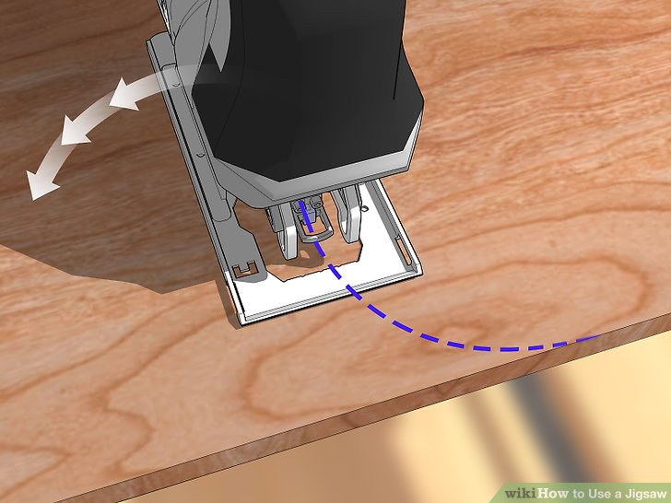
What health and safety processes have you followed when using the jigsaw.
How many different jigsaw bits have you used and describe what you used them for? You can research online (YouTube) how others can be used.

Teacher feedback

