Marking wood
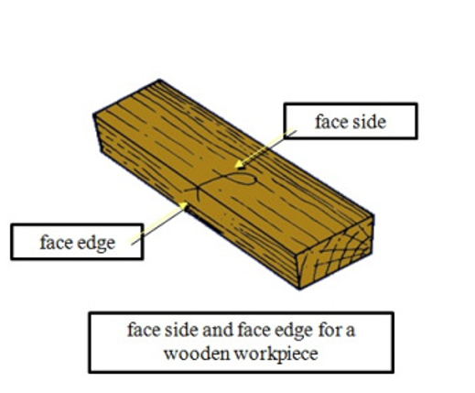
marking gauge -> mark lines parallel to the face side or face edge on a wooden workpiece
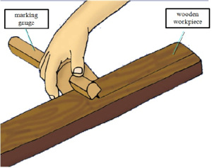
marking gauge -> mark lines parallel to the face side or face edge on a wooden workpiece
A marking knife is used with a try square to cut a line across the grain of a piece of wood where a section of the wood needs to be removed.
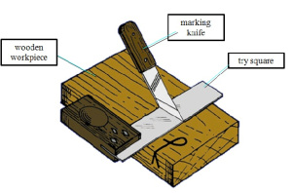

Use a try square with a pencil to mark a line at right angles to the face side or face edge on a wooden workpiece.
Face marking
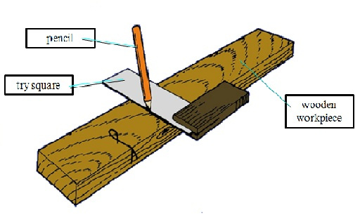
Pencil
Edge marking
Notes:
_______________________________________________________________________________________________________________________________________________________________________________________________________________________________________________________________________________________________________________________________________________
Measuring angles
There are different kinds of squares that measure different angles. A ‘mitre square’ measure 45 degrees on one side and 135 degrees on another.
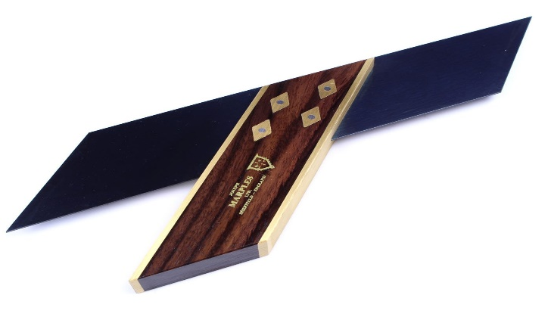
A ‘sliding bevel square’ has an adjustable knob that allows you to set it at any angle. You can use a protractor to set it at any precise angle.
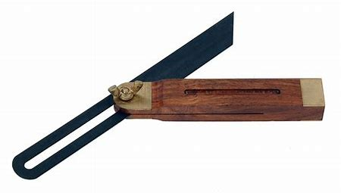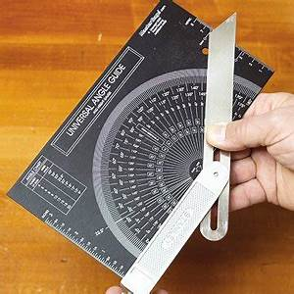
A ‘combination square’ can measure multiple angels of 45, 90, and 135 degrees.
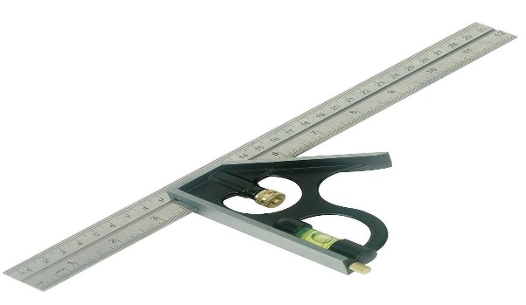
You might be wondering why you need a ‘try square’ or a ‘mitre square’ when you can manage these angles with a combination square. For one thing, convenience. A try square is a simple tool with 2 blades attached to each other at 90 degrees. For another, readings for a 90 degree angle tend to be more accurate from a try square as compared to a combination square. At least that’s what many woodworkers will tell you.

