Measurement in DT and Construction

The humble tape measure is the world’s most commonly used measuring tool, accompanying millions of tradesmen and contractors to work every single day.

Whilst seasoned professionals will no doubt be fully aware how to read the various markings on a tape, there will be amateurs, enthusiasts or those just starting off in their training who aren’t yet so knowledgeable. Regularly the question is asked by students “how do you read a tape measure”. In response I put together this simple guide that explains just that!
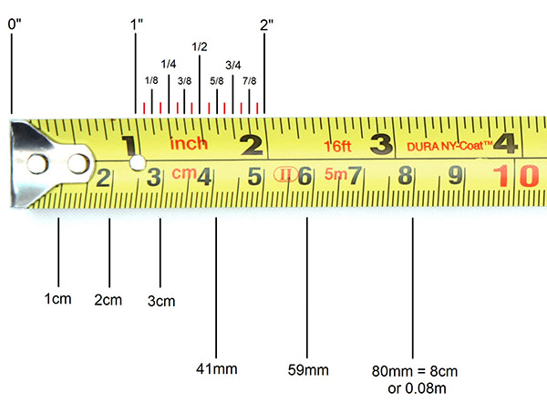
How to Read a Metric Tape Measure
Above you'll see a picture of a metric/imperial pocket tape measure. The measurements at the top are ‘Inch’ and the bottom ‘centimetres and milimetres.’ There are 10mm in each centimetre (shown by the ten spaces between each cm) and 100cm in each metre. Whilst the centimetres are clearly numbered, to make the blade easier to read the millimetres are not numbered. Also, whilst a few tapes show '1m' to display the 1 metre mark, the majority will show '100cm'.

When looking at the image above, the 1st small mark after the 4cm point denotes a measurement of 41mm. The next small mark in line would be 42mm, the next would be 43mm and so on. 41mm can also be referred to as 4.1cm (0.041m) but the majority of trades in the UK do tend to quote measurements in milimetres.

How to Read an Imperial Tape Measure
Whilst Britain now officially operates a metric system of measurement, our nation still sees a curious mix of both metric and imperial measurements being used on a day to day basis. We measure our height in feet and inches, our weight in stones and pounds and our speed in miles per hour. Despite this almost all 21st Century technical, engineering or construction measurements are quoted in millimetres. Most manufacturers have, therefore, opted to produce UK-spec tape measures with both metric and imperial graduations.

When referring to the diagram above you'll see a series of large numbers marked 1, 2, 3, and 4. These numbers sit next to long vertical marks which represent whole inches. Put simply 1 = 1", 2 = 2" and so on. Between those numbers are a series of shorter marks which represent fractions of an inch. The mark directly in the middle of the inch denotes a measurment of 1/2" whilst the markings either side of it represent measurements of 1/4" and 3/4" respectively. Even smaller marks then denote 1/8ths and 1/16ths (marked in red) of an inch.
- 1 foot = 12 inches
- 1 inch = 16 x 1/16th of an inch, 8 x 1/8th of an inch, 4 x 1/4 of an inch or 2 x 1/2 of an inch.
General Tips
The hook or 'tang' of the tape measure is the small, usually metallic component at the end of the blade. In pocket tapes (as seen in the image below), this is usually a straight piece of metal attached to the blade by a number of rivets. You will normally find (on any pocket tape of quality) that the hook 'floats'. In other words it moves in and out ever so slightly. Some people mistakenly think of this as a manufacturing defect but this is not the case.

When taking internal measurements (i.e. from the inside edge of an object such as between one internal wall and another) the hook can be pushed against the object (e.g. skirting board) providing an accurate measurement.

When taking external measurements, however, the hook can be placed around/behind the object and pulled gently towards the measurer. Not only does this keep the blade in place whilst measuring, it also guarantees an accurate measurement by compensating for the thickness of the metal hook in the measurement. Be sure to use the hook properly when using your tape measure!

Safety Tips
Whatever you do, never allow the blade and hook to return uncontrolled at full speed when rewinding. Whilst the ability to return the blade quickly into the case can seem like a useful function, it can be very dangerous with a number of people each year being injured by wildly flailing hooks. All manufacturers recommend that users make use of safety glasses/goggles when doing any work that requires a tape measure for exactly this reason.

What's more, some tape measures (regardless of expense or quality) can feature steel blades with relatively sharp edges. They may not feel sharp at first but it can be a very different story when travelling at speed. Remember health and safety is everyone’s responsibility.
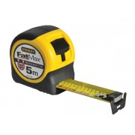
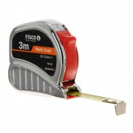
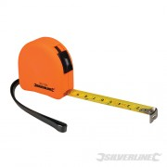
Tape measure worksheet

Name the parts of the tape measure
Look around the workshop and measure two items in cm and two in inches.
Item name | Measurement
 | cm
 | cm
 | inches
 | inches
What are the measurements marked by the green line?
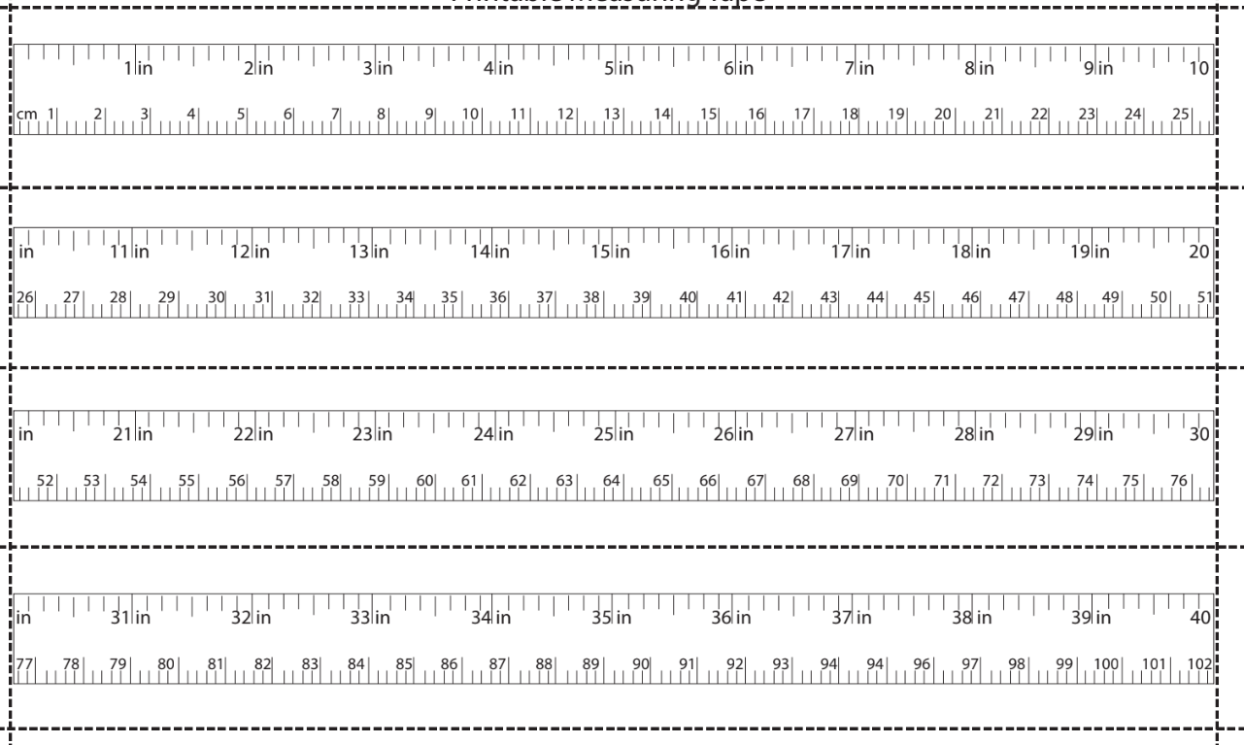

in

cm

in

cm

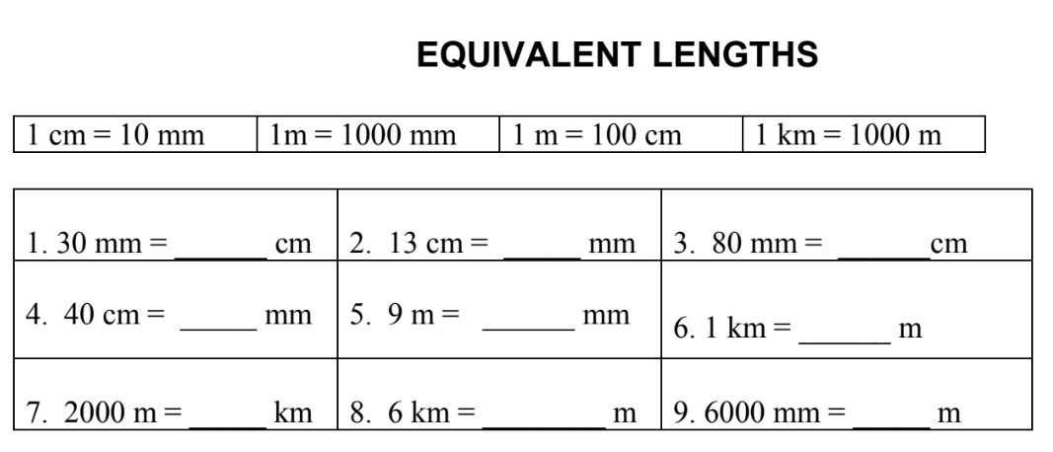

Internal and external tape measuring

Add a caption to the pictures of you measuring internal and external measuring.

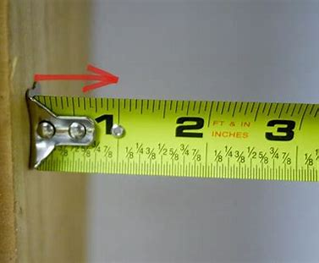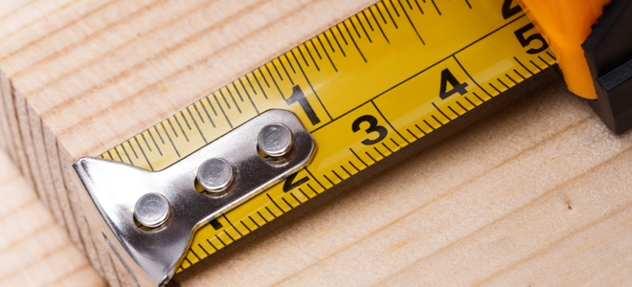

In this picture _______________________________________________________________________________________________________________________________________

In this picture _______________________________________________________________________________________________________________________________________

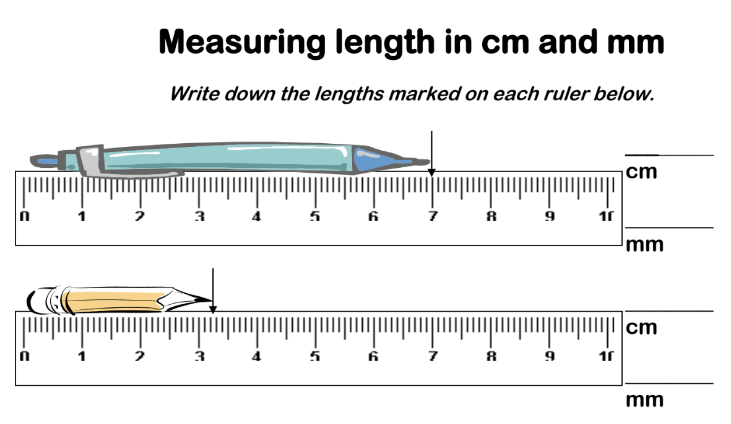
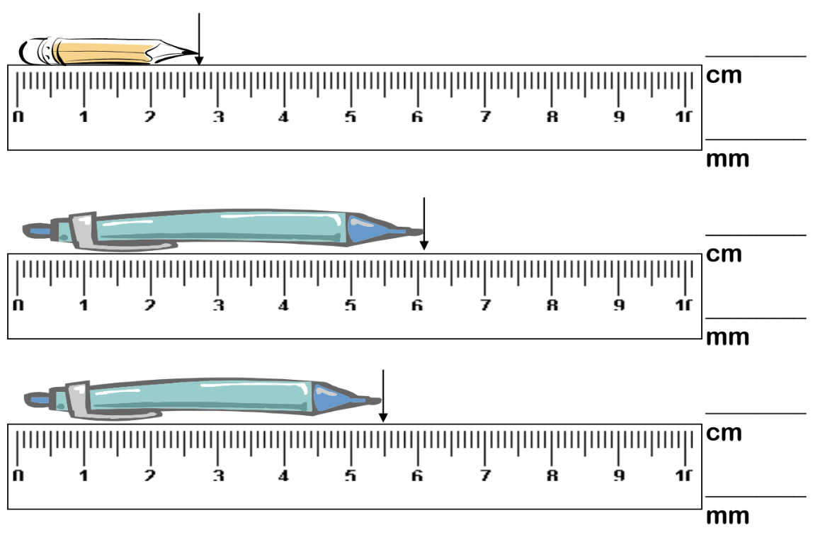

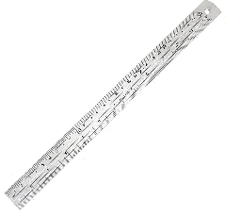
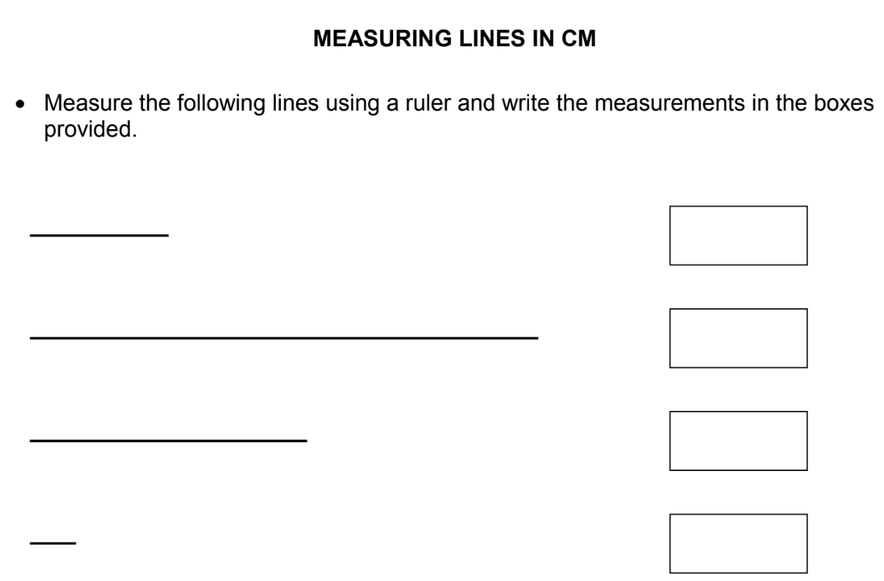

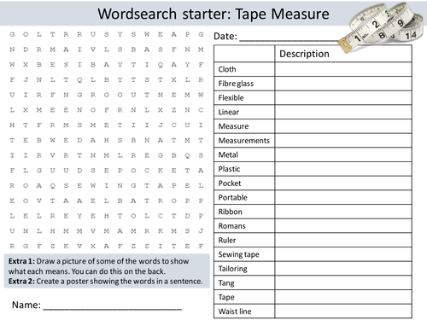

Any feedback? __________________________________________________________________________________________________________________________________
EBI-
EBI-
WWW-

