Parts of a nut and bolt
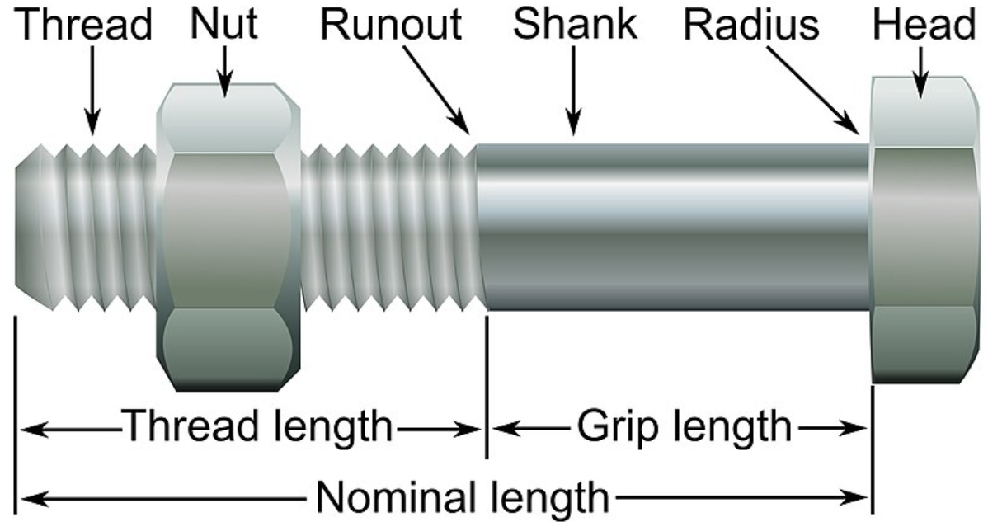

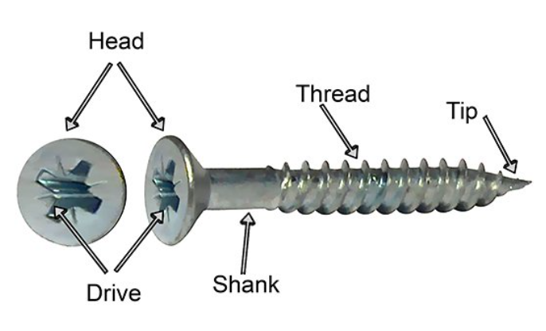

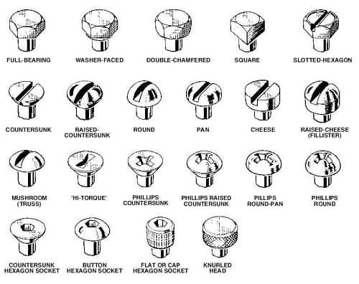
In front of you will be a collection of screws and bolts. List their names and describe where they could be used

Teacher feedback

